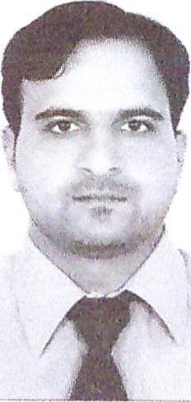
CURRICULUM VITAE

Name: Wasi Ullah Abdul Haleem
Address: Abu Dhabi, United Arab Emirates
Email: wasiullah@careerjobsuae.com

Desired Position: Maintenance Supervisor

To work with an esteemed organization as a Maintenance Supervisor using my expertise and experience gained for the benefit of the organization and to grow professionally at the same time.

CAREER OBJECTIVE
I am seeking a position in an organization that can utilize my abilities and further develop my experience. I intend to apply for the required position with the vision to utilize my skills and performance for the productivity and profitability of your reputed company.

Skills
- Dealing with corporate clients
- Good sales skills
- Ability to grasp and learn things quickly
- Presentable and talented
- Proper Time Organizer, Teamwork
- Logical and analytical approach to solving problems

Educational Qualification

- Diploma in Basic of Computer
- Secondary School Certificate from Board of Intermediate and Secondary Education, Peshawar — Pakistan in 2003
Job Experience

- Worked as a Domestic Wiring Electrician & Plumber for 5-Years.
- Working as General Maintenance Supervisor since 2009.
- Presently working as Public Relations Clerk with White Ruby General Maintenance in Abu Dhabi UAE from 2018 to till date.

Languages known

- Arabic (Speak-Read)
- English (Speak-Read-Write)
- Urdu (Speak-Read-Write)
- Pashto (Speak-Read-Write)

Strength and weakness

- Optimistic
- God fearing

Extracurricular activities

- Interact with people who like to talk
- Traveling

Personal Profile
Name : Wasi Ullah Abdul Haleem
Name of Father : Najabat Ali
Date of Birth : 01-01-1986
Place of Birth : Peshawar, Pakistan
Nationality : Pakistan
Marital Status : Married
Religion : Muslim
Gender : Male
Passport Details
Passport No : ET2747801
Date of Issue : 23-01-2013
Date of Expiry : 22-01-2023
Place of Issue : Pakistan
Status of Visa : Employment Visa
Emirate ID No : 784-1986-5272470-3
Date of Expiry : 01-04-2020

I hereby certify that the above mentioned statement is correct and true to the best of my knowledge and belief.

Wasi Ullah Abdul Haleem

