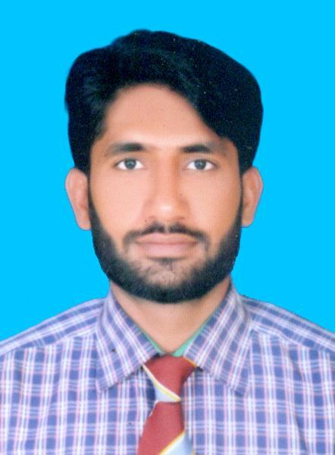
Malik Muhammad Ramzan

Present Location : Pakistan
Nationality : Pakistani
Religion : Islam
Date of Birth : 15 February, 1992
Marital Status : Married
Language : English, Urdu, Saraiki, Punjabi
CNIC Number : 36302-2608435-1
Passport Number : CF9214352
Driving License : Pakistan
Contact : 00923447229674
Email : malikramzan722@gmail.com
Postal Address : Hashmi Canal View House #. 139, Qasim Purr Bridge, Mumtazabad,
Multan, Pakistan
Objective:-

A Progressive position where I can utilize my skills in the field of mechanical engineering and production managements in a growth oriented organization.

Summary of Qualification:
Year of Completion Result/Division
- Plumber(NAVTTC) Multan 2018 B Grade
- F.SC (per-engineering) (Multan Board) 2010 2nd Division
- Matriculation in Science (Multan Board) 2008 1st Division

Professional

Summary of Experience

Bio-Officer at Etimad (Pvt) Ltd,

October 2016 – July 2020, Multan, Pakistan

I.T Consultant at Steel Craft (PVT) LTD,

December 2012 – April 2013, Lahore, Pakistan

Computer Assistant at Nadia Textile International Limited,

April 2011 – October 2011, Multan, Pakistan

Computer Operator at Delta Tech (PVT) LTD,

February 2009 – May 2009, Lahore, Pakistan

Extra Diplomas

- Graphic Designing
- Adobe Photo-shop 7
- MS Office
- In page
- Networking

Summary of Skills

- Self-motivated
- Enthusiastic
- Time management
- Problem solving
- Able to take responsibility
- Effective communication skills
- Creative
- Team working

Computer Skills

- Ms. Office (Word, PowerPoint, Excel, Access, Outlook)
- Auto Cad (2d)
- In-page
- Internet & Email

Interests

- Mechanical engineering
- Management
- Planning
- Motivating
- Cricket
- Traveling

Reference

Will be provided on request.

