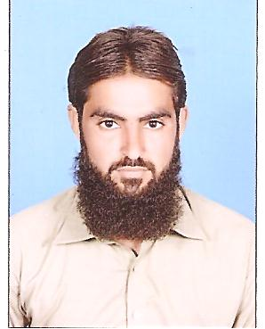

URRICULUM
ITAE
SARDAR AHMAD
Address Basti Kumb Chachran Moza Bhuta Kot P/ O Box Iqbal Abad
Tehsl & District Rahim Yar Khan
Mobile # 0303-2775007, 0303-0911949
WattsApp 0303-2775007
E-mail sardarahmad206@gmail.com

OBJECTIVE:

Seeking a position where I can utilize my skills in career opportunities. I am an out going high energy person and want to do work for my safe future. I want a suitable place for job.
Father’s Name | Hussain Bukhsh
C.N.I.C # | 31303-9671753-7
Date of Birth | 04 Jan 1993
Marital Status | Single
Domicile | Rahim Yar Khan (Punjab)
Nationality | Pakistani
Religion | Muslim

Personal Details:
Educational Qualification:
DEGREE | YEAR | Marks | Board / University
Matriculation | 2011 | 559/1050 | BISE ( BWP )
Diploma  Electrical & Electronics | 2014 | (Private ) | City & Guilds in Uk
Experience

- 6 Month Experience With Descon Engineering Limited as Insturment Technication in Raftar Project Rafhan food unilever (Phool Nagar)
- 3 Years Experience as Electrician in US Embassy in Islamabad. (B.L.HARBART INT.)
- 2 Years Experience With I Kan Enginneering as Electrician Nestle Site Skp.
- Install Troubleshoots and Repairs New Equipments & Systems including all lights.
- Troubleshoots , Repairs & Maintains Electrical Distribution Systems including Electric Motors
- Connect wires to circuit breakers and other Components.
- Inspect electrical systems, equipment, and components’ to identify Hazards
- Defect , and the need for adjustment or repair..
- Instlation of Smoke Decetuer & Sounder

LANGUAGES

- English
- Urdu
- Punjabi
- Saraiki

REFERENCE

- Will Be furnished On demand

