
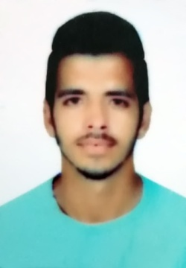
+971506864939 +919056190510
Ganesh Saini
ganeshsaini210@gmail.com

I am Ganesh Saini, I belong to Jalandhar,Punjab. I have done Diploma in mechanical engineering from St. Soldier Groups Of Instituitons with 63%. I want to join the Environment where, I must learn maximum and show my skills to the world with Confidence.

AGE
23
ABOUT ME

Work Experience Highlights

• 5 Years in VMC Operating & Programing.
• 11 Month in Autocad, Solidworks, SolidCam, WorkNC.
- Accurate Edge Precision Equipment L.L.C (United Arab Emirates, Dubai) 24 August 2019 to Present as a CNC Milling Setter cum Programmer
2. Center Instituitions of Hand Tools, (Jalandhar) 1 April 2019 to 15 August As a Programmer & Design
3. Sharp Chucks & Machine Limited, (Jalandhar) 3 January 2018 to November 2018
As a VMC Operator cum Setter.
4.Highway Industries Limited, (Ludhiana, Nichi Mangli) 28 june 2015 to 31 december 2017
As a VMC Operator cum Setter.
Education

CAD/CAM
Master certification in CAD-CAM 6 Months
(NSQF Level-6) at CIHT Jalandhar 1 October 2018 to March 2019

Diploma
St. Soldier Group of Instituitons, Jalandhar Passed, 2015 Punjab Technical University Marks 63 %
Jalandhar, Punjab Division 1

10+2
St. Soldier Divine Public School PSEB Board, 2015
Jalandhar, Punjab Marks 64 % Division 1
10th
N.C Public High School, Jalandhar Passed,2012 PSEB Board Marks 76 %
Jalandhar, Punjab Division 1

• CNC Milling Operating & Programming
- AutoCAD
- Solidworks
- SolidCam
- WorkNC
Training Attend
Technical Skills

• 5S, SPC, Kaizen
Knowledge Of

• Solidworks, SolidCam, AutoCad, WorkNC.
• HAAS control, FANUC, SIEMENS control & Windows based controls.
• Diework,Production, Molds, Core, Cavity, Assemblies & Production process in Industries.
• Knowledge of quality instruments & components drawings.
Computer Proficiency

• MS Word, MS PowerPoint, MS Excel
Languages

- English, Hindi, Punjabi.
Personal Interests

- Travelling
- Learn about new technology
Personal Details

Father’s Name: Mr. Vijay Kumar Marital Status: Single
Birthday: May 10, 1996 Nationality: Indian
Gender: Male
Declaration
I do hereby declare that the information given in these vitae is true and correct to the best of my knowledge & belief.

Ganesh Saini Signature_____________

