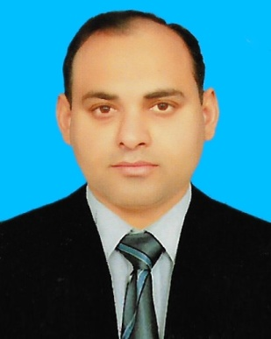
RIZWAN

QUALIFICATION
B.Sc ( Bachelor of Science with Double Mathematics and Physics)
F.Sc ( Mathematics,Physics,Chemistry)
MATRICULATION (Science Group)
Telecommunication course “Line & Mobile” technology.
I.T course (Ms.office & Internet Explorer).
SKILLS
Electric and Electronics Tools, Mechanical field,Inventory,Supervision,Customer dealing,
Administration,Business Account, Marketing.
Professional Experience
(1)Business Experience:
I am working as an Electronics manufacturing engineer almost from 12 years in my own business.I am manufacturing and selling Electronics items.I am manufacturing U.P.S(Uninterrupted Power Supply),All kinds of Transformers,Stabilizers and Battery Chargers.I can use many kinds of Electric and Electronics very good.I also deal with the customers myself.I have also given this technical education to many boys.I started my small business in October 2007 and still i am working in this business.
(2)Inventory Coordinator:
I have worked in Holiday Inn hotel of Islamabad as an Inventory Coordinator,in main store section,in Accounts department.I used to receive fresh Chicken,fresh Fruits,fresh Vegetables,Mutton,Beef,Grocery items,General store items and Ice cream.I also used to make all the items bills.I also issue all these items to the Hotel staff.I worked from 25-11-2005 to 01-06-2006.
(3)Teaching Experience:
I have very small teaching experience.I taught in different small public
schools of my city.I taught from 2004 to October 2005.

PERSONAL INFORMATION

Mobile Numbers: +923345089805 & +923166837202

WhatsApp number: +923345089805

PERMANENT ADDRESS: House # 514 Ward # 1 , Street Jahan Shah District Layyah.
Layyah. Pakistan.
E-MAIL ADDRESSES: rizwanalizaidi1983@gmail.com & rizwanalizaidi@yahoo.com

Passport Number: DM5972042

DATE OF BIRTH: 03-04-1983

Languages
English and Urdu (Read , Write , Speak).

