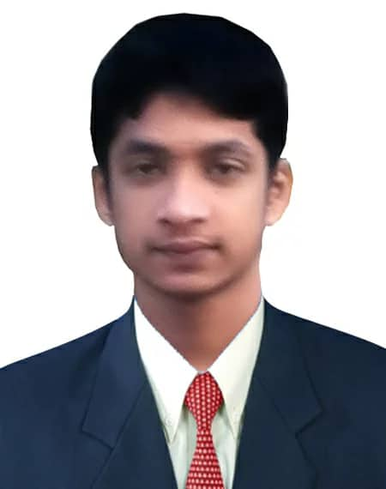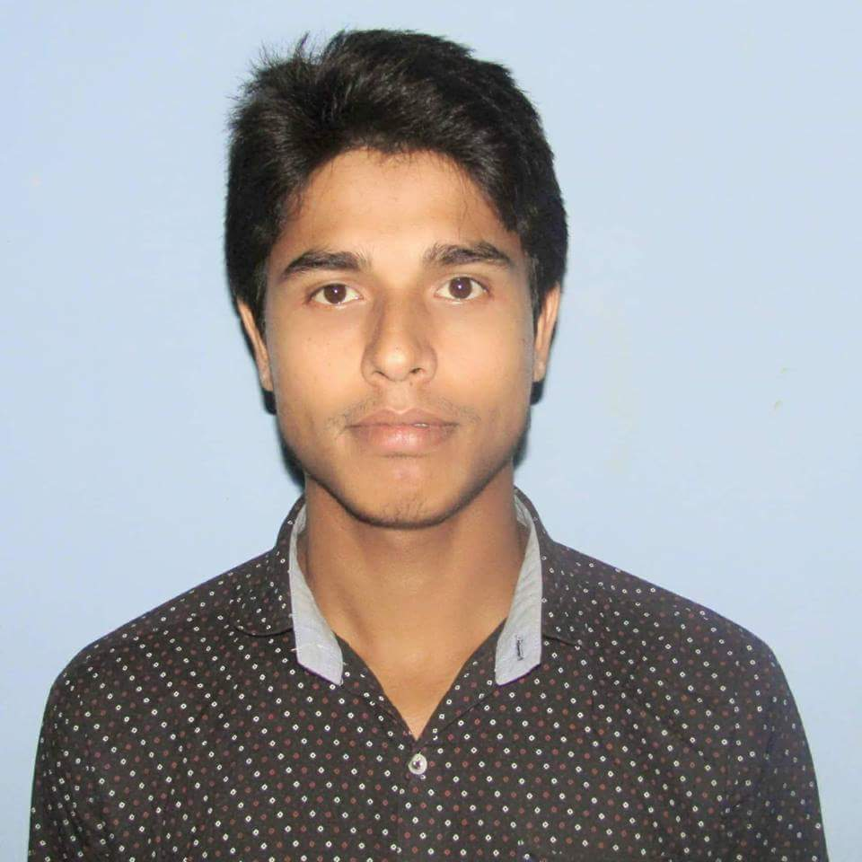
CURRICULUM-VITAE
OF
Mahedi Hasan
Diploma in Electrical Engineering
Email: Mahadihasan808@gmail.com
Cell: +8801640836383

OBJECTIVES | To become a dynamic and versatile person who is capable of merging innovative ideas, technology, knowledge and experience for positive contribution and communication Technology.

PROFESSION | ELECTRONICS ENGINEERING

EDUCATIONAL QUALIFICATION | Degree  Institute Name  Department  Duration  Board  Year of passing  Result | : Diploma in Engineering.  : Ccn polytechnic institute.  :Electrical Technology.  : Four Years.  : Bangladesh Technical Education Board (BTEB).  : 2017  : CGPA- 3.51(Out of 4)
EDUCATIONAL QUALIFICATION | Degree  Institute Name  Board  Group  Year of passing  Result | : Secondary School Certificate.  :bangla bazar High School.  : Dhaka  : general  : 2011  : CGPA- 4.81(Out of 5)

SELF ANALYSIS | - Strong motivation and commitment for work.  - Endurance to work for long hours and under pressure.  - Ability to work independently as well as a team member.  - Sound ethical background and integrity.  - Commendable communication and presentation skills.
INDUSTRIAL TRAINING | - Three moth Industrial training on “Ibrahim composite textile mills Ltd.” Narayanganj dhaka

COMPUTER SKILL | - MS Office (MS- Word, MS- Excel, MS-Power Point,).  - Internet Browsing.  - English Typing Speed 35 WPM  - Bangla Typing Speed 15 WPM

LANGUAGE  PROFICIENCY | Language Writing Reading Speaking  Bengali Excellent Excellent Excellent  English Good Good good

PERSONAL INFORMATION | Name:  Father’s Name:  Mother’s Name:  Permanent Address:  Present Address:  Date of Birth:  Sex:  Religion:  Marital Status:  Nationality: | Mahedi hasan  Md. Abul kasem  Rabya bagum  Vill: Holudia, P.O: Chikan Chhara  P.S: vhujpur, Dist: Chittagong  Vill: comilla P.O:Durgapur 2no  P.S: kotwalil, Dist:Chittagong  27th March 1994  Male  Islam  married  Bangladeshi by Birth

I am Mahedi Hasan here by certify that all the above-mentioned factors are true of my complete knowledge only.
Mahedi Hasan
Date: | ………………….......................

