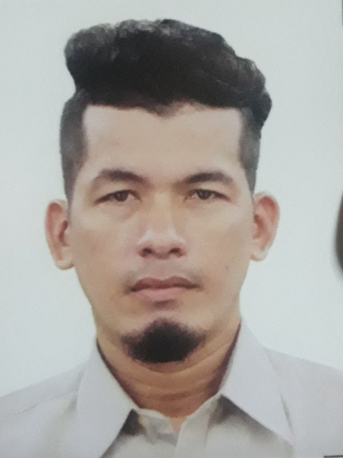

ELECTRICIAN FOREMAN

CLAVER YTAK ENAD
CAN-ASUJAN, CARCAR CITY, CEBU
Contact #: 09430551438
Email Address: claverenad2019@gmail.com

Objectives:

To be a part of your prestigious company and obtain a position and work with my fullest potential.

Personal Data:

Birth Date: September 9, 1980
Religion: Roman Catholic
Age: 39 years old
Civil Status: Single
Nationality: Filipino

Mother: Vevencia Ytak Enad
Father: Benedicto Tangaro Enad

Skills and Capabilities:

- Knows how to multi-task
- Has good communication skills
- Can work under pressure
- Flexible
- Fast learner
- Able to work even with less supervision
- Honest
- Hardworking
- Keen on work details
- Can read and identify Electrical Plans and Layouts

Educational Attainment:

Primary Education: Can-asujan Elementary School (1992)
Secondary Education: Carcar Academy (1996)
Vocational: Technical Education and Skills Development Authority (TESDA) (2018-2019)
Course: Electrical Installation Maintenance 1 & 2

Certificates:

- National Certificate I (NC I )
- National Certificate II (NC II)

Work Experience:

- Alen Air Cebu Inc., (Aircon Installer, 2000-2005)
- George Ong Construction (Electrician/Welder/Painter, 2005-2011)
- JB Rock Builders (Plumber/Electrician 2011-2012)
- Maney Builders General Construction (Electrician Leadman, 2012 up to present)

Character References:

Name: Engr. Ronald Villanueva
Work/Position: Maney Builders/Project Manager
Contact #: 09325892774
E-mail Address: barns_1119@yahoo.com

Name: Antoniette Gonzaga
Work/Position: Maney Builders/Office Staff
Contact #: 09238475046
E-mail Address: antoniettegonzaga@gmail.com

Name: Engr. Lito Diaz
Work/Position: Maney Builders/Project Manager
Contact #: 09234333805
E-mail Address: litodiaz15@gmail.com

