CURRICULUM VITAE
WISDOM IBRAHIM

Address: P. O Box 246, Tarkwa. Cell: +233 244 487689 /0277513575. Email: wisdomib.abbey@gmail.com Skype: wisdomibrahim

PERSONAL PROFILE
I am an enthusiastic, well organized and self-motivated person with a wide mechanical exposure. I possess good communication skills and have over the years developed my leadership skills. I have proven to be a team player who is focused on meeting targets and can working under pressure with or without.

CARRIER OBJECTIVE
My main objective is to become a very experience mechanical superintendent who knows the pros and cons of all heavy mining fleet and to be updated with the latest technology being applied in my field of expertise the world over.

PERSONAL DETAILS
Date of Birth : 29th July, 1981
Sex : Male
Nationality : Ghanaian
Marital Status : Married
SKILLS & EXPERIENCE
Over the past 10 years of working with heavy mining fleet, I have worked on the following equipments CAT Equipments (777, 785C, 793D, DER - D10T, 14H - 16M) and Komatsu Equipments. I have also had the opportunity to study the mechanical framework of Exploration Rigs.
EDUCATIONAL HISTORY
Institution : Takoradi Polytechnic, Takoradi
Certificate Received : Technician 3
Course Duration : 2002-2005

Institution : Kikam Training Institute, Kikami
Certificate Received : Motor Vehicle Intermediate :
Course Duration : 1999-2001

Institution : Roman Catholic JSS
Certification Received : Basic Education Certificate Examination (BECE)
Course Duration : 1994-1997

CERTIFICATES
- Maintaince Training Course by Koatsu - 2013
- Training of HME Team working 365 days with Zero Harm - Dec 2015
- Training course in Troubleshooting Techniques - 2016
- Certificate in Recognition and Appreciation of Royalty and Dedication at Tarkwa Gold Fields - 2018
- Royalty and dedication Award at Tarkwa Goldfields Mine - 2018

OTHER COURSES
- Cat Electronic Engineering (CAT ET)
- Service Information System on CAT Products (SIS)
- New Products Introduction (NPI) by Caterpillar DTTT Truck type tractors, D10T, DIT, D8T)
- Trouble Shooting Training On 785c Haul Trucks
- Basic Engines On 3512 Course
- Fire Fighting Training Course
- Health And Safety Policy
- Environmental Competency Training
- Defensive Driving

WORKING EXPERIENCE
Company : Engineers & Planners
Position : Leading Hand (Mechanic workshop)
Date : 15th March 2018 - 2019
Responsibilities:
- To troubleshoot and repair breakdown equipments that report faults at the workshop.
- To change out major component such as Torque Convertor, Hydraulic Pump, Final Drives, Front hub, Hoist Cylinders, Differentials, Engines and Transmission during Equipment Rebuild.
- To inspect equipment for backlogs and order parts for replacement from workshop stores.
- Using SIS to gather equipment part information and schematics.
- To ensure that other colleagues are working effectively on their assigned jobs.
- Other assignment as assigned by Supervisor.

Company : Goldfields Ghana Limited, Tarkwa Mine
Position : Leading Hand (Mechanics - Workshop)
Date : 2010 to Date 2018
Responsibilities:
- To troubleshoot and repair breakdown equipments that report faults at the workshop.
- To change out major component such as Torque Convertor, Hydraulic Pump, Final Drives, Front hub, Hoist Cylinders, Differentials, Engines and Transmission during Equipment Rebuild.
- To inspect equipment for backlogs and order parts for replacement from workshop stores.
- Using SIS to gather equipment part information and schematics.
- To ensure that other colleagues are working effectively on their assigned jobs.
- Other assignment as assigned by Supervisor.
Company : Mantrac Ghana Limited - Goldfields Ghana Ltd, Tarkwa Mine Position : Technician 3 Mechanic (workshop)
Date : 2009-2010
Responsibilities:
- To troubleshoot and repair breakdown equipments that report faults at the workshop.
- To change out major component such as Torque Convertor, Hydraulic Pump, Final Drives, Front hub, Hoist Cylinders, Differentials, Engines and Transmission during Equipment Rebuild.
- To inspect equipment for backlogs and order parts for replacement from workshop stores.
- Using SIS to gather equipment part information and schematics.
- To ensure that other colleagues are working effectively on their assigned jobs.
- Other assignment as assigned by Supervisor.
Company : Pierro Engineering Services – Damang Mine
Position : Fields Service Technician
Date : 2007-2008

Responsibilities:
- To troubleshoot and repair Pantera machines, Drill Rigs UDR as well as Schramm,
- Servicing Heavy Duty Equipment such as Dump Truck (773,777F, 785C) Grader, Excavator Scraper, Loader, Dozer, Mobile Crane and Forklift and to be able to operate Forklift, Crane and Dump Truck UDR Machines, Tamrock Drilltech 245K.
- To change out major component such as Engine, Hydraulic Pump, Front Hip, Cylinders, Transmission, Pantera HL 1100, Pantera 1500 during Equipment Rebuild.
- To troubleshoot and repair breakdown equipments on Heavy Duty Equipments and Rigs Machines, Damang AMS Drill Rigs Machines, Light Duty such as Land Cruisers, Isuzu, Land Rover and Mercedes Benz Truck
- Other assignment as assigned by Supervisor.
PERSONAL ATTRIBUTE & SKILLS
- Adopt to New Working Condition
- Analytical & Problem Solving Ability
- Interpersonal Skills
- Good Communication Skills

REFEREES
Mr. Kofi Boafo Mr. Isaac Obeng
Supervisor – Mechanical Supervisor - Mechanical
Goldfields Ghana Ltd Tarkwa Mine Goldfields Ghana Ltd Tarkwa
TEL: 024-4485850 TEL: 0249 176409

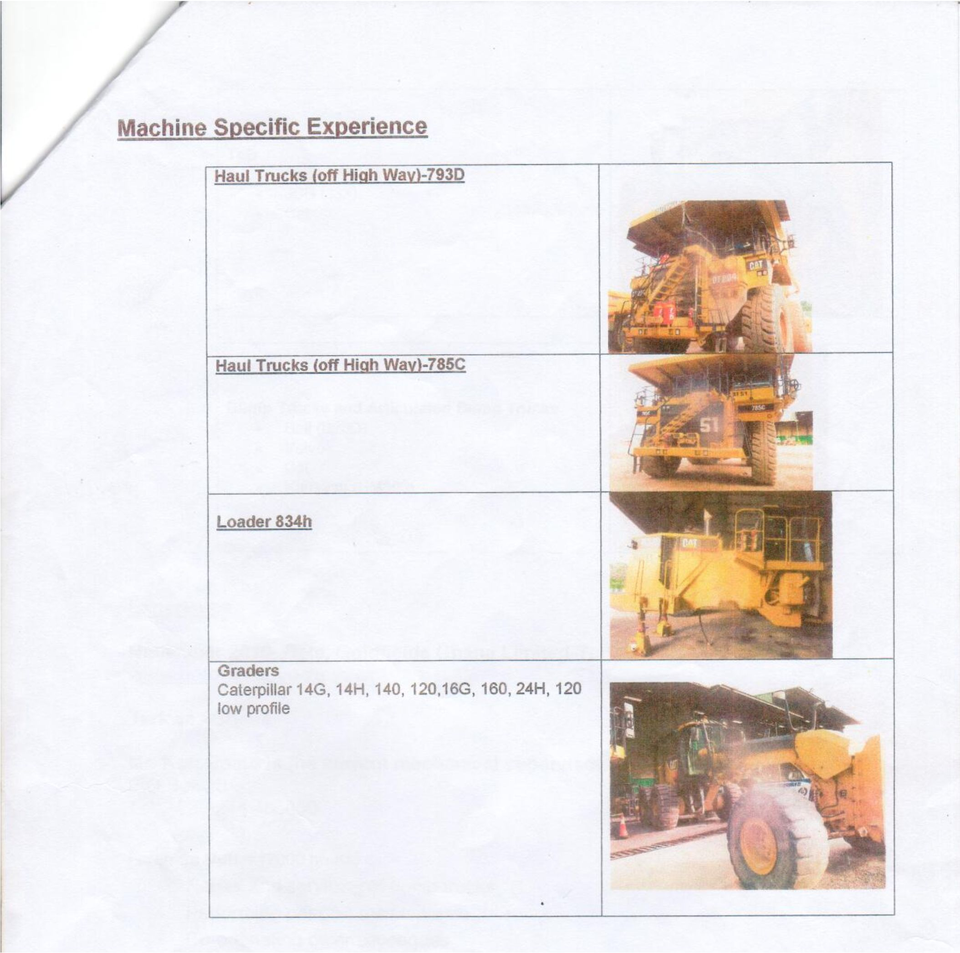

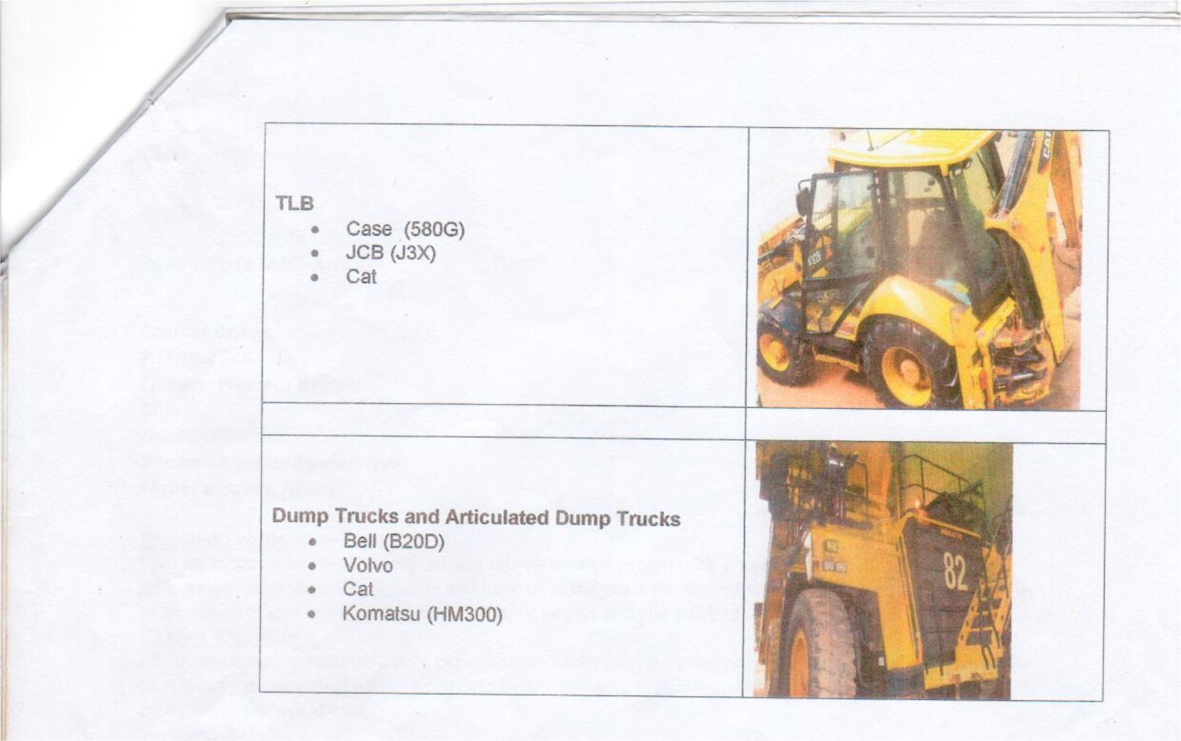

Abraham Erzuah Supe

nb

