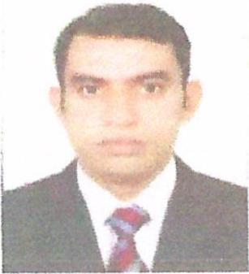
CURRICULUM VITAE

Name: Muhammad Intisar Ahmed
Address: Dubai, United Arab Emirates
Email: intisar@careerjobsuae.com

Desired Position: Electrician

To manage, oversee and ensure the safety, efficiency and integrity of the electrical systems on all projects undertaken by the Company.

Career Objective

To apply professional and academic knowledge to challenging problems leading to growth development of the organization and career advancement.

KEY COMPETENCIES

- Reading of all types of logical drawings.
- Trouble shooting of all electrical circuits,
- Installation and termination of cables underground,
- Installation of LT Panel's and motor control panels.
- Installation CCTV camera systems.
- Tasting of Wiring Circuits by Megger
- Installation of battery backup system.
- Installation fire fitting and fire alarm system.
- Single phase OR three phase wiring, open & underground, by G.I pipe, G.I cable tray type wiring for industries, residence and multi-story buildings

Educational Qualification
Govt Jamia Millia Polytechnic Institute, Diploma in IPC Pakistan
Associates Engineering with First Division
2004-2007
Pakistan

New Montina English School, Matric (Science)
Passing with a 60%
2003 – 2004
Pakistan

Job Experience
Alex and Cold Well L.L.C, Dubai UAE
Electrical Foreman
2013 to till date

- Supervising all electrical installation, Index tower Next care and boulevard plaza, Mursa Dubai Millennium Palace Hotel, Orchid Residency Tower, and Orient Gate Residential Building.
- Fit Out Projects: Index Tower Residential & Commercial Building, Boulevard Tower 1 and Tower 2 Commercial Building, Burj Alsalam Tower Commercial Building, Mazaya Tower Jumera Commercial Building.

PAL Technology L.L.C. Abu Dhabi
Electrical Foreman
2009 - 2012

- Supervising all Electrical installation, Final Inspections of all electrical Installation in Hydra Village (2500 villas) project at Shahama, Abu Dhabi, and Hydra Avenue, Reem Island high rise building project, Abu Dhabi.

Green Star, Pvt. Limited, Karachi, Pakistan
General Maintenance Foreman
2007 to 2009

- Supervised repairing of electrical equipment’s in work shop installation and repair of UPS, installation of all electrical work in Housing Society.

Field Training Course
- Course of theoretical and practical training on structured and fiber optical cable installation, testing commissioning from Legrand Structured Cabling Systems & Solution Certification Course Dubai, UAE for 3 days.

Personal Profile
Name : Muhammad Intisar Ahmed
Name of Father : Muhammad Azam
Date of Birth : 2nd Sept. 1986
Place of Birth : Karachi, Pakistan
Nationality : Pakistan
Gender : Male
Marital Status : Married
Languages Known : English
Religion : Islam
Passport Details
Passport No : HV1152673
Date of Issue : 15-03-2017
Date of Expiry : 14-03-2022
Place of Issue : Pakistan
Status of Visa : Employment Visa
Emirate ID No : 784-1986-3513713-0
Date of Expiry : 11-07-2021

I hereby certify that the above mentioned statement is correct and true to the best of my knowledge and belief.

Muhammad Intisar Ahmed

