CURRICULUM VITAE

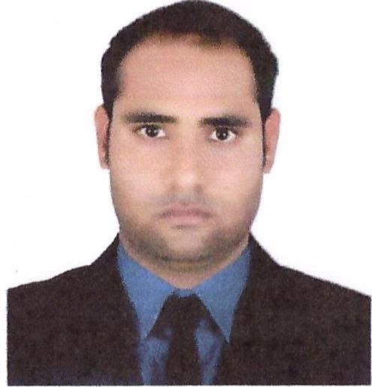
Name: Kaunain Mohammad
Address: Dubai, United Arab Emirates
Email: kaunain@careerjobsuae.com

Desired Position: Electrician

To manage, oversee and ensure the safety, efficiency and integrity of the electrical systems on all projects undertaken by the Company.

Career Objective

To work in progressive and challenging environment where I can fully utilize the best of my skills, experience and hard work for the development of the company as well as the achieve growth in my career which have always been my forts in all the endeavors for the development of the organization and oneself.A position as an industrial electrician which allowing me to use my skill and strong experience to develop organization and will help me in improving my skills further.

PERSONAL SKILLS

- Installation and Connectivity
- Maintenance ,Troubleshooting And Analytical Thinking Testing and Optimization
- Strong knowledge in Coding

Educational Qualification
- D- Metric
Professional Qualification
- Having Electrician certificate from AAISHA SITE CENTRE in Mumbai India.
- Certificate of Recognition from Le Meridian Dubai UAE.
- Employee of the month certificate from GECO MEP

Indian Working Experience:
- Worked as an electrician in Gautam Trading Co. for 7 years at Mumbai India.

Gulf Experience:
- Worked as an electrician in GECO MEP from 18/03/2012 to 15/06/2018 at Sharjah UAE.
- Presently working as an electrician in Fujairah National Properties from 02/07/2018 at Fujairah.
Job Responsibilities: As an Industrial Electrician
Job responsibilities includes complete Installation, Testing and Commissioning of Electrical Panel Boards for Residential and Commercial Building including Installation of Pumps, Motors, Blowers Including requires single phase /3 Phase cabling, Earthing etc. also H.T. and L.T. cable works Electrical Maintenance.
Personal Profile
Name : Kaunain Mohammad
Name of farther : Mohammad Shameem
Name of Mother : Surkhab Bano
Date of Birth : 23-09-1985
Place of Birth : Pratapgarh
Nationality : Indian
Gender : Male
Marital Status : Single
Religion : Islam
Languages Known : English , Hindi,Urdu
Passport Details
Passport No : J6906374
Date of Issue : 07-04-2011
Date of Expiry : 06-04-2021
Place of Issue : Lucknow/India
Status of Visa : Employment Visa (Transferable)
Emirate ID No : 784-1985-9804614-6
Date of Expiry : 01-08-2021

I hereby certify that the above mentioned statement is correct and true to the best of my knowledge and belief.

Kaunain Mohammad

