CURRICULUM VITAE

Name: Ali Haider
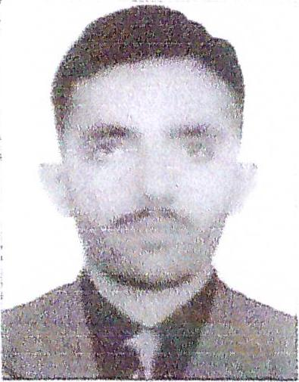
Address: Abu Dhabi, United Arab Emirates
Email: alihaider@careerjobsuae.com

Desired Position: A/C Technician

Looking for the challenging job position of AC technician in a satisfying working environment that helps me to make use of my technical skills and experience to contribute in organizational development

Career Objective & skills

Experienced Refrigeration Technician skilled at maintaining and repairing climate control systems in buildings and other structures. Familiar with electronics, mechanics and electrical components required to manage and diagnose refrigeration materials.
• Excellent practical knowledge of the trade and standard procedures
• Ability to operate and use tools, equipment, and materials used in refrigeration system
• Familiarity with the safety and hazards precautions
• Excellent verbal and written communication skills
• Skilled in working with wireless handheld electronic work order tool
• Skilled in reading and interpreting blueprints, drawings, and schematics
• Self-discipline
• The ability to effectively prioritize tasks
• Dedication & Commitment to problem resolution
• The ability & willingness to communicate
• The ability to learn for experience
• Logical & creative

Work Experience

Technician of Air Conditioners (may 2018- still Continue)
Al Saweed Company(United State of Arab Emirates)
- Installed, overhauled and repaired electrical, refrigeration and electrical units off-site for customers under warrant
- Utilized effective strategies for minimizing leakage
- Used temperature control and monitoring to ensure product quality
- Evaluated and generated reports on equipment conditions
- Maintained systems, implementing preventative measures

Technician of Air Conditioners (May 2016-Jan 2018)

Noor Enterprises(United kingdom of Saudi Arabia)

- Installed, overhauled and repaired electrical, refrigeration and electrical units off-site for customers under warrant
- Utilized effective strategies for minimizing leakage
- Used temperature control and monitoring to ensure product quality
- Evaluated and generated reports on equipment conditions
- Maintained systems, implementing preventative measures

A.0 & REFRIGERATION TECHNICIAN 1 (2014 - May 2016)
BHATTI MARRIAGE HALL
- Installed, overhauled and repaired electrical, refrigeration and electrical units off-site for customers
- Utilized effective strategies for minimizing leakage
- Used temperature control and monitoring to ensure product quality
- Evaluated and generated reports on equipment conditions
- Maintained systems, implementing preventative measures

A.0 & REFRIGERATION TECHHNICIAN I (Apr-2014 —May 2016)
NEW PAK COOL
- Install, and repair refrigeration equipment
- Inspect, overhaul, and maintain refrigeration units and systems
- Detect, repair, replace, and adjust broken parts as necessary
- Repair and adjust valves, fittings, couplings, and piping connections
- Diagnose and troubleshoot malfunctioning of refrigeration units and systems
- Install thermostats, humidistat and motors
- Dismantle defective components using right equipment as required
- Respond to emergency calls from customers as required

A.0 & REFRIGERATION TECHN ICIAN I (Oct-2013 - Mar-2014)

- Analyzed, repaired, and restored functioning of refrigeration system
- Fabricated and assembled outer and inner components of refrigeration system
- Aligned components into correct position with hoist DAWLANCE
- Installed brackets and hangers on floor and walls by
- Examined and tested system operation with
- drilling holes gauges and instrument
- Insulated shells and cabinets of systems to preven
- Tested connections for leaks and break of
- electricity shock power
- Repaired defective parts by soldering
Educational and Technical Qualifications

- Dae Refrigeration ( 2012-2013)
- EAI ( 2010-2012)
- Matriculation ( Arts ) I ( 2007-2009)

PERSONAL PROFILE

Name : Ali Haider
Name of Father : Muhammad Ishfaq
Date of Birth : 27 Apr 1993
Place of Birth : Gujranwala, Pakistan
Nationality : Pakistani
Gender : Male
Religion : Islam
Languages Known : English , Urdu, Hindi, & Punjabi

Passport Details
Passport No : TF 1802152
Date of Issue : 17-04-2018
Date of Expiry : 17-04-2023
Place of Issue : Pakistan
Status of Visa : Employment Visa
Emirate ID No : 784-1993-1575161-2
Date of Expiry : 19-06-2020

I hereby certify that the above mentioned statement is correct and true to the best of my knowledge and belief.

Ali Haider

