CURRICULUM VITAE

Name: Yasar Hassan
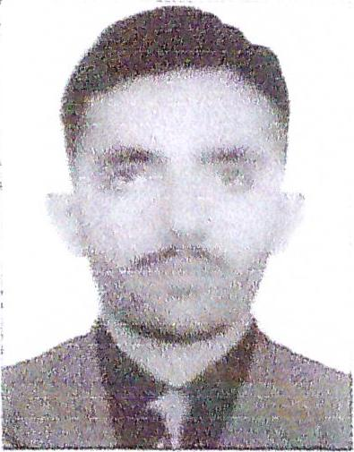
Address: Abu Dhabi, United Arab Emirates
Email: yasarhassan@careerjobsuae.com

Desired Position: A/C Technician

Looking for the challenging job position of AC technician in a satisfying working environment that helps me to make use of my technical skills and experience to contribute in organizational development

Career Objective

A challenging position in HVAC & Chiller Technician, where my skill and knowledge can be successfully utilized to enlarge productivity.

Summary

- In-depth knowledge of the methods and techniques of repairing and maintaining a i r-conditioning systems
- Possess the ability to inspect, diagnose and repair the defects or malfunction in
- machinery
- Profound knowledge of cooling towers and air conditioning systems
- Skilled in operating and maintaining air conditioning equipment in an industrial plant
- Sound knowledge of control drawings, blue prints as well as other related electrical schematics
- Skilled in calibrating, adjusting, and replacing electrical, electronic and pneumatic control systems
- Extensive knowledge of installation or operation of a wide variety of HVAC systems

Work Experience

- Presently working as HVAC TECHNICIAN with SAWAEED EMPLOYMENT L.L.0 in Abu Dhabi, UA E since Or June 2018 to till date.
- Site Under working in Sawaeed
- Abu Dhabi International Airport(TCAJV)-7 Months
- Upper ZAKUM Project EPC2 -750 in Petrofac —DSME Offshore island Facilities Worked 07 Monthes
- EFECO DEPA — DUCTMAN AND STUD WELDER —Project- MTB AIDA Worked 06 Monthes
- Worked as AC TECHNICIAN with MASHA ALLAH AIRCONDITIONING SERVICE in Karachi, Pakistan for 1 year.
- Worked as AC TECHNICIAN with ZAHEER ELECTRONICS in Karachi, Pakistan for 2 years.

Educational and Technical Qualifications

- Intermediate Passed
- Diploma in HVAC Technician for 2 years.

Job Responsibilities:

- Heating ventilation & air conditioning
- A/C types, working
- Split A/C Installation and Repairing
- Chiller Operation & Troubleshooting
- Package unit Repair and Maintenance
- HVAC System Operation & Maintenance
- AHU (Air Handing Unit) Operation & Maintenance CCU Unit Maintenance
- FCU (Fan Coil Unit) Operation & Maintenance Trouble Shooting in HVAC System
- PPM all HVAC system
- Cold Storage Unit Operation
- Maintenance of HVAC open system (Chilled Water System)
Maintenance of HVAC close system (Chilled Water System)
- First Aid Trained
- Fire Extinguishers Trained

PERSONAL PROFILE

Name : Yasar Hassan
Name of Father : Muhammad Walayat
Date of Birth : 13 Dec 1997
Place of Birth : Hafizabad, Pakistan
Nationality : Pakistani
Gender : Male
Marital Status : Single
Religion : Islam
Languages Known : English , Urdu, Hindi, & Punjabi

Passport Details
Passport No : JU 6800371
Date of Issue : 16-10-2017
Date of Expiry : 15-10-2022
Place of Issue : Pakistan
Status of Visa : Employment Visa
Emirate ID No : 784-1997-1736470-9
Date of Expiry : 02-07-2020

I hereby certify that the above mentioned statement is correct and true to the best of my knowledge and belief.

Yasar Hassan

