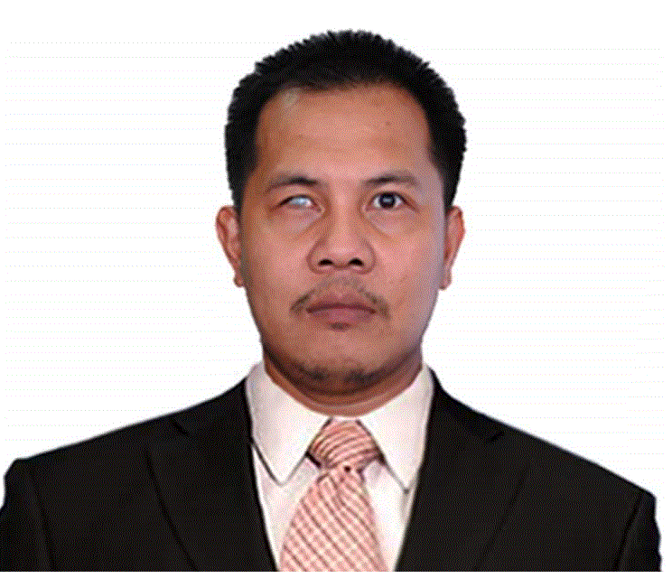
Adrian Z. Catapang
Blk. 1 Lot 78 Green-Mark 2 Malagasang 2-B Imus
Cavite City Philippines
Email: azcatapang@gmail.com
jhanno2003@yahoo.com
Mobile No: +639064579688

Work Experience
Maynilad Water Service Inc. (MWSI) Manila, Philippines
Department:
Central Non-revenue Water-Integrated Meter Management
(CNRW- IMM)

Designation:
Maintenance Foreman
March 1, 2013 - Present
- Provides daily job accomplishment report for replacement and investigation of large meter (Mechanical Meter)
- Maintains detailed records of IMM equipment, maintenance tools and facilities including equipment replacements and electro-mechanical upgrades
- Provides technical services to all offices with regards to the flow and pressure measurements
- Supervises field testing for accuracy and reliability of newly introduced instruments
- Provides daily maintenance schedule of activities and work loads
- Provides weekly & monthly report on accomplishment, work program, work schedule, materials inventory and other IMM requirements
- Preforming outside services such as flow and pressure validation and troubleshooting at local water district like: Iloilo, Nueva Viscaya, Nueva Ecija and Bulacan
- Supervision of preventive maintenance of mechanical meter.
- Lead team in all aspect of work. Technical, customer relation, safety and proper job implementation.
- Coordination with different department regarding mechanical meter, and flow-meter related activity.
- Carry out replacement and installation mechanical water meter and its appurtenances.
- Perform flow verification using clamp-on ultrasonic flow-meter in newly commissioned GP (Gauging Points)
- Preforms other duties as assigned.

Maynilad Water Service Inc. (MWSI) Manila, Philippines
Department:
Telemetry - Technical Services Division (TSD)
Designation:
Maintenance Foreman
September 2007 – February 2013
- Performs troubleshooting, repair & configuration of workstations, base modems, and field equipment such as laptop, instrument, communication cables, and other field devices
- Performs configuration and commissioning of data loggers with SMS capability, electromagnetic insertion-type flowmeters, ultrasonic flowmeters, and full-bore flowmeters
- Supervises and monitors field equipment maintenance and maintain close coordination with the Central Control Monitoring and Analysis and Supply Management and Analysis Head to ensure the measuring points are giving accurate hourly average readings such as flow and pressure.
- Supervises the implementation of preventive/corrective maintenance of all base and field equipment with intermittent/continuous transmission and other related equipment
- Analyses/tracks down undesirable interference that affect the communication network
- Supervises and monitors the communication equipment of all on-line boosters and pumping stations. Ensure that the equipment is sending data regularly to the Central station
AIMSTAFF INCORPORATED
Department:
Telemetry (Maynilad Water Services Inc.)
Designation:
Instrument Technician (Project Employee)
September 2004 – September 2006

- Performing troubleshooting, repair & configuration of workstations, base modems, and field equipment such as laptop, instrument, communication cables, and other field devices
- Preparing inventory and history report for each new and old flow meter
- Preforming installation of portable flowmeter such as insertion and clamp on flowmeter.
- Make history report of each flow meter unit and direct reporting to immediate supervisor
- Review daily maintenance report for preventive maintenance.

Crest Contraction Development. Corporation
Department:
Flowmeter Division
Designation:
Instrument Technician
August 1998 – September 2004
- Performing troubleshooting, repair, Re-configuration, and Recalibrate the flowmeter of Manila water and Maynilad water
- Preparing history report of each Flow Meter units.
- Prepare of Costing of replace part of the flowmeter and submitted to immediate superior

Personal Details

Personal Data:
Age: 38 yrs. old
Date of Birth: September 28, 1977
Nationality: Filipino
Religion: Roman Catholic
Civil Status: Married
Language Spoken: English / Tagalog

Education:
Second Highest Education: Mayuro National High School
Education Level: Vocational Diploma / Short Course Certificate
Course: Electronic Service technician / Electronic Computer Technician
School: Tolentino Technical Inst.
Skills:
Computer Literate: Microsoft Office (Word, Excel, Access
PowerPoint, Outlook and MS Office Tools) Internet Explorer and Hyper
Terminal Knowledge in Repair and troubleshooting any kind of
Flow-meter, Data logger; Data acquisition and Configuration Software:

Kinds of Software:

Radlog for Windows – Radcom Technologies Ltd PMAC Plus PMACLite – Technolog
Primeworks – Primayer Ltd Primeware – Primayer Ltd
Floware Dos Version – Marsh-McBirney Inc. Floware for Windows - Marsh-McBirney Inc.
Flotote Cal - - Marsh-McBirney Inc. ABB Toolkit – ABB Limited
ABB Aqua Master Error Decoder – ABB Limited ABB Screw Driver - ABB Limited
ABB Utilities - ABB Limited Flowmeters MCE Link- Euromag International
Kinds of Flowmetes: Kinds of Data Logger:
Euromag - Euromag International Multi-log Flash GSM/SMS - Radcom Technologies Prime Probe - Primayer Ltd Multilog MX - Radcom Technologies
Hydrins - Hydrika Log-Log Flash - Radcom Technologies
GE panametrec – GE NewLog – Technolog
Ultrasonic Sonoflo – Danfoss Cello – Technolog
Ultrasonic Sitrans FUS 060 – Siemens
Ultrasonic Ultraflux
Fullbore Magmaster – ABB
Fullbore Magflo – Danfoss
Fullbore Explorer – ABB
Electromagnetic Insertion Aquaprobe – ABB
Model 258P (Open and Close Conduit) - Marsh Mc-Birney
Flotote Model 268E Data logger - Marsh Mc-Birney
Model 2000 Flomate - Marsh Mc-Birney
Model 285 MultiMag - Marsh Mc-Birney

Training and Seminar

RIDGID TRAINING CENTER
In Manila Philippines

- 1 Day Product Training
November 25, 2016

PHILIPPINE MECHANICAL ENGINEERING PRACTITIONERS

- National Symposium And Awareness to Philippines Nuclear Power Plant Program
November 10, 2016

Flowtork Technologies Corporation
GE Flowmeter Product Training

- For TransPort PT878 Panametrics Portable Clamp on Ultrasonic for
Water and Waste Water Application
January 12, 2016
July 26, 2016

Indutria Philippines And Global Corporation
v_Base International Conference Seminar

- Technical Lecture on noise and Vibration Troubleshooting
Developed By v_BASE Committee Mechanical, Measurement and control Division of Japan Society of Mechanical Engineer (JSME) organized by Shinkawa Electric Co., Ltd Japan Industria and Global Corp.
June 14, 2016

ICI System Inc. & Endress+Hauser Philippines
Customer Seminar for Water & Wastewater Industry
May 6 & 7, 2015

- Analytical Portfolio How it Can Reduce Capex and Opex in Drinking water and Wastewater
- Memosense & Liquiline Technology for pH, Chlorine, Conductivity, Turbidity, Ammonium and Nitrate.. etc.
- Flow portfolio for the Water and Wastewater Industry
- EMF vs. Ultrasonic technology
- EMF sensor which one is best suited for my application
- Heartbeat technology reliable self-monitoring, compliant testing and condition based

ICI System Inc. & Endress+Hauser Philippines
Customer Seminar for Water & Wastewater Industry
“Cost Savings and process optimization”
March 19, 2014

- Level + Pressure measurement in water & wastewater operation
- Flow portfolio for water & wastewater application including new transmitter with integrated webserver (Promag 400) and new battery operated flow-meter (Promag 800)
- Analytics – complete water & wastewater sensor portfolio, including samplers
- W@M life cycle Measurement

Hydroventure Corporation.
Product / Installation / Servicing of Siemens Sitrans FUS Sonokit Ultrasonic
Jan. 31, 2013

East Asia Solution Technologies Corporation
Installation, Programming and Troubleshooting of ABB Aqua 3 Probe
Insertion Type Electromagnetic Flowmeter.
Jan.14, 2013

Waterkonsult Equipment and Services Inc.
Application, Installation, Operation and Programming of ‘Technolog’
Cello Data Logger And PMAC Software
Oct. 2-3, 2012

MFI Foundation, Inc. (Formerly Meralco Foundation Inc.)
MFI Bldg Ortigas Avenue, Pasig City 1600
www.mfi.org.ph
Gas welding, Cutting And Brazing
May 25-29, 2009

NATIONAL ENGINEERING CENTER
University of the Philippines, Diliman Quezon City
Instrumentation And Control For Industrial Application
Aug 6-8, 2007

Waterkonsult Equipment and Services Inc.
Radcom, Multilog, SMS/GSM Data Logger Training
Nov 21-23, 2005

Waterkonsult Equipment and Services Inc.
ABB Flow meter’s Aqua Probe, Aqua Master And MagMaster Training
Nov 24-25, 2005

Marsh - McBirney, Inc.
4539 Metropolitan Court Frederick, Maryland 4539 Metropolitan Court, Maryland 21701-8364 US
Factory Service Training: Repair and Re-calibrate Flo-tote II / Model 268E/ Model 258P / Closed Conduit Flow Transmitter Model 2000 Flo-Mate
Oct. 21, 1999

