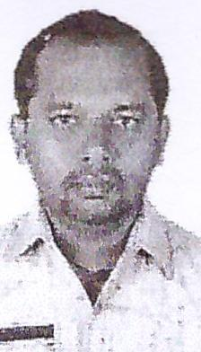
CURRICULUM VITAE
Name: Sumanta Kumar Samal
Address: Abu Dhabi, United Arab Emirates
Email: sumantasamal@careerjobsuae.com

Desired Position: Plumber

To attain the position as a plumber where skills and training in plumbing, installing and fixing sanitary fittings, and repairing water heating systems could be effectively utilized.

CAREER OBJECTIVE
To work and build up successful career with an esteemed organization, fully utilizing my abilities and expertise.

EDUCATIONAL QUALIFICATIONS
- Secondary School
- ITI - Fitter
WORK EXPERIENCES

- Working as a MEP Technician with EIPS in Abu Dhabi, UAE since last Two years.
- Worked as a Plumber in Bangalore, India for Fifteen years.
- Experience with BVG India Ltd, Narayana Integrated facility. Harivayu Maintenance & Services Pvt. Ltd.
- Experience in GI, CI, PVC, PPR, C PVC pipes.
- Currently working as Pipe Installation Worker with Emirates International Property Services in Dubai UAE from 2017 to till date

Additional Qualifications

- Handle the pressure of work
- The Ability to adapt to conditions.
- Enjoy the work and the spirit of cooperation and assistance.
- Desire in the continued development of my skills.

PERSONAL PROFILE
Name : Sumanta Kumar Samal
Date of Birth : 25/02/1981
Place of Birth : Odisha
Nationality : Indian
Gender : Male
Civil Status : Married
Religion : Hindu
Language Known : English, Hindi, Kannada, Bangali, Oria

Passport Details
Passport No : P7839876
Date of Issue : 10-02-2017
Date of Expiry : 09-02-2027
Place of Issue : Bengaluru
Status of Visa : Employment Visa
Emirates ID No : 784-1981-6468515-2
Date of Expiry : 30-10-20219

I hereby certify that the above mentioned statement is correct and true to the best of my knowledge and belief.

Sumanta Kumar Samal

