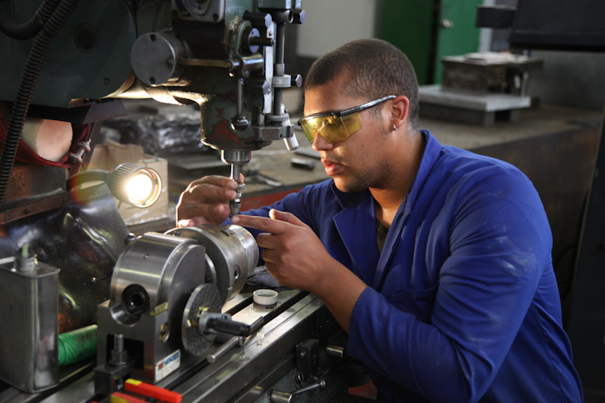

Peter Fisher (861016 5107 085)
40 Matterhorn Crescent
Tafelsig
Mitchell’s Plain
7785
Cape Town
South Africa
Cell: +27 76 687 0607
Email: pfkaydee@gmail.com
Marital Status: Married
Dependants: Two
Health Status: Excellent
Driving License: Yes

EDUCATION:
SECONDARY EDUCATION: Spes Bona Secondary School
HIGHEST GRADE PASSED: Grade 12 (2004)
SUBJECTS PASSED: English HG
Afrikaans HG
Mathematics SG
Technical Drawings SG
Electronics SG
HIGHER TERTIARY EDUCATION:
INSTITUTION: False Bay – Westlake College
YEAR: 2005
CERTIFICATE: Fitting & Machining

INSTITUTION: Northlink – Wingfield College
YEAR: 2007
CERTIFICATE: Tool,Jig & Die Maker

EMPLOYMENT :
NAME OF COMPANY: Pin Clip Industries
POSITION: Toolmaker
DURATION: 2015 - Current
DUTIES: Milling
Turning
Surface Grinding
Hardening & Tempering of materials
(Tool steels & Gage plate)
Maintenance: Press Tools
Multi Slides: Bilher
Neilson
Latour
MRP

NAME OF COMPANY: Dramco Tooling cc
POSITION: Toolmaker
DURATION: 2007 - 2015
DUTIES: CNC Milling
CNC Turning
EDGE Cam drawing / Programming
Sparking
C-Tech/Milling Machine
Surface Grinding
MANUFACTURE: Machine Components
Press Tools
Injection Moulds / Thermo Moulds
Jigs
Hydraulic & Pneumatic Punching Units

REFERENCE:
Dramco Tooling: Kevin Dramat
Contact: +27 82 823 6940
+27 21 905 4754

Pin Clip: Johan Welgemoed
Contact: +27 83 235 4481
+27 21 951 2248

