carriculum vite
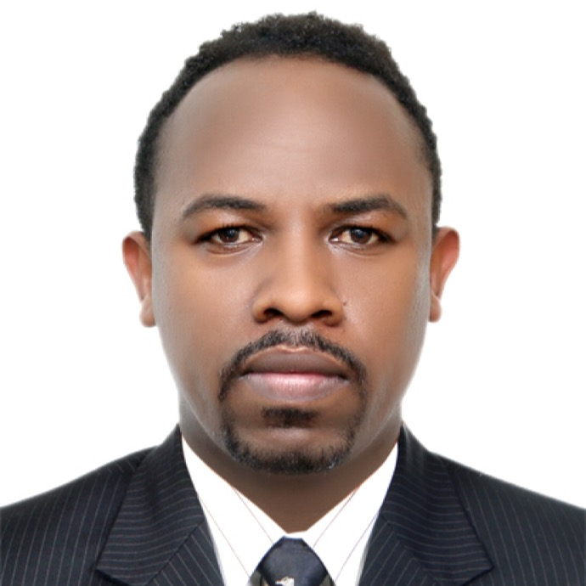
WONDEMAGEGN METEKU JIMMA
Sex Male
Date of Birth Dec.1.1981
Nationality ETHIOPIAN
E-mail ID wondeee@gmail.com
Mobile +971 56 669 5268
Dubai UAE

Career goal
To work in an organization where I can use my skills to achieve the organization objective and get conductive environment to Learn and grow a position in Electro mechanical Engineering which will utilize my extensive experience and training.

Summary
- I have more than (18) eighteen years’ experience in position requiring electrical and electro mechanical activities.
- Skilled in installation, service and repair of electrical and mechanical plants with a good knowledge of the basics three types’ maintenance.
- Self-motivated; know what it takes to get the job done.
- Resourceful in solving problems and maximizing resources.
- Inspire and support others to work at their highest level.
- Competent and reliable professional, committed to top quality work.
- Have wonderful communication skills in both verbal and written.

Academic Background

- Graduate10+3 advanced Diploma Electricity technician in Addis Ababa
Tegbareid Technical and Vocational education and training college
From September 2008 – February 2010
- Certified 10+2 Electric Technician in Tefrimekonen Technical school From September, 2002 – 2004
- Certified UNDERSTANDING THE ISO 9001:2000 QUALITY MANAGEMENT SYSTEM 29 -30 September 2007 by AJB INSTITUTION OF QUALITY MANAGEMENT
- Driving licence.
- IPAF PAL licence.
- PASMA licence.
- Man lift operating licence.(JCB operating)
- Working at height training certified.
- A good skills in electronics maintenance
- Fire and safety training
- Practiced Computer Programming Skills
- Proficient with a use of Microsoft Word, Microsoft Excel, and Microsoft Access.
- Using MAXIMO , ENFOR EAM softwares.

Work Experiences

1. LEGOLAND DUBAI THEME PARK
SEPTEMBER 2016-DATE
Rides maintenance supervisor

2. FERRARI World Abu Dhabi THEME PARK
NOVEMBER 2015-AUGEST 2016

Rides maintenance team leader
- Assigning the technicians’ rids PM allocation.
- Creating work orders.
- Monitoring all PM checks completion on time.
- Checking & signing the check lists after complete.
- Preparing tools and consumables for rides workshop.
- Receiving downtimes and assigning the technicians.

July 2013-To NOVEMBER 2015
Senior Ride Technician (Electrical)
- All rides electro mechanical maintenance works.
- Hydraulics system maintenance.
- Pneumatic system maintenance.
- Cars maintenance.
- Simulators maintenance.
- Plc. System maintenance.
- Different types of sensors for rides maintenance.
- Electronics maintenance.

3. BANYAN tree Al Wadi 5* hotel and resort UAE ( Ras Al kahimah)

May, 2011- June, 2013
Senior Technician (Electrical)
- Generator and kitchen equipment technician.
- Club car preventive maintenance and repairing.
- Audio video setup technician for meeting hall.
- Villa electro mechanical maintenance work.
- Data and telephone

4. UNECA (United Nations Economic commission for Africa) under Midroc energy house PLC (ethiopia)

November, 2010 – April, 2011
Electrician
- Building Electrical preventive maintenance work.
- Refrigerator, Air Conditioner, Cold room installation & repair.
- Repairing of generator, Welding machine & battery Charger.
- Building Industrial electrical installation.
- 20-30KVA UPS maintenance and installation work.
- Kitchen appliances maintenance work.

5. UNECA (United Nations Economic commission for Africa)

under Sigma Electric PLC (ethiopia)

June, 2007 – November, 2010
Electrician
- Building Electrical preventive maintenance work.
- Refrigerator, Air Conditioner, Cold room installation & repair.
- Repairing of generator, Welding machine & battery Charger.
- Building Industrial electrical installation.
- 20-30KVA UPS maintenance and installation work.
- Kitchen appliances maintenance work.

6. NU trading private Limited Company (ethiopia)

March, 2006 – May 30, 2007
Senior Technician
  - Assembling of new imported cleaning machines.
  - Maintenance work for cleaning machines.
  - Give training for new costumer how to use the machines.

7. GCS (Global Computing Solutions Plc) Royal Netherlands Embassy (RNE Project) MINISTRY of Capacity Building (MOCB Project)

December 16, 2004 – June 30, 2005
Senior Technician
- Data and Telephone Networking Installation.
- CCTV Systems Installation.
- Access control System Installation.
- Intrusion detection system Installation.
- Fire Alarm Systems Installation.
- Data and power cabling installation.

8. MOHAMMED Abdulmohsin AL-Kaharafi &Sons on Bole International Airport Terminal Building Installation Project (ethiopia)

December 6, 2000 – June 12, 2004
Electrician
- Power System installation.
- Lighting System installation.
- Fire Alarm System installation.
- Security System installation.
- CCTV System installation.
- Flight Information Display System installation.
- Public Address System installation.
- Lighting Control System installation.
- Signage System installation.
- Commissioning Work.
- Labeling for Power and Light System.
- As-Built Drawing for Light and Power
- Panel Board Installation

Other interest
- Collecting music, watching movies, reading,, traveling and biking.

Language
Amharic, English
I do hereby declare that all the above information furnished by me are true and correct to the best of my knowledge.

