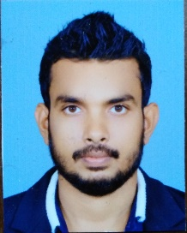
8/23/2019
Gayan Wimalasiri
+94712276537
gweezyfrat@gmail.com
1/180, Bopitiya, Ku/Bopitiya, Sri Lanka

Personal Details

Name : Rathnaweerage Gayan Wimalasiri

Date of Birth : 18th October 1991

NIC No : 199129204513

School Attended : Joseph Vas College

Marital Status : Married

Nationality : Sri Lankan
Education

Successfully completed Ordinary Level (2007) and completed Advanced Level (2010) in Joseph Vas College Wennappuwa Sri Lanka

Successfully completed Marine Engineering Diploma in Naval Institute of Technology in Srilankan Navy (2012 - 2015)
Experience

I am still working as a Marine Technician in Srilankan Navy since 2012. I have worked in three naval ships Engine- MTU 20v 8000 series, pielstick 16v 280, Deuts 12v.
Top overhaul experience in Cummins 12v.
Auxiliary experience in chill water ac plant, STP, RO Plant, Purifier and OWS.
Have experience in Hamilton propulsion system, yammer and Cummins engine.

Skills

Huge experience in designing and maintaining array of marine aquaria

Familiarity outboard, inboard and diesel marine power systems

Working knowledge of hulls,propellers,masts,sails and navigational equipment

Ability to install and test sanitation and refrigeration systems

Strong and logical diagnostic and team orentation

I herebyby declare that the above furnished by me are true and correct to the best of my knowledge.

Sincerely
Gayan Wimalasiri

