ΒΙΟΓΡΑΦΙΚΟ ΣΗΜΕΙΩΜA
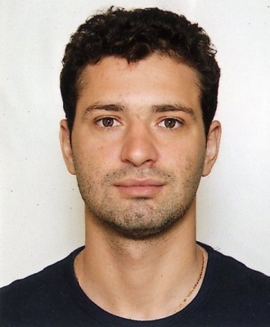

Προσωπικά Στοιχεία
Name | : | Taulant
Surname | : | Mengjezi
Address | : | Vrachoriou 38 street  Athens, 10444  cel 1. : 6971989761  cel 2. :6957396207  email : lani_peshkaqeni26@hotmail.com
Date of Birth | : | 24-01-1986
Status | : | Single
Profession | : | Registered Electrician

Education Background
Sept 2010- Present | : | Polytechnic High Schooll of Illion,  Andromaches and Chasias, Ilion,13122, Greece  mail@2epal-iliou.att.sch.gr  Secondary education, instruction of technical arts and applied sciences.
Working Experience:  May 2013-Sep2019 |  | Dionysos Zonar's, Restaurants  43, Roverrtou Galli, Str.  11742, Athens, Greece  info@dionysoszonars.gr  Waiter  My duties as waiting staff include preparing tables for a meal, taking customers' orders, serving drinks and food, and cleaning up before, after and during servings in a restaurant  Pyramis technical & commercial Company
Sep. 2007-May 2013 |  | http://www.pyramisatee.gr/images/contact.JPG  115 26 Athens, Greece  Industrial Electrician.  My job as an industrial electrician involved installing, testing, repairing, and maintaining electrical equipments and devices in companies as  - Phillip Morris  - Athens International Airport  - Jean-Herni Dunant Hospital of Athens  - Bio-iatriki Group of Companies
Jun. 2000 – Aug. 2004 |  | Emm. Ioannis Mamantakis Construction company
15, Polytechneiou, str. Hierapetra,
72200, Crete, Greece
Helper Electrician
Special knowledge / skills |  | Responsible for assisting electricians with installing and maintaining electrical and power systems. Worked at construction sites, factories, businesses, and residences.  Understanding blueprints and visualizing spaces  Automatic control  Programmable Logic Controller (P LC)
Languages |  | Albanian and Greek (Mother tongues, Bilingual),  Italian  English
Computer skills |  | Competent with most Microsoft Office programmes - experience with HTML
Driving licence |  | B, Motorbike

