Zeus HV Services Competency Record
COMPETENCY RECORD FOR:  Name: Gary Conway  Address: 576 Beach Road Qualicum B.C. V9K1K7  Email : conwaygd@gmail.com  Mobile: 1(250) 739-0552 |  |  |  |  | 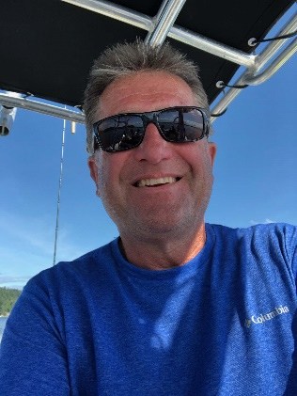
Proposed Position: | Power Line Technician
Name of Present Employer: | Zeus HV Services
Name of Person: | Gary Conway
Profession: | Power Line Technician/ Energized Work Methods Specialist
Date of Birth: | 12th JAN 1957 |  | Nationality: |  |  | Canadian
Years associated with Firm/entity: |  | 2.5 years
Years of Experience in Power Line Technician field |  |  |  | 25 years

Membership/ Affiliation in Professional Societies
- Member of IBEW Local 258

Key Achievements - Career
- Journeyman Electrician/Foreman BC Building Trades IBEW local 344 Industrial projects
- Apprentice private contractor Twin river electric residential commercial industrial, mining, projects
- Work Safe Advance Trades Education Provider #200017152BC
- Live Line/Barehand international training – Turkish Foreign Nationals
- Work Methods Specialist in Standards and Work Procedures: Barehand work methods, Live Line work methods, Equipotential Bonding and Grounding Specialist
- Played a key role in the development and implementation of Ascent Helicopter Hoist program; development of methodology and training /mentorship.
- Development of Power Line Technician standard and special operating work methods standards and procedures.
- Coordinates with the client, project management and project services in preparing required reporting procedures and formats for both the client and Rokstad Power’s management needs.
- Reviews costs, estimates, budgets, forecasts and schedules.
- Participates in conflict resolutions such as labor disputes, workforce staffing, material delivery and contract/subcontract administration.
- Coordinates with the project managers, design engineers, procurement, planning and scheduling and other personnel in setting and maintaining priorities to ensure projects remain on time and on budget.
- Directs the Foremen in field Live Line Transmission efforts.
- Participates in the review and/or development of functional operations and controls.
- Review and approve preliminary estimates and project schedules as required and participates in the engineering and construction review meetings and management review meetings where approvals of tentative schedules and budgets are made.
- Coordinated and supervised the restring of D/C-1 and D/C-2 between Vancouver Island and Saltspring Island, with the challenge of a 7000ft span and 1 mile of 1.2 mil conductor
- Coordination of annual work plan, and the implementation of that work plan which includes the following circuit maintenance projects and construction procedures on a variety of circuit defects from 60kV – 500kV AC and DC:
- Development and implementation of corporate utility annual safety plans.
- Comprehensive work on Transmission and Distribution voltages from 60kV – 500kV.
- Responsible for annual BC Hydro work activities: Wood and Steel Structure Changes (Mono and Lattice),Conductor Stringing, Insulator Changes, Marker Ball Replacements, Dampeners, Spacers, Arcing Horn Installations, Circuit Bypass, Switch Maintenance, Removing and Splicing of Conductors
- BC Hydro – Arcing Horn and Spacer Damper Installations, Lytton BC. Install arcing horns and replace spacer dampers on energized 500kV 5L41 line.
- BC Hydro – Bipole I & II Spacer Damper Replacement. Conduct the removal and disposal of 56,560 spacer dampers and installation of 61,250 new spacer dampers on existing 500kV HVDC transmission line under live line conditions.
- BC Hydro – 60L129 Circuit Uprating, Vancouver Island. Replace over 300 wood poles and cross arms on an energized 69kV radial feed line.

Qualifications
- Electrician Red Seal ITA#10003976 - Lineman Red Seal ITA#0050-LI-95
- Live Line Trainer work methods Trades Trainer
- Barehand Energized work methods Trades Trainer
- Grounding Equipotential Bonding Specialist
- Qualified Crane Operator: Level B Ticket
- Helicopter work methodology: Taylor Platform Barehand Trained, Flying in Wire Environment, Energized Helicopter Hoist Trained, Fire Suppression methodology, Hoist to Hostile Terrain, Hoist to Access Structure, Hoist to Work on Energized and De-Energized Conductor
- High Angle Rescue Trained

