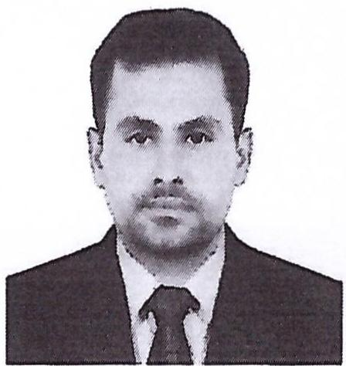
CURRICULUM VITAE
Name: Fakhar Hayat Harl
Address: Abu Dhabi, United Arab Emirates
Email: fakhar@careerjobsuae.com

Desired Position: Electrician

To manage, oversee and ensure the safety, efficiency and integrity of the electrical systems on all projects undertaken by the Company.

Career Objective
Looking for a job as an "ELECTRICIAN TECHNICIAN" in any suitable and professional organization to express my experiences in some beautiful manners.

EDUCATIONAL BACKGROUND
- Electrical Engineer
- Word, Excel, Power Point

JOB EXPERIENCE

- Ghantoot Transport General Contracting LLC (11/07/2015- 02/03/2019)
- Worked as an "ELECTRICAL TECHNICIAN, ELECTRICAL POWER SINGLE PHASE / THREE PHASE, FIRE ALARAM SYSTEM, EMERGENCY LIGHTHING, CBS SYSTEM CABLE TRAY ACCESSORIES, TESTING AND COMMISSIONING FOR FIRE ALARM LOW VOLTAGE AND LIGHT POWER LIGHTING PRODUCTION, DB Dressing, Cable Glanding Can Read the all kind of Drawings, Light Power EM, LCS, FA, Single Line Diagrams, Schematics Diagrams, Load Schedule" for last 4 years in Abu Dhabi UAE

- Jeel Altimouth Technical Contracting since 04/03/2019 till Now
- Currently Working as an "ELECTRICAL TECHNICIAN, ELECTRICAL POWER SINGLE PHASE / THREE PHASES, FIRE ALARAM SYSTEM, EMERGENCY LIGHTHING. CBS SYSTEM CABLE TRAY ACCESSORIES, TESTING AND COMMISSIONING FOR FIRE ALARM LOW VOLTAGE AND LIGHT POWER LIGHTING PRODUCTION" since 04/03/2019 till Now

- Descon PVT {01/02/2013-25/01/2015)
- Worked as an "ELECTRICAL TECHNICIAN, ELECTRICAL POWER SINGLE PHASE / THREE PHASE, FIRE ALARAM SYSTEM AND EMERGENCY LIGHTHING / CBS SYSTEM CABLE TRAY ACCESSORIES" for 2 years

Personal Profile
Name : Fakhar Hayat Harl
Name of Father : Mahr Mulazim Hussain
Date of Birth : 01/09/1990
Place of Birth : Pakistan
Nationality : Pakistan
Gender : Male
Marital Status : Single
Languages Known : English and Urdu
Passport Details
Passport No : FG6903262
Date of Issue : 07/07/2019
Date of Expiry : 05/07/2029
Place of Issue : Pakistan
Status of Visa : Employment Visa
Emirates ID No : 784-1990-8460405-9
Date of Expiry : 15-03-2021

I hereby and certify that the above mentioned is true and correct to the best of my knowledge and belief.

Fakhar Hayat Harl

