
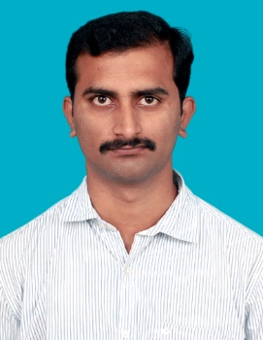
STAAD PRO
STAAD FOUNDATION
AUTO CADD
MICROSOFT OFFICE family
CLB 7 band in IELTS
Use THEODOLITE, DUMPY LEVEL, and TOTAL STATION
CIVIL STRUCTURAL ENGINEER
ABILASH, M.Tech.,

CIVIL ENGINEER
PWD Construction Contractor, Pernambut union, 2012 – present.
- Supervise 30+ project Labor workers, including in-house, external contractors, and sub-contractors.
- Perform and execute drafting according to specifications; ensured compliance with all project QA procedures and requirements
- Inspect inventories and prepared Bids for Civil housing projects and refractory materials in line with budgeted figures averaging ₹100,000,000; worked with tender scheduling and sanction orders.
- Have undertaken new road formation and maintenance of existing roads involving surveying and leveling followed by WBM and tack coat and seal coat.
- Have involved as sub-contractor in the construction of the retaining wall along a state highways.
CONTACT
RESUME OBJECTIVE
SKILLS
EXPERIENCE

A Civil Engineer with 6+ years of experience. Capable of working independently with least supervision, and committed to providing high quality service to every project, with a focus on health, safety and environmental issues. Possess an M.Tech in Civil Structural Engineering.
Email: abilash.ce@gmail.com
Phone: +91-7708633710
Address: Door no: 102, Satham bakkam vill, Ambur Tk, Vellore Dt, Tamil Nadu-635808
Skype mail id: abilash.ce@gmail.com

EDUCATION & CREDENTIALS
M.Tech Structural Engineering
Hindustan University, Chennai.
2014.
FREELANCE STRUCTURAL CONSULTANT, (2016 – present).
- Have been doing as a freelancing structural consultant for few residential construction and a couple of commercial wedding halls.
- Have a clear knowledge about the design of steel connections as per ASTM.
- Have some innovative ideas regarding the seismic resisting structures.

SUMMARY
With Knowledge, hunger to succeed and Self-Confidence I assure that I can contribute and satisfy the needs of the society.
B.E Civil Engineering
Anna University, Chennai.
2012.
WES VERIFIED EDUCATION PROFILE.

CERTIFIED PWD CONTRACTOR.
EXPRESS ENTRY PROFILE NUMBER: E001281899

