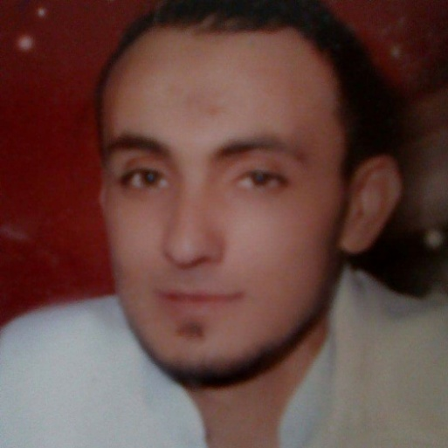

Timoumi Riadh
- 37 years
- 21 ,street Ebn Charef City Ennacim Nasrallah
- 3170, Kairouan, Tunisia
- 0021656127800 / 0021622454784
- ryadh-timoumi@hotmail.com
- Driver's license: A1, B, H (04/49074) years 2005

  - Primary school: At the primary school cited Ennacim, Nasrallah. From 15 September 1987 to June 1992 with success.
  - Secondary school: Nasrallah High School. From September 15, 1992 to June 30, 2002 with success.
  - Graduate School of Engineering: I did two years in 2003-2004 without success, and I do stimulation for another subject.
  - Senior Technicians in Industrial Chemicals: I graduated in Industrial Chemistry on June 27, 2007 from Ksar Hellal's Higher Institute of Technological Studies, Monastir
  - Qualified Plumber: In April 2017 I received my diploma of technical qualification in plumbing.
  - Trade: I have a little experience in trade (sale and purchase). I run for 8 years (until now) a small hardware store (sanitary equipment, electricity, tools, heating, air conditioning ... etc). so I am in parallel with AYA agricultural society (biological and chemical drugs).

WORK EXPERIENCE
- September 2007 - April 2008
SPONGITEX: STE SPONGE CLOTH
Road Ksar Helal ZI-Bouhjar 5015 Monastir, Tunisia
Established for over 30 years, is an integrated group SPONGITEX up subsidiary consists of 3 companies active in the fields of yarn, dyeing and weaving. Manufactures textile products è domestic and industrial use.
Spot :
I was responsible laboratory and I run some dyeing machines:
- Preparation of dye recipes to be, wools, cottons, ...
- Control of dyeing machines: autoclaves (classics & modern), centrifuges,
- Preparation of color kitchens.

- July 2008 - December 2012
CHO COMPANY: GROUPE EGYHUILE
Route Mahdia Km 18-3066 Sfax - TUNISIA
- Packaging of olive oils
- Refining of olive oils
- Extraction of pomace oils
- Production of soaps made from olive oil
Spot:
- Analysis & test of acidity of the oil extracted from pomace.
- Test the moisture pomace.
- Check the refined oil stocks.
- Check the export of dried pomace.

- January 2012 - Dec. 2018
AYA AGRICULTURAL COMPANY
Road to Kairouan - Manzel Mhiri Kairoua
- Department store of agricultural equipment.
- Sale of biological and chemical drugs.

Spot:: Chemical Responsible for Organic Products
- Treatment of agricultural and biological drugs
- Analyze and test some drugs on some vegetables.
- Control drug stocks at the stores.
- Controlling the effects of biological drugs on land
---------------------------------------------------------------------------------------------------------------------------

- Internships:

March 2004.
1st internship in 2004 at ACRYLAINE Hajeb El Ayoun, Kairouan, Tunisia (Wind dyeing)
▪ Analysis of dye recipes.
▪ Check with the workers and technicians the steps of winding (cleaning primary material "raw wool" to the reel queues).

March 2005.
2nd internship in 2005 at STARTEX Ksar Hellal, Monastir, Tunisia (dyeing on trousers "djean's")

June 2007.
Final project at ISET-Ksar Hellal (Higher Institute of Technological Studies).
My final project was June 30, 2007 at the institute laboratories as "natural dyeing on silk, wool, cotton" a new project idea. But he was very effective with a new work taste and with a new performance experience.

TRAINING

- April 2017
I have an experience in plumbing:
- Works on all types of pipes (steel, copper, multilayer, PEX, PVC)
- Sanitary Replacement (shower, bathtub, sink, sink, toilet, faucets)
- Bathroom Realization
- Sanitary offices
- Gas water heater replacement and electrical
- Sanitary and storm drain network.
Company 3.FPRO: THE THREE PROFESSIONAL FLUIDS
Street Om Salma Makzoumia, city erriadh Sousse-4023 Sousse
Spot: Plumber qualify.
Replacement of gas and electric water heaters, replacement of sanitary ware, realization of bathroom
For 8 years the plumbing was my job in parallel with my small hardware project.

LANGUAGES

- Arabic: Fluent (read, written and spoken)
- French: Fluent (read, written and spoken)
- English: Fluent (fair)
INTERESTS / ACTIVITIES
- Design, use new technologies.
- Persuade, negotiate.
- Defend, monitor, and assist.
- Lead, Decide.
- Investigate, search, and analyze information.
- Teach, educate.
- To be independent.
- Exercise artistic or creative profession.
- Making, build.
- Do research.
- Trading.
- Make sport.3
- Make precision work.
- Inform, communicate.
- To repair.
- Caring.
- To work outside.
- Work abroad.
- Work with nature.
- Work material.
- To preserve the environment.

