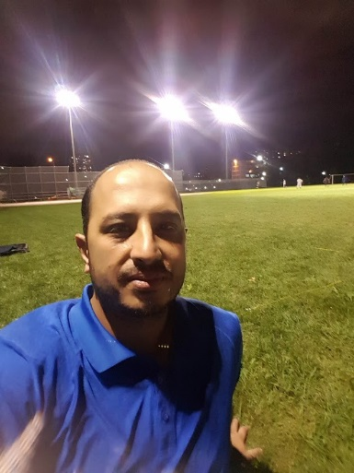  Technically oriented Electrical Technician with over 5 years working experience in installation, maintenance and operation of electrical systems across domestic, commercial and industrial sites, |  | Aziz Ahmad  Journeypersons Class Electrician  Summary of Qualifications  - More than five years’ experience.  - Profound ability to isolate defects in wiring, switches, motors, and major electrical equipment.  - Strong ability to install and maintain motors, lighting fixtures, generators, circuit breakers, and transformers.  - Knowledge of electrical systems including planning additions and modifications on secondary circuits.  - Proficient use of hand and power tools applicable to trade.  - Install grounding leads.  - Strong ability to read commercial electrical blueprints and apply NEC through the full range of commercial and industrial maintenance and construction work.  - Ability to install and maintain motors, lighting fixtures, generators, circuit breakers, and transformers.  - Excellent ability to diagnose and repair electrical controls, industrial motor control centers, and programmable logic controllers.  - Ability to work from ladders, scaffolds, hydraulic towers, or in tunnels and crawl spaces.  - Ability to work in extreme temperatures of hot or cold, stand, bend, sit, twist
Core Skills  - Electrical system maintenances * Control Panel installations  - Fault finding/ tasting * Ruffing * finishing * Running the wires and slab  Contact  PHONE:  6476076494  EMAIL:  Ahmedaziz.khan9@gmail.com  additional information  Microsoft office including world, Excel,  IT, troubleshooting,  Reference are available by requests |  | EDUCATION  (Baluchistan College of business)  Diploma in Commerce  Electrical training from Baluchistan college  WORK EXPERIENCE  Colwis ---As (Electrician)  2017-8-26–2019-01-30  I started working from base of the building as electrician which includes slab, running corallines, PVC pipes and putting all boxes, next ruffing pulling wires, panels, and finishing of all units with installing lights, switches, smoke detectors, fire alarms and TV panels.  Times Electric—As (Electrician)  2019-02-05–2019-06-30  Installed all LED lights as Ontario new standards, blasts tubes, and faulty circuits. Installation of new conduct wiring system Assemble, install, test, and maintain electrical or electronic wiring, equipment, appliances, apparatus, and fixtures, using hand tools and power tools. Connect wires to circuit breakers, transformers, or other components. Diagnose malfunctioning systems, apparatus, and components, using test equipment and hand tools, to locate the cause of a breakdown and correct the problem.  47 Thorancliffe Park Dr  Toronto Ontario Canada  M4H 1J5

