
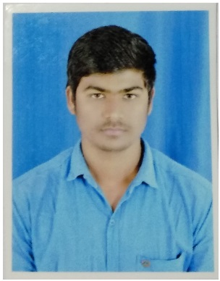
PRITAM PRASAD




info@aryanpaper.com
pritamprasad0@gmail.com

+91-7698716344
Seeking an Instrument Engineer position, leveraging education, practicum and experience. Looking for a dynamic, team environment which meets the demand of a growing market with outstanding integrity and commitment to service believed that your company’s.
focus is on clients and be very responsible in gearing towards success through innovation, performance and
team work.
.

ABOUT ME
WORK EXPERIENCE
3 years

AGE
25


Education

BE (Bachelor of Engineering)
JUNE 2016 With 7.2 CGPA
C.U Shah College of Engineering & Technology.
Wadhwan, Ahmedabad.

Intermediated (10+2)
June 2012 Gujarat Board
Saraswati Vidyalaya School. Marks 54.46%
vapi.

High school (10th)
June 2010 Gujarat Board
ST Mary’s School. Marks 69.08%
Vapi.


Other Qualification

Training taken in 5S and TPM. Implemented various Kaizen project.
Sofcon India Pvt Ltd. Rajkot.
PLC, SCADA/HMI, Variable Frequency Drives, Industrial Networking, Panel Designing, Process Instrumentation, AutoCAD, DCS.


Work Experience

ARYAN PAPER MILLS PVT LTD., VAPI  
JULY 2016 TILL DATE (PURSUING)
Working as Instrumentation Engineer

My core responsibilities in this organization belong to:

- Maintenance of Instruments on periodic Basis.
- BOM and Data Sheet preparation of the equipment for the project.
- Preparation of Techno-commercial comparison for the equipment.
- Creating its implementation to build the System.
- Erection and Commissioning activities for the Project.
- Calibration of Instruments, diagnosing of faults, Report making, Preventive & Predicative Maintenance.
- Erection of 5.5 MW CPP Power plant.
- Commissioning of cethar boiler (25 T)
- Different type of Transmitter and Control valves calibration and mounting.


Computer Proficiency

- Word 2010, Excel 2010, Power Point 2010
- AutoCAD
- SCADA
- PLC
- DCS


Personal Details

Father Name : Ram Naresh Prasad
Mother Name : Anita Prasad
D. O. B. : 07 Jan 1994
Gender : Male
Marital Status : Unmarried
Blood Group : AB+

Declaration
I, hereby declare that the information contained herein is true and correct to the best of my knowledge and belief.

____________________________
Pritam Prasad

