Roy Sawulayi  Sawroy81@Yahoo.com • http://www.linkedin.com/in/roy-sawulayi  555-555-1212 • Chililabombwe, Copperbelt | 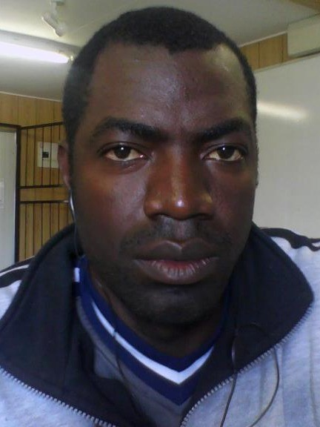
Heavy Duty Diesel Mechanic
Highly skilled and certified mechanic with over 8years’ experience in all facets of equipment, engine, and vehicle maintenance, Troubleshooting, repairing, installing, and removing. Adept at arc welding, loader operating, and assembling and disassembling components. Proficient in carrying out preventive maintenance machine rebuilding and daily machine inspection as per company procedures and maintaining HSE standards. Excellent communicator with proven ability to establish professional relationships with clients, team members, and senior management.
- Vehicle Auditing  - Monitoring & Evaluation  - Budgeting & Time Management |  | - Preventive Maintenance  - MS Office & SAP  - Conflict Resolution | - Interactive Communication  - Cross-team Collaboration  - Leadership & Training
 | Career Experience
Heavy Duty Diesel Mechanics, Rebuild workshop, Chililabombwe, Zambia 2/2012 to Present
Konkola Copper Mines Plc
Perform various tasks, including machine auditing, stripping down, disassembling, and assembling of components. Carry out equipment rehabilitation, rebuilding, maintenance, and repairing of underground heavy duty equipment. Enhance machine reliability and availability to minimize costs and accomplish high production objectives. Rebuild equipment, remove and install engines, power train and hydraulic components, monitor Caterpillars, Atlas Copco, and Sandvik machines, including LHDs, Mine Trucks, and Drill Riggs. Manage remote control systems on LHDs.
- Reduced equipment maintenance cost by 20% through initiation of control measures, including supervising and conducting equipment fail inspection and test.
- Increased equipment availability from 60% to 95% through equipment rebuilds and rehabilitation and performed components re-conditioning that improved equipment performances.
- Enhanced equipment liability and durability by introducing operator technical training skills that made tremendous improvements on equipment reliability.
- Received certificate of achievement in supervisory course, computer literacy, automotive electrical trouble shooting, basic air conditioning and refrigeration, and total quality management training.
Heavy Equipment Diesel Mechanics, Chililabombwe, Zambia 6/2010 to 12/2011
Konkola Copper Mine plc, Underground Services crew
Perform preventive maintenance and daily machine inspection as per company procedures and maintain health, safety, and environment standards. Execute underground machine maintenance procedures and activities, including troubleshooting, repairing, removing and installing minor and major components. Oversaw Caterpillars, Atlas Copco, and Sandvik machines with the inclusion of Loader, Mine Trucks, and drill Riggs to support accomplishment of underground mining development and production targets.
- Acquired and utilised six new skills through company sponsored training programs.
Heavy Equipment Mechanic Apprenticeship, Chingola, Zambia 4/2010 to 3/2011
(Nchanga Open Pit)
Carried out daily preventive maintenance, repairing, removal, and installation of components in accordance with safety procedures. Removed and installed engines, power train, and hydraulic components. Managed Wheel Loader 994F, Wheel Dozer 854G, Dozer D10T and D11R, and Grader 24H and 24M.
- Spearheaded availability of mobile equipment from 60% to 90%.
- Serviced drained engine oils, hydraulic oils, axle, and differential oils.
Career Note
Heavy Mobile Equipment Operator/Mechanic, Konkola Copper Mine plc, Chililabombwe, Zambia, 6/2008 to 2/2010
All Mining Operations learnership, Konkola Copper Mine plc, Chililabombwe, Zambia, 9/2007 to 5/2008
Qualified and obtained Blasting licence token
Truck Driver/ Mechanic, R.S Transport, Luanshya, zambia,3/2006 to 5/2007
Education
Craft Certificate of Automotive Mechanics
Livingstone Institute of Business and Engineering Studies, Livingstone, Southern Province, zambia
General Certificate of Secondary Education
Mwinilun'ga high school, Mwinilunga, North West province, zambia
Certificates & Courses
Basic International Mining Safety | Mining Advanced First Aid | All Mining Operations | Blasting licence (includes; transportation of mining explosives, charging and Blasting) | LHD & Mine truck operation | Basic mechanics refresher course | Engine System & Application | Basic Hydraulic & hydraulic systems | Computer literacy | Operator technical skills | Basic arc welding | Basic slinging and rigging | Parts manual literacy | Project management | Total quality Management | Sandvik technical modules and basic electro hydraulics | Occupational Health, Environmental and Safety Awareness | Level 1 and level 2 Bogger remote control installations, operations, testing, and maintenance of remote control systems by Remote control technologies (RCT) Australia

