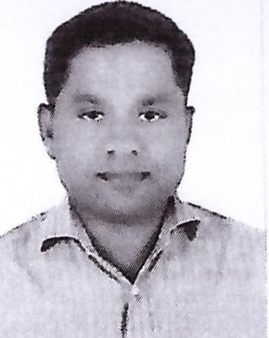
CURRICULUM VITAE
Name: Raveendran Vijayakumari
Address: Abu Dhabi, United Arab Emirates
Email: raveendran@jobsearchuae.com

Desired Position: Light Vehicle Driver

To gain employment as a light vehicle driver at an excellent and reputable company; to utilize my extensive skills and vast experience in order to provide superior services to my passengers

CAREER OBJECTIVE
A self-driven individual, Competent and values the virtue of Integrity, who is ready to comply with the industries rules and regulation to towards achieving the zeal goal stated by the company, improving my weak areas to make them my strong points. Ready to raise my knowledge and skills, so as to attain more experience that is relevant to my duties, profession and remain important towards the company's achievements.

EDUCATION QUALIFICATIONS

- (S.S.L.C) Board of Secondary school Certificate Kerala ,India
- +2 in Commerce

WORK EXPERIENCE

Worked as an LN Driver, Mini Bus Driver and Assistant HR works in Oil & Gas Plant project Abu Dhabi (Satah Al Razboot Plant facilities PKG-4) with M/S Hyundai Engineering Company Pvt. Ltd. Since the date of 22nd July,. 2015 to still

Worked as an L/V Driver, Mini & Heavy Bus Driver and Documents Submission & Receiver in Substation Project Dubai (DEWA - 400kV & 132kV Substation Project (ES-401& ES-135) with M/S Hyundai Engineering Company Pvt. Ltd. Since the date of 01St May,. 2007 to 21st July. 2015

Worked as an L/V Driver, Mini & Heavy Bus Driver and Documents Submission & Receiver in UAE (Emirates National Grid OH Tower line Project (ET-401) with MS Hyundai Engineering Company Pvt. Ltd, Since the date of 09th Aug,. 2004 to 30th Apr. 2007

Worked as an L/V Driver, Documents Submission & Receiver in Substation Project south zone in Abu Dhabi (ADDC - 33kV - Baniyas Project (ES-032) with M/S Hyundai Engineering Company Pvt. Ltd, Since the date of 01 Jan,. 2003 to 08 Aug. 2004

Worked as an L/V Driver and Messenger Boy in Substation Project south zone in Abu Dhabi (ADDC - 33kV - Baniyas Project (ES-031) with M/S Hyundai Engineering Company Pvt. Ltd, since the date of 31 Dec. 2000 to 31 Dec. 2002

Worked as a Taxi Driver in Umm Al Quwain Taxi, Since the 1999 to 2000

STRENGTHS

- Resourceful person
- Excellent communication & organizational skills
- Willing to learn and work under pressure & having team spirit
- Responsible & knowing how to priorities my work
- Always willing to take up new challenges (multitasks)
- Able to work efficiently in a team

PERSONAL PROFILE
Name : Raveendran Vijayakumari
Date of Birth : 16-05-1971
Place of Birth : Azhoor Kerala
Nationality : Indian
Gender : Male
Passport Details
Passport No : M0911284
Date of Issue : 14-09-2014
Date of Expiry : 13-09-2024
Place of Issue : Dubai
Status of Visa : Employment Visa
Emirate ID No : 784-1971-1706507-4
Date of Expiry : 22-04-2021
License Details
License No : 1180651
Date of Issue : 07-08-2007
Date of Expiry : 07-08-2027
Permitted Vehicle : Light Vehicle, Light Bus, Heavy Vehicle and Heavy Bus
Place of Issue : Dubai, UAE

I hereby certify that the above mentioned statement is correct and true to the best of my knowledge and belief.

Raveendran Vijayakumari

