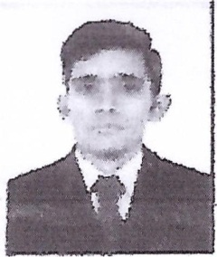
CURRICULUM VITAE
Name: Abdullah Ghafoor
Address: Abu Dhabi, United Arab Emirates
Email: abdullahghafoor@jobsearchuae.com

Desired Position: Light Vehicle Driver

To gain employment as a light vehicle driver at an excellent and reputable company; to utilize my extensive skills and vast experience in order to provide superior services to my passengers

CAREER OBJECTIVE
Seeking a challenging position in multinational agencies where I can utilize my skills and gain more experience

PROFILE

A Suitable position with an organization where I can utilize the best of my skills and abilities that fit to my education, skills and experience a place where can encourage and permitted to be an active participant as well vital contribute on development of the company.

SKILLS

- Very Energetic result oriented and organized
- Efficient and well behaved person
- Extremely hardworking self-motivated and able to work independently in a team environment under supervision
- Keep excellent inter personal relations with colleagues and ready to help them.

LANGUAGE KNOWN

Urdu, English, Punjabi & Arabic

EDUCATIONAL QUALIFICATION

- MATRICULATION (2012- 2014)
- FSC-PRE ENGINEERING (2014-2016)

WORK EXPERIENCE

- Worked as a Light vehicle In Pakistan since 01 Year.
- Presently working as a light vehicle driver & forklift, boom loader operator With Al Khubar Transporting & General Contracting Sole- Proprietorship L.L.0 since 2 years.

PERSONAL PROFILE
Name : Abdullah Ghafoor
Name of Father : Ghafoor Hussain
Date of Birth : 16-02-1998
Place of Birth : Gujrat,PAK
Nationality : Pakistani
Gender : Male
Passport Details
Passport No : BJ4187381
Date of Issue : 12-05-2014
Date of Expiry : 11-05-2019
Place of Issue : Pakistan
Status of Visa : Employment Visa
Emirate ID No : 784-1998-4292747-9
Date of Expiry : 18-06-2020
License Details
License No : 2292787
Date of Issue : 30-01-2017
Date of Expiry : 27-01-2020
Type of License : Light & heavy Vehicle Driver

I hereby certify that the above mentioned statement is correct and true to the best of my knowledge and belief.

Abdullah Ghafoor

