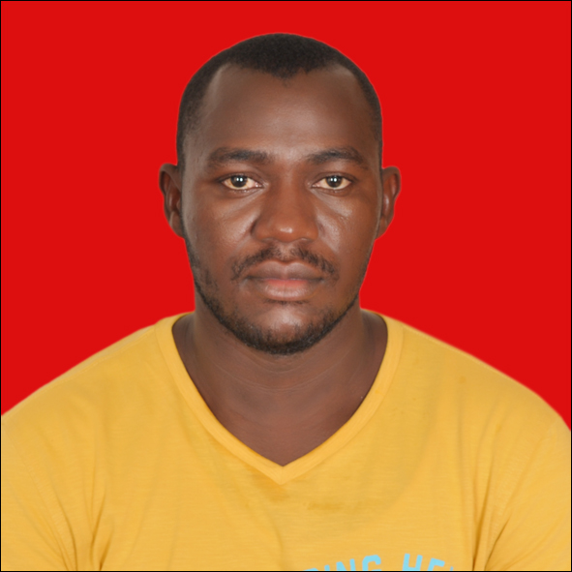
CURRICULUMVITAE

Name : FONGANG CONSTANT ROVEL
Date of birth : 04 January 1990
Place of birth : BANKA BAFANG
Marital Status : MARRIED, 02 CHILD
Nationality : CAMEROONIAN
Residence : ABU DHABI and YAOUNDE
Language : ENGLISH (excellent) and FRENCH (excellent)
Email : fongangconsty@yahoo.fr/fongangconsty@gmail.com
Telephone : +971564287199 (WORK) / +237650013144 (HOME)
PASSPORT NO : 0511867 Expiry date: 21 /09/ 2021
DISCHARGED BOOK NO : F1200485 Expiry date: 13/03/2024
POSITIONS APPLYNG FOR : MARINE MECHANIC ( MOTORMAN / OILER )

CERTIFICATES AND TRAINING
INSTITUTIONs | CERTIFICATEs OBTANED | Certificates no | Expiry date
Regional Maritime University | Marine Engine Mechanic | S/N001303 | None
Regional Maritime University | Proficiency in Elementary First Aids | EFA/01316/16 | 21/11/2021
Regional Maritime University | Proficiency in Personal Safety and Social Responsibilities | PSR/01317/16 | 21/11/2021
Regional Maritime University | Proficiency in ISPS Awareness | ISR/00820/16 | 21/11/2021
Regional Maritime University | Proficiency in Personal Survival Techniques | PST/01332/16 | 21/11/2021
Regional Maritime University | Proficiency in Fire Fighting and Fire Prevention | BFP/01342/16 | 21/11/2021
Ghana Maritime Authority | Basic Safety Training  (Manilla 2010) | FB000109 | 21/11/2021
NPCC TRAINING CENTER | H2S | ERW/00104/16 | 21/11/2021
Regional Maritime University | Proficiency in Rescue boats and survival craft | PSC/00562/16 | 21/11/2021
Regional Maritime University | Lifeboat | LBT/00486/16 | 21/11/2021
Ghana Maritime Authority | C.O.C WATCHKEEPING (lll/4) | ED100273 | 21/11/2021
GTSC ABU DHABI | T- BOSIET | 52515501270917261169 | 21/09/2021
NPCC TRAINING CENTER | HSE | 42709014290917 | 22/09/2019
PROFESSIONAL BACKGROWND ( SEA TIME EXPERIENCE )
COMPANY | VESSEL/TYPE | BHP | RANK | SIGN ON DATE | SIGN OFF DATE | GRT/DWT
Tema Port and Harbor Authority | SAKUMO LAGOON (TUG) | 4750 | OILER | 03/ 09/ 2012 | 30 /11 /2012 | 269 / 200
Tema Port and Harbor Authority | SAKUMO LAGOON (TUG) | 4750 | OILER | 02 /01/ 2013 | 30/05 / 2013 | 269 / 200
LIWA MARINE Services (Khalid Faraj Shipping) | KESSAB1 (AHT) | 4400 | MOTORMAN / MECHANIC | 15 /03/2015 | 21/12/2015 | 482 / 269
LIWA MARINE Services (Khalid Faraj Shipping) | KESSAB1 (AHT) | 4400 | MOTORMAN / MECHANIC | 30/01/2016 | 13/10/2016 | 482 / 269
LIWA MARINE SERVICES (Khalid Faraj Shipping) | DEBRAN1 (TUG) | 4400 | MOTORMAN / MECHANIC | 10/01/2017 | 29/08/2017 | 476/266
NPCC | NPCC AL MARYAH (DSV) | 4400 | MOTORMAN / MECHANIC | 20/09/2017 | 29/05/2018 | 3389/1863
NPCC | NPCC AL MARYAH (DSV) | 4950 | MOTORMAN / MECHANIC | 05/07/2018 | 07/02/2019 | 3389/1863
NPCC | NPCC AL MARYAH (DSV) | 4950 | MOTORMAN / MECHANIC | 06/04/2019 | Till present | 3389/1863

Total sea experience 51 Months and 19 days
OTHER SKILLs : Marine Diesel Engines Maintenance and Repair, Basic Fabrication, Welding, Painting and Decoration.
Computer knowledge : BASIC MICROSOFT WORD and EXCEL.
Hobbies : Swimming, Reading, Music, Sport.
I am available now

