Curriculum Vitae

Of

Heinrich Jonkers

CONTACT DETAILS

Address: 5544 salie straat
Kuruman
Northern Cape
8460

Contact Numbers: 0725309654/0650239101
E-mail Address: cjjonkers100@gmail.com

PERSONAL DETAILS

Full Names: Heinrich Christian
Surname: Jonkers
Date of Birth: 04 April 1993
ID Number: 930404 5091 086
Marital Status: Single
Dependents: None
Home Language: Afrikaans
Other Languages: English
Gender: Male
Nationality: South African
Health: Excellent
Criminal Record: None
Religion: Christian

EDUCATIONAL DETAILS

Institution: De Beers Technical Training Centre
Year: 2012- 2015
Course: Plater/ Welder (Qualified: 08 December 2015)

College: Northlink College, Belville Campus
Year: 2012
Subjects: Mathematics N2
Engineering Science N2
Plating and Structural Drawings N2
Plates Theory N2

School: Schoonspruit Secondary School
Highest Grade Passed: Grade 12
Year: 2010
Subjects: Afrikaans
English
Mathematics Literacy
Biology
Geography
Business Studies

CAREER OBJECTIVES

To be a valuable asset to any organisation or institution that will utilize my knowledge and skills
through hard work, dedication and discipline.

SPECIAL SKILLS, QUALITIES, ABILITIES AND INTERESTS

I produce work of the highest quality and I am committed to meeting deadlines. I have an excellent
manner, friendly and reliable. My work, as well as stress that accompanies work of this nature is
done efficiently. I enjoy support from my colleagues and management. I specialise in boilermaking,
pipe fitting as well as welding (arc mig and tig welding).

EMPLOYMENT HISTORY

Employer: SFG Engineering Services (Contract)/IMDH/IMDSA/Sea Harvest, De Beers Marine
Position: Boilermaker/ Pipe Fitter/ Welder
Duration: 20 November 2017- January 2018
Responsibilities:
- Repairing chutes, crushers and handrails
- Welding work pieces
- Hard face welding
- Welding flanges on pipes
- Welding pipes
- Fitting flanges on pipes according to standards(pipefitting)
- Replacing worn pipes with new pipes
- Repairing pipes
- Maintenance on vessel
- Reporting to Vessel Manager
- Attend to breakdowns
- Attend to workshop duties

Employer: Tronox Namakwa Sands Mine(open cast)
Position: Boilermaker
Duration: August 2012- July 2017
Responsibilities:
- Inspected plant daily, fault finding inspection, maintained, repaired and installed equipment
- Workshop fabrication
- Boilermaker as well as Plant Maintenance Boilermaker
- Planned weekly shutdowns
- Supervised sub-contractors
- Standby duties
- Counter weight forklift and machinery.
- Undertake site visits to record measurements and working drawings.
- Undertake the fabrication of sheet metal work and pipework.
- Complete job cards, time sheets, material requisitions, attendance register.
- Motivate and train apprentices, mechanical assistants, trade workers, handymen and other staff.
- Undertake various types of structure related activities, the manufacture and installation thereof and any other duties that fall within the scope of mechanical engineering.
- Undertake the installation and maintenance of HDPE pipework and equipment.
- Use of scaffold and the operation of overhead cranes.
- Undertake the rigging operations.

Employer: Assmang Black
Rock Operations
(Underground)

Coy nr: 10063874

Duration: 1 Oct 2018-Present

Responsibilities:
- Comply with SHEQ requirements
- Adhere to legislated safety, health and environmental in every task performed
- Confirm work order to correct time and all details required to standard
- Provide feedback to maintenance supervisor
- Communicate if spares, equipment unavailability arise on work order and to maintenance supervisor
- Conduct trade related inspection on TMM equipment
- Ensure adherence to safety, health, environmental, quality and good housekeeping practices
- Conduct fault finding on equipment where required
- Maintain and repair mechanical parts, components and equipment
- Adhere to lock out procedure
- Comply to company values:accountability, care, integrity, excellence, collaboration, embrace diversity

CONTACTABLE REFERENCES

Name and Surname | Postion | Company | Contact Details
John Kuhn | Boilermaker | SFG Engineering | 074 578 9396
Stuart Pearce | Foreman | IMDH/IMDSA | 078 695 9117
Solly Rupping | Foreman | Tronox Namakwa Sands Mine | 082 878 0033
Gerrit Waldeck | Boilermaker | Tronox Namakwa Sands Mine | 072 983 0757
Monty  Mokubung | Charge hand | Assmang Black Rock | 079 244 3186

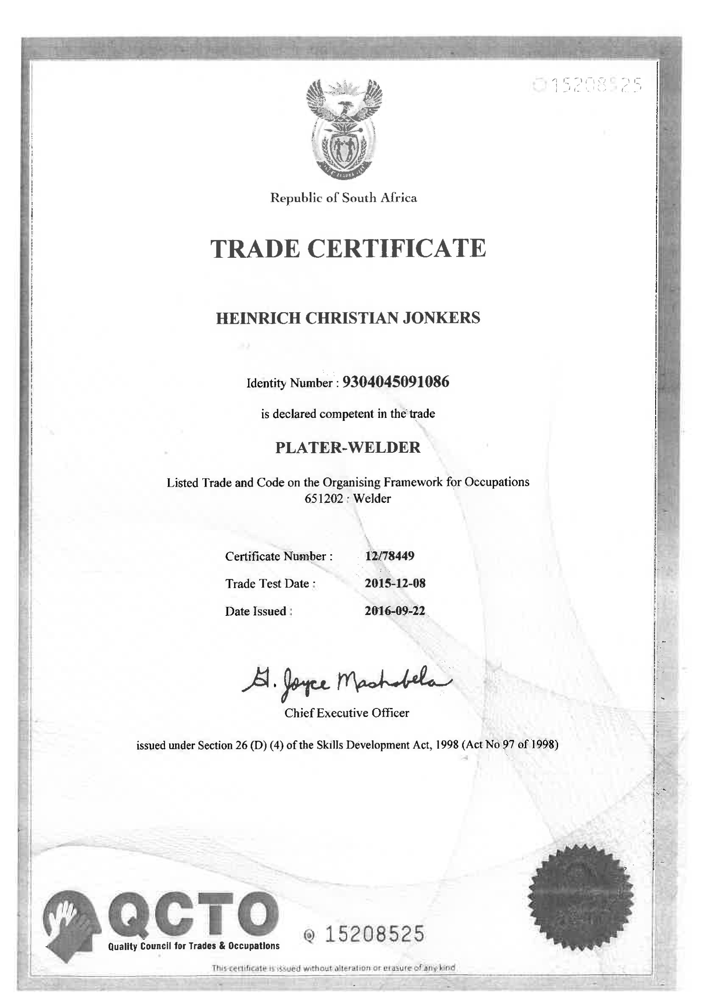
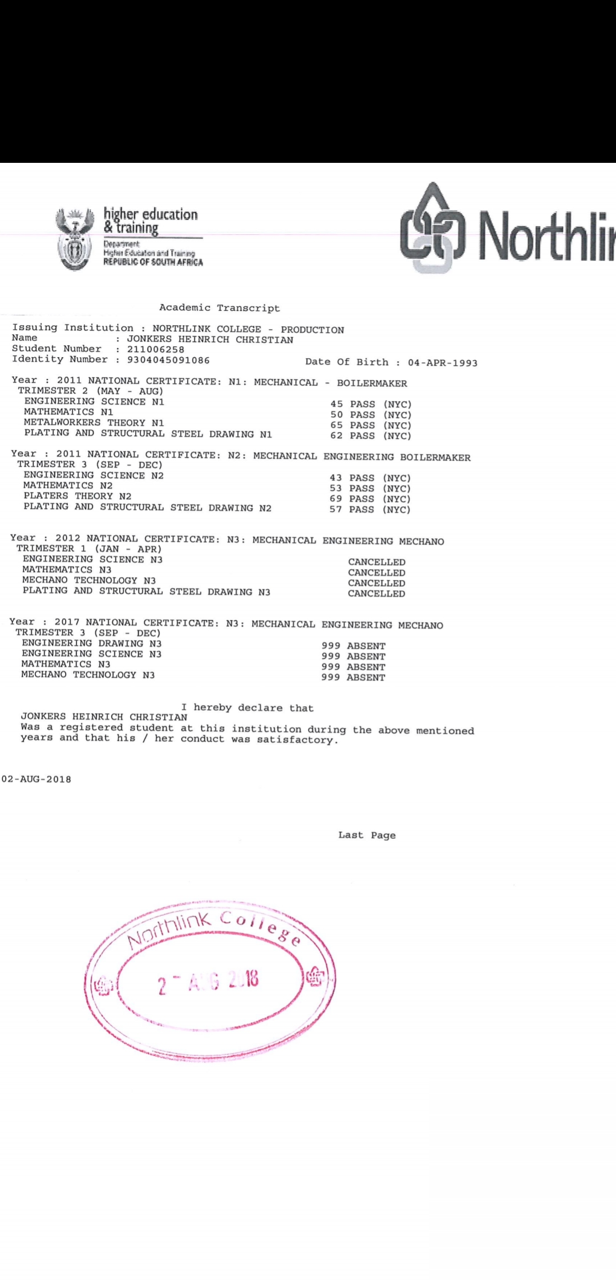

REPUBLIC OF SOUTH AFRICA NATIONAL IDENTITY CARD
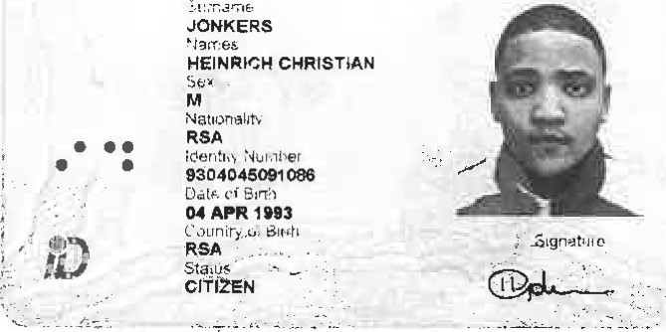
M r / MS HEINRICH CHRISTIAN JONKERSREPUBLIC OF SOUTH AFRICA
WCED
0000
near Mr / Ms JONKERS
CONFIRMATION OF NATIONAL SENIOR CERTIFICATE RESULTS CONFIRMATION or NATIONAL SENIOR CERTIFICATE RESULTS
CONFIRMATION OF NATIONAL SENIOR CERTIFICATE RESULTS
Candidate examination number 4589992
The Department hereby wishes to confirm your National Senior Certificate results :
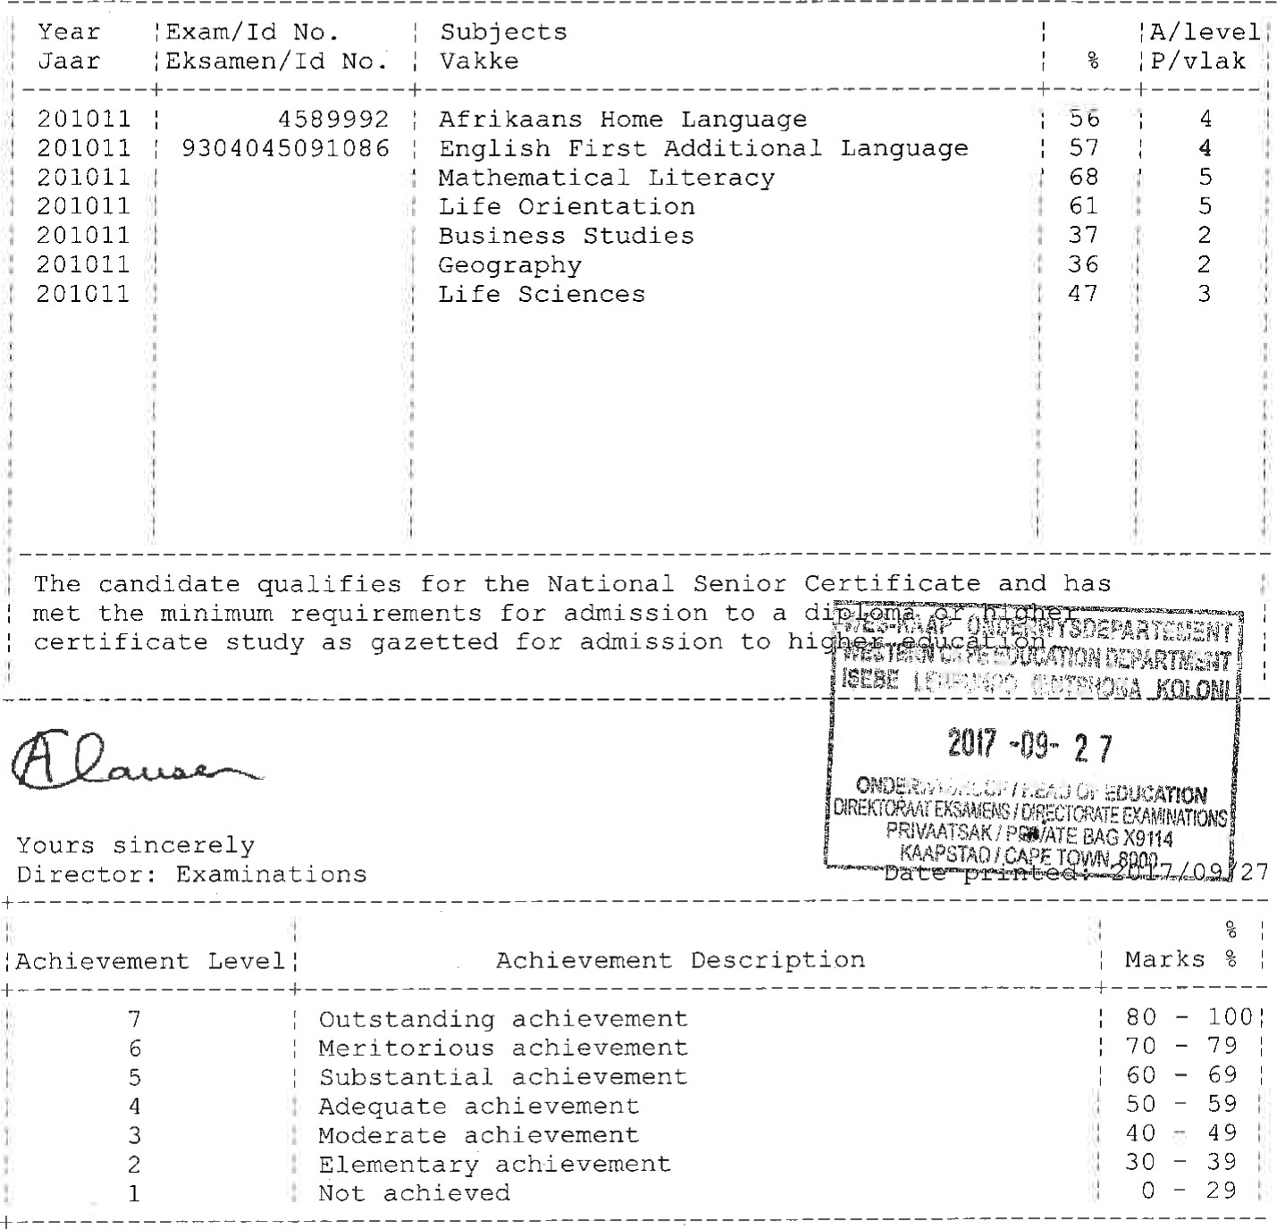
# This document is issued without alterations or erasure of any kind and is subject to the approval of the Department of Education. The Department of
Education reserves the right to effect changes to this document.

