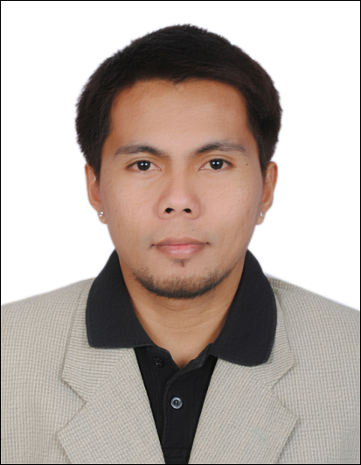
Marlon L.Gonzalvo
Address: Al Sharja Al Nahda U.A.E
Email: marlon.gonzalvo@yahoo.com
Mobile No.: 00971525000143 / 00971581024891
Driving license: Light vehicle

Career Objective

Experienced and knowledgeable electrician with more than 10 years of experience in the field seeks a position with a busy contractor or top electrical or construction firm in need of a hard worker with solid technical skills.

Work Experience

THE HEART OF EUROPE
JK Bauen Building Contracting L.L.C.
2017 -Present
Marine Electrician

Technical skills:

- Laying Out and Installing Wiring Circuits
- Replacing Defective Wiring Systems
- Terminating and Setting Switchgear, Panels, and other Distribution Equipment
- Testing and Repair of Equipment
- Repair Wiring Systems, Electrical Conduit, and Related Equipment
- Pulling cable and Securing the cable

Physical Strengths:

- Lifting and Placing Heavy Systems
- Using Power Tools for Drilling and Cutting
- Working from Ladders and Scaffolds
- Working Odd Hours
- Working in Adverse Conditions
- Reading Technical Materials

Work experience

GRANDWELD SHIPYARDS ATOS, LLC
Ship Electrician Technician
2007-2016
Dubai, United Arab Emirates

Technical skills:

- Prepare sketches or follow blueprints to determine the location of wiring and equipment and to ensure conformance to building and safety codes
- Navigation Light Assembly
- Construction of Navigational Light Panel
- Testing and Surveying of Common Alarms and Fire Alarms
- Installation and Termination of different Electrical Equipments
- Construction of Cable Tray and its support
- Main Switch Board construction

- Fixing switch, sockets, lights, fire alarm bell, smoke detector, navigation lights, call manual point, TV antenna, search light, flood light
- Assembled, install, test and maintain electrical or electronic wiring, equipment appliances, apparatus, and fixtures, using hand tools and power tools
- Maintaining Tools and Equipment
- Safety Procedures and Regulations
- Wiring for common alarm with PLC module
- Trouble shooting
- Measuring, Cutting, and Bending Conduit Using Hand and Hydraulic Benders
- Using hydraulic crimping tool for big cables
- Cable pulling
- Dressing the cable using steel cable tie
- Glanding for the panel
- Installing all kind of antenna with clamp
- Commissioning and Termination of AC and DC Panels
- Commissioning all kind of tank sensor like black water tank, fresh water tank, grey water tank and fuel tank sensor

Physical Strengths:

- working alone
- Using Power Tools for Drilling and Cutting
- Working from Ladders and Scaffolds
- Reaching Overhead for Extended Periods
- Working under pressure
- Lifting and Placing Heavy Systems

Fixfon Cell Phone Repair Technology
Training
2002/04/26 – 2002/10/26
Technician and Sales Staff
Batangas City, Philippines

Work discription:

- Greet the costumers.
- Educate the consumers about the new arrivals, new styles, features and benefits of the product line-up.
- Always check the overall status of the mobile before opening to detect if there's any other damage.
- Remove the sim card and memory card before repairing the mobile.
- Always check the serial number and version of the mobile.
- Assist customers by providing them with right product knowledge and good service.
- Set-up and up-grade mobile phones using software and hardware like Tornado, JAP and Twister.
- Repairs and troubleshoot mobiles system specially hardware and other spare parts like IC's LCD, power switch and others.
- Give the costumers satisfaction of the work done

Education

Tertiary: Batangas State University
BIT - Bachelor of Industrial Technology
Major in Electronics
2000 - 2002

Personal Information

Date of Birth: March 11, 1983
Civil Status: Married
Gender: Male
Religion: Roman Catholic
Height: 5’6
Weight: 63kg
Passport No. EB7036860
On Resident Visa
Skills: Speaks and writes English fluently and Filipino
Computer Literate: Tornado, Twister, JAP, Microsoft Office, Internet browsing

I HEREBY CERTIFY that the above information is true and accurate to the best of my knowledge.

Marlon Lanto Gonzalvo

