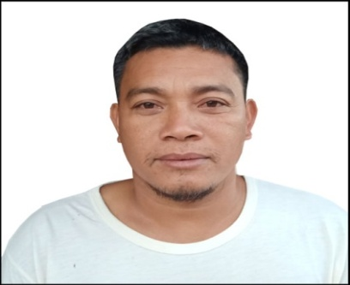
ROGER R. OBIDOS
Brgy. Casandig II, Paranas, Samar
Contact No. – 09396712517

Position Applied: Hydraulic Mechanic

Personal Background

Date of Birth : August 6, 1979

Place of Birth : Casandig, Paranas, Samar

Sex : Male

Civil Status : Married

Citizenship : Filipino

Religion : Catholic

Weight : 68 kg

Height : 5’6”

Educational Background

Elementary : Casandig Elementary School

Secondary : Casandig National High School

College : Samar State Polytechnic College ( SSU)

Course : Bachelor of Science in Industrial Technology
Major in Automotive (Undergraduate)

Work Experience

AL-HAWIZI COMPANY
Hydraulic Mechanic
Khamiz, Saudi Arabia
September 2014-May 2016

Job Description

Repair and trouble shoot hydraulic malfunction like EC210 Backhoe Volvo, Doosan 225 and 300 Backhoe Hyundai.
Repair and overhaul of hydraulic main pump, hydraulic controlled valve, relief valve, hydraulic charging pump and hydraulic cylinder.

AL-MARRIE GROUP ESTABLISHMENT
Hydraulic Mechanic
Dammam, Saudi Arabia
July 2011to July 2012

Job Description

Repair and trouble shoot of hydraulic malfunction like Grader 14 G Caterpillar, PC200-5 backhoe Kumatsu
320C Backhoe Caterpillar
Repair and overhaul hydraulic main pump, hydraulic controlled valve, relief valve, charging pump, and hydraulic cylinder.

IPM Construction Development Corporation
Hydraulic Mechanic
Sta. Ana, Tatay, Rizal
June 4, 2008 to June 15, 2009

Job Description

Repair and trouble shoot of hydraulic malfunction like PC 200-5 Backhoe Kumatsu, EX 200-5, EX 220, EX270 backhoe Hitachi, 320C Backhoe Caterpillar, 416B Backhoe, Loader Caterpillar.
Repair and overhaul hydraulic main pump, hydraulic controlled valve, relief valve, charging pump, and hydraulic cylinder.

Replace packing seal like hydraulic boom, arm and bucket cylinder, swivel center joint.
Repair of hydraulic leaking.

SHIB’H AL-JAZIRAH CONTRACTING COMPANY
Riyadh, KSA
February 14, 2006 to April 4, 2008

Job Description

Trouble Shoot of hydraulic malfunction like PC200-5, PC 300, PC310 Backhoe.
Repair and overhaul hydraulic main pump and repair hydraulic leaking.
Repair and replace packing seal like hydraulic boom, arm and bucket cylinder.

Bulldozer D155, 375 kumatsu, D9L, D8L Caterpillar
Repair under carriage like adjuster packing.
Repalce roller, Track Link assembly.

IPM Construction & Development Corporation
Hydraulic Mechanic
Sta. Ana, Taytay, Rizal
March 2013-December 2005

Job Description

Trouble shoot and repair of hydraulic malfunction of Heavy Equipment
Under construction like PC 200-5, backhoe Kumatsu, EX200-5,EX220 Backhoe Hitachi, E200B Backhoe Caterpillar.
Repair and overhaul of hydraulic main pump, hydraulic controlled valve.
Replace packing of hydraulic Boom, Arm, Bucket cylinder and Hydraulic center joint and repair hydraulic leaking.

IPM Construction Development Corporation
On-the Job Training (OJT)
Sta. Ana, Taytay, Rizal
July2002 to February 2003

Job Description

Assist the mechanic in repairing of excavation construction Equipment like Bulldozer D8K, Caterpillar, D60P, PC200-5 backhoe, Kumatsu Ex200-5, EX220 Hitachi.
Assist carriage repair.

Character References

JOEL A. OBIENA
Service Technician
RedHead Equipment Company
Swift Current, Saskatchewan

Hon. Atty. EUNICE U. BABALCON
Municipal Mayor
Paranas, Samar

HON. MARDONIO D. JABULIN
Brgy. Captain
Casandig II, Paranas, Samar

