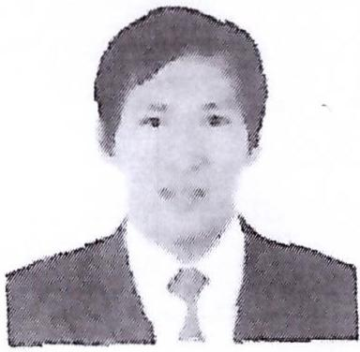
CURRICULUM VITAE

Name: Jay Ar Mangubat
Address: Abu Dhabi, United Arab Emirates
Email: jayarmangubat@jobsearchuae.com

Desired Position: Electrical Technician

To manage, oversee and ensure the safety, efficiency and integrity of the electrical systems on all projects undertaken by the Company.

CAREER OBJECTIVE

To secure a challenging and exciting career in an esteemed organization and put to use my talents and skills to the overall development of myself as an individual and more towards the society and my surroundings in a larger sense.

EDUCATIONAL QUALIFICATION
College New Era University 1999-2000
AMA Computer Learning School 1998-1999
Secondary Taal National High School 1994-1998
Primary Butong Elementary School 1988-1994

WORK EXPERIENCE

TECHNICAL SUPPIES SERVICES CO. LLC
Industrial Senior Technician
September 16, 2018 Up to present
Abu Dhabi, UAE

Duties and Responsibilities:
- Chiller Operator.
- 33kv cable pulling & termination power cable/control cable.
- Control Cable termination such as switch gear, transformer, remote terminal unit (RTU), Fiber optic box (FOB), Vacuum florescent display (VFD), and Motorized valve panel control.
- Power cable glancing and termination, main distribution board (MDB), Sub main distribution board (SMDB), Final distribution board (FDB) & Isolator etc....
- Maintaining clean and safe work area

SCHROEDER PROJEICT ELECTROMECHANIC LLC
Electrical HV/LV Foreman
October 15, 2017 to September 15, 2018
Abu Dhabi, UAE

Duties and Responsibilities:

- Maintain records on electrical jobs and assign to appropriate personnel.
- Advice coordinator and assistant director of technical problems concerned with installation, modification and repair of electrical assignments.
- Determine procedures for maintenance, installation, modification and repair of electrical assignments.
- Assist in coordinating job assignments with the other trades, e.g., plumbers, carpenters, etc.
- Support Electrical Engineers in design needs.
- Maintaining clean and safe work area

VMJ CONSTRACTION COMPANY Bldg. Electrician/ Plumber
March 19, 2016 — June 13, 2016
Madalaii Koror,Palau

- Wire pulling, terminating, commissioning (AIMELIIK POWER PLANT)
- Road contracting (NGIWAL STATE)
- Installing PVC pipe and submersible motor (AIRAI STATE)
- Installing G.I pipe for HP motor and also wiring for pump (ANGAUR STATE)
- Maintaining clean and safe work area

JOTHOUR AL-AAMAL CONT/LTD, Bldg. electrician/ Plumber
December 18, 2010 — November 17, 2014

- Laying out electrical pipe for convenience outlet ,lighting outlet, A/C supply and outdoor supply
- Installing pull box, panel box, busbar chamber, wiring of lighting outlet, air conditioning, heater and motor and electrical devices such as switches, dimmer, convenience outlet and also terminating panel box to their corresponding circuit breaker.
- Laying out of sleeve pipe for copper tube of a/c, sleeve pipe for water supply to every each of unit of bathroom
- Sanitary piping and assembling water closet, floor drain, storm drain, lavatory drain and sewer line going septic tank
- Water line piping using PPR pipe to all (bathroom) hot and cold system and returning line pipe.
- Maintaining clean and safe work area.

ATLANTIC GULF & PACIFIC COMPANY
Industrial Electrician
March 1, 2015 — September 30, 2015
Batangas, Philippines

- Preparing all need materials
- Installing &fixing cable tray
- Pulling & measuring armored wire
- Termination & commissioning
- Maintaining clean and safe work area

BATANGAS REAL ESTATE BROKERAGE CORPORATION
Building Electrician
August 1, 2005- November 30, 2010
Batangas, Philippines

PERSONAL PROFILE
Name : Jay Ar Mangubat
Date of Birth : 23-03-1981
Place of Birth : Taal Batangas, Philippines
Nationality : Filipino
Gender : Male
Marital Status : Married
Languages Known : English, Arabic and Tagalog
Religion : Iglesia ni Kristo
Passport Details
Passport No : P0831855A
Date of Issue : 02-11-2016
Date of Expiry : 01-11-2021
Place of Issue : DFA Batangas
Status of Visa : Employment Visa
Emirates ID No : 784-1981-9626962-9
Date of Expiry : 21-10-2019

I hereby certify that the above mentioned statement is correct and true to the best of my knowledge and belief.

Jay Ar Mangubat

