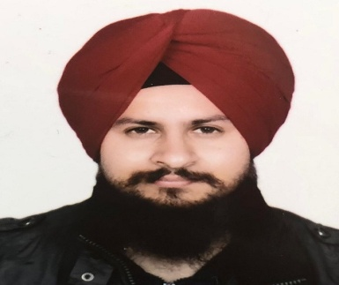RAVNEET SINGH GROVER  ravneet_grover4u@yahoo.in  ADDRESS:-03, 3025 Parliament Avenue, Regina Sk  S4S2L6.  References:  Dale Hawkins (Program Head- Auto Body technician  Saskatchewan Polytechnic, Regina) 306-775-7744  Bob Davies- Instructor (Arts & Science- Saskatchewan Polytechnic, Regina) 306-515-3671  Vekkas Bansal- former Owner (M.D at Precision Industrial Fasteners, India)  +91 98785-00193  Gurvinder Singh- Friend (Sales Associate- Walmart, Gordon Road, Regina)  306-313-2110
  +1 639-997-1430
  OBJECTIVE
  Experienced in Mechanical field in manufacturing industries, able to solve customer issues and can deal with industrial machines.
  Able to handle production and quality management.
  QuALITIES AND SKILLS
  - Being Honest, reliable, physically fit and able to work independently.
  - Having Team Work, problem solving and decision making skills.
  - Co-operating and Leadership qualities.
  - Having Good Communication & strong customer service skills.
  - Able to work effectively under pressure.
  - Knowledge of MS office and internet.
  Experience
  maintenance ENGINEER/ precision industrial fasteners, INDIA. +91-98784-00193.
  03, 2018 – 12, 2018
  - Providing training regarding the importance of cleaning, oiling and tightening (COT) of machines.
  - Implementing preventive & corrective action on major repeated breakdowns.
  - Ensuring the preventive maintenance of machines as per preventive maintenance schedule.
  - Carrying out the TPM project by coordinating with production and quality department.
  maintenance & PROD. ENGINEER/ leader steel manufacturing co, INDIA. +91-80545-58001.
  09/2013 – 02/2018
  - Ensuring the routine maintenance of machines through daily, weekly and monthly checkpoints.
  - Diagnosing faults and carrying out the repair procedures as on priority basis.
  - Carrying out automation of machines based on hydraulic, pneumatic and machine design.
  - Making of Pareto chart and their analysis.
  maintenance SUPERVISOR / NICKS (INDIA) TOOLS, INDIA. +91 161 4685000
  06/2011 – 08/2013
  - Calculating breakdown, preventive & planned maintenance cost.
  - Implementing safety & 5S procedures on shop floor.
  - Identifying kaizen and implementing on shop floor.
  - Keeping a record of critical spare parts both mechanical and electrical.
  CustOMER SERVICE/ IDEA CELLULAR, INDIA.
  02/2011 – 05/2011
  - Maintaining the stock of sim cards.
  - Dealing with customers regarding sim services.
  Education
  PRESENTLY PURSUING YEARLY AUTO BODY TECHNICIAN COURSE
  SASKATCHEWAN POLYTECHNIC
  REGINA, SK.
  ADVANCED COURSE IN CAD/CAM ( 2010- 2011)
  CENTRAL TOOL ROOM – MSME
  INDIA.
  DIPLOMA IN MECHANICAL ENGG (2007 – 2010)
  PUNJAB STATE BOARD OF TECHNICAL EDUCATION
  INDIA.
  The Diploma is equivalent to 2-Year Post Secondary Diploma as per World Education Services (WES).
  Volunteer Experience or Leadership
  Being a part of maintenance team, manufactured a hydraulic rotary indexer for multi spindle drill machine.
  Given training on 5S, safety and hydraulic system.

