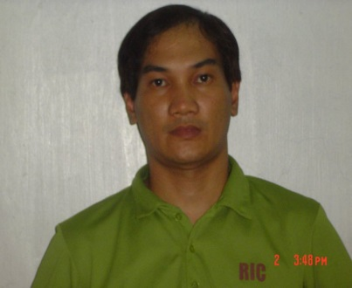
Ricardo Deocareza
222 Doctor Sixto Antonio Avenue
Pasig, Metro Manila, 1606
09674139778
ricdeocareza85@gmail.com
Summary
Electrician with commercial residentials experience focused on quality,safety,and facilities knowledge all areas, install and maintain the wiring and control equipment through which electrician flows,maintain of condition unit abnormalities,control pannels and pressure ,tank, water resevoir and motor pump.
Over 14 years of my carreer I have develop my skills set directly relevant to the maintenance technician role and I provide services based on honestly realibility and safety commitment ,seeing employment with the electrical field that enchance and develop and bringing valuable experience from large corporate constration sites as well as residential home and project electrician.
Electrician bringing solid understanding of mechanical troubleshooting and electrical installation techniques.
Education
Famous Academy, Mandaluyong, Metro Manila
Refrigerator and Aircon Technician
Graduating - March 15, 1993
Work –
Currently work as Electrician
Skills
- Repaired wiring and lighting system.
- Utilized equipment to fit faults and defects in the electrical system.
- Connect wires to circuit breakers,and other components Diagnose malfacturing systems,apparatus or components,using test equioment and hand tools to locate the cause of breackdown andcorrect the problem
- Perform other duties and responsibilities as assigned
- Install and repair buiding electrical system
- Installed and uninstalled complicated circuitry systems
- Identify and implement energy and serving solution
- Maintains currency in the installation maintenance and repair of electrical systems and equipments and national and local cores
- Knowledge of standard for electrical safety in the work place
- Fixture installation
- Filling of wire changes of flourecent ballats switches,repair walls,sink,floors connect wires to circuit breakers
- Condition of the units,abnormalities,contril pannel areas,pressured tank and motor pump,and water reservoir and motor pump
Other skill
- Professional driver
- Pasigbrotherhood volunteer fil and chineese rescue

Reference:
Architect Daniel Bonifacio
Engr. Joel Juico

