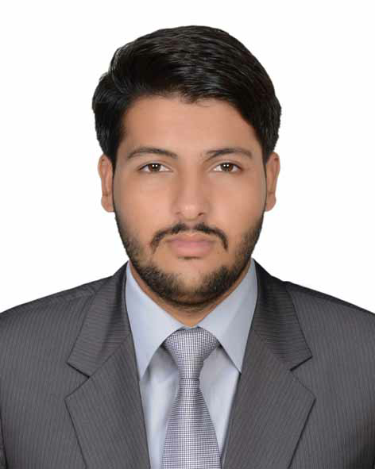
Yasir ali
Electrician with pakistan Experience
D.O.B.: 18-nov-1996
Nationality: pakistan
Location: lahorei, pakistan
Mobile: +92 3354940599
Email: aliy83615@gmail.com
Pakistasn Passport no: sr1810321

PROFILE
Yasir ali is an electric copmany with 6 years of experience as a electrician . and skills would be put in use.

OBJECTIVE
Experienced and knowledgeable electrician with more than 6 years of experience in the field seeks a position with a busy contractor or top electrical or construction firm in need of a hard worker with solid technical skills.

EDUCATION
Secondary school , lahore, pakistan,
Intermediate 2012
Computer
Basic iT+internet

LANGUAGES

Basic English – reading, writing and speaking
Urdu – Excellent reading, writing and speaking

SPECIALIZED SKILL

•
6+ years’ experience in the electrical trade
Able to work well on a team
Capable of lifting and carrying a minimum of 50 pounds without assistance
Excellent hand-eye coordination
Demonstrable knowledge and skills for electrical installation, maintenance and repair of electrical systems and equipment
Strong interpersonal communication skill.

PROFESSIONAL EXPERIENCE
electrician at shahbaz electric company lahore pakistan(2012-2018)
Currently i am working as as foreman

Responsibilities and Role details:

- Assemble, install, test, and maintain electrical wiring, equipment, appliances, apparatus, and fixtures, using hand tools and power tools.
Diagnose malfunctioning systems, apparatus, and components, using test equipment and hand tools, to locate the cause of a breakdown and correct the problem.
install, maintain, or repair electrical wiring, equipment, and fixtures.Test electrical systems and continuity of circuits in electrical wiring, equipment, and fixtures, using testing devices such as , voltmeters, Repair or replace wiring, equipment, and fixtures, using hand tools and power tools.

OTHER INTERESTS
Bike Riding, internet sufing YouTube videos, Gadgets freak

THANKS

Yasir ali

