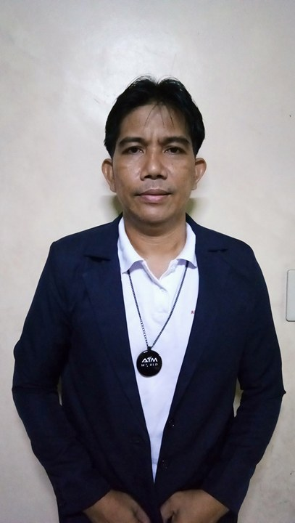
AMANDY B. ORIARTE
Blk.12 Lot 1 Brgy. San Isidro Bagong Nayon II Antipolo City
Contact no.: 09472994671/09756172682

PERSONAL DATA
Position Desired : Fiberglass Technician
Date of birth : December 16, 1972
Place of birth : Ligao City
Height : 5’7”
Weight : 64 kg.
Religion : Catholic
Civil Status : Married
Name of wife : Violeta B. Oriarte
No. of children : 5
Graduated at : Ligao National High School, Albay

SPECIAL SKILLS
Fiberglass fabricator/modifier/technician/laminator/carbon fiber
Professional Driver

EMPLOYMENT RECORD
Starbright General Merchandise – Fiberglass worker (April 15, 1991- September 1, 1994)
MMR RD C Raymundo Avenue Caniogan, 1600, Pasig City
- Production, such as: bumpers, sideskirt, rearskirt, spoilers, hood, fenders, flaring, etc.
- making corrugated sheet, flat sheet
- grinding and finishing products using grinding/ sanding machine & drilling machine
Red Line Racing - Fiberglass Fabricator/Laminator (October 19, 1994- March 18, 1996)
#14 Araneta Avenue, Corner Palanza Street, Quezon City (CLOSED)
- modification of car bodykits
- making patterns
- making molds/molding
- installation of car bodykits
- productions (making product on mold)

Kai Racing - Fiberglass Fabricator/Laminator (May 10, 1996- September 29, 1998)
Sta. Maria compound, Marcos hi-way, Santolan, 1610 Pasig City
- modification/creation of car bodykits (according to the design given by the customer)
- making molds/molding
- making products on mold
- carbon fiber (making products with carbon fiber)
- installation of car bodykits

Goldrich Car Accessories - Fiberglass Fabricator/Laminator (October 28, 1998- January 11, 2008)
170 / 172 Banawe St, Quezon City, 1113 Metro Manila
- modification/ creation of car bodykits
- making molds/molding
- making products on mold
- installations of car bodykits

Limestone Trading Car Aircon & Car Accessories - Fiberglass Fabricator/Laminator/Modifier (February 4, 2008- December 9, 2011)
126 C. Banawe Street, Tatalon, Quezon City
- making molds
- making products on mold
- carbon fiber (making products with carbon fiber)
- installation of car bodykits
P4 Bodykits - Fiberglass Fabricator/Laminator/Modifier (January 9, 2012- December 5, 2014)
21 Mindanao Avenue, Novaliches, Quezon City, 1116 Metro Manila
- modification/creation of car bodykits
- making molds/molding
- carbon fiber (making products with carbon fiber)
- installations of car bodykits

Tuned In Style - Fiberglass Technician/Modifier (January 5, 2015- November 25, 2016)
No. 953 Delmonte Avenue Quezon City, Philippines 1114
- modification/creation of car bodykits
- making molds/molding
- carbon fiber (making products with carbon fiber)
- installations of car bodykits

Glowen88 AutoHub+ - Fiberglass Fabricator/Laminator/Modifier (December 5, 2016- Present)
222 Sumulong Hwy, Antipolo, 1870 Rizal
- modification/creation of car bodykits
- making molds/molding
- carbon fiber (making products with carbon fiber)
- installations of car bodykits

CHARACTER REFERENCES
Ladislao Tan Manager/Owner Goldcars Car Accessories/Goldrich Car Accessories
John Lopez Manager/Owner Tuned in Style
Robert Chan Manager/Owner Glowen88 AutoHub+

OTHER FIBERGLASS JOBS DONE
- skylight roofing
- kiddie slide (6 meters)
- pool slide (20 meters)
- truck wind breaker, front face, panels, etc.
- tanks
- corrugated sheets
- flat sheets
- swimming pool (laminated on 4th floor)
- bathtubs
- 27 ft. half side of coke bottle stand position (fabricated in fiberglass used to advertise coke)
- Speed boat/ rescue boat with foam chemical (mold, product)
- Bus panels
FIBERGLASS MATERIALS AND CHEMICALS
- Polyester resin
- Gelcoat resin
- Flexible resin
- Styrene monomer
- Cobalt accelerator
- Catalyst or hardener
- Fiberglass/ strand mat (cm 230, cm 300, cm450, cm600)
- Carbon Fiber
- Carbon Kevlar
- Woven roving (wr600, wr800)
- Woven cloth (wcl200, wcl300)
- Designer veil fiberglass
- Texalium Fabric
- Designer cloth
- Core mat
- Toners
- Dyes
- Release wax
- Stopsag, calciumine
- Glues and adhesives
- and more…
TOOLS
- mixer
- paint brush
- laminating roller
- dispenser
- cutter disc, sanding disc, sand paper
- aluminum roller for removing bubbles
- grinder/ sander
- drilling machine
- spray gun
- air compressor
- and more…

