RESUME

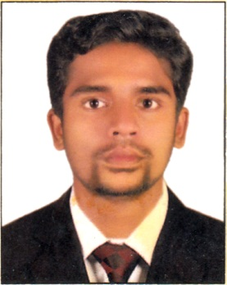

EBIN SUNNY

Present Address:
Ebin Sunny
Vettimoottil (House)
Kakkoor P.O.
Koothattukulam, Ernakulam Dist,
Kerala State, India - 686 662

Contact Details
Mob: +91 9544755198
E-mail: ebisunny97@gmail.com

Personal Data:
Date of Birth : 29/04/1992
Sex : Male
Religion : Christian
Nationality : Indian
Marital Status : Unmarried
Qualification : Plus Two

Languages Known:
English, Malayalam.

Hobbies
Driving, Collecting Information from Internet, Reading.

Passport Details
Passport No. : K1069005
Date of Issue : 16/05/2012
Date of Expiry: 15/05/2022
Place of Issue : Cochin

OBJECTIVE:
To apply my knowledge gained from my studies for the firm that I will be working with and work assiduously in a professional and progressive working environment in order to achieve personal and organizational goals.

9656881713.

ACADEMIC RECORD:

SSLC fro Govt. HSS Pampakuda (2008)
PLUS TWO Kerala State Open Schooling (2011)

COMPUTER KNOWLEDGE:

- Ms. Office
- Basic With Internet

EXPERIENCE

- Worked as Fitter and Fabricator in Al Mailam
Industries, Kuwait.
- Worked as Fitter and Fabricator in Ferin Fab,
Cochin during 2009 to 2013.

DECLARATION

I hereby declare that all information given above is true and correct to the best of my knowledge and belief.

Place:
Date : Ebin Sunny

