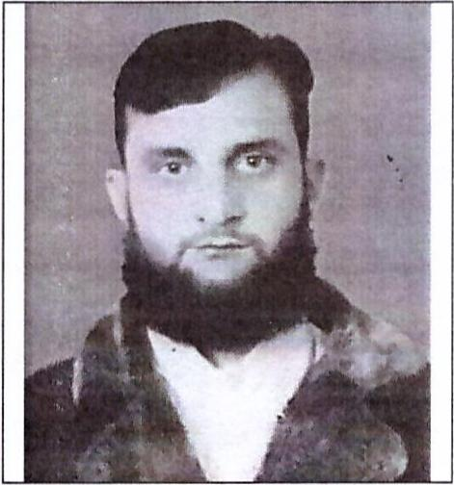
CURRICULUM VITAE
Name: Syed Mufarrikh Shah
Address: Sharjah, United Arab Emirates
Email: syedmufarrikh@jobsearchuae.com

Desired Position: Electrician

To manage, oversee and ensure the safety, efficiency and integrity of the electrical systems on all projects undertaken by the Company.

CAREER OBJECTIVE

To work in an organization in the environment of which I can enhance my skill and add values to them. Use management skill and knowledge to conceive, develop, and implement programs that significantly impact the organization I am associated with. Bringing unmatched success to the organization that I work of through maximum, possible values addition and utilization of my cognitive ability, creative through process and flair of teamwork.

Highlights Qualifications
- Good interpersonal skills.
- Discipline respect and loyalty in employment.
- Dealing with people at all task within the organization.
- Enthusiastic, competitive and highly motivated.
- Ability to work with minimal supervision.
- Works well under pressure.

EDUCATIONAL BACKGROUND
- UNIVERSITY: Sarhad University Islamabad. BS-Tech Continues Since 2013 To 2015. Safety Training (Health and Safety Special Training Course) 30 Days since 2014

- DIPLOMA: Associate Engineer. (3years Associate Engineering in Electrical)
Lahore Board, Since 2010 to 2012

- MATRIC: Federal Board Islamabad. Since 2007 & 2008
- OFFICE AUTOMATION: (6Months) - 2009 - Micro Soft Office, Window installation, Internet, Browsing, Mailing, Printing, Searching, Uploading and Downloading).
- COMPUTER TECHNICIAN: (1 Year) 2009 and 2010. Hardware Repairing, PC System, Laptop, All kinds of hardware Accessories,
WORK EXPERIENCES

- Presently working as Wiring Electrician Assistant in Dubai UAE under Drake and Scull Engineering Company LLC from 2016 to till now.

- Worked Expert in all kind of (UPS) installation, Main Electrical Control Panel (LT 11000W) Cable Wiring, Single phase and 3 phases (400mm till) Lighting Designing, Multi pack machines, Fault trouble shooting, Sealer's Machines, Promo Machines, Solar panel (System), Generator Operator, Maintenance of Generator (175KVA and 400KVA) maintenance and overhauling. 3phase induction motor's (overhauling, replacement, bearing, varnish, winding cleaning and daggering). Illumination, Inverter, Hand Jews, Drafting Table, All Kinds of Technical Parts.

Skills & Competence

Gulf Experience: (I have Continues building Electrician Experience Working as Drake & Scull Engineering LLC.
Working in: DP Dressing, DP Installation, Cable Glanding, Cable installation, PVC, GI, EMT Piping and installation, GI cable try and franking, BMS System, GRMS System GSM System ACS System, and Lighting Control System Installation, since 2017 to up to now

Instructor Electrical: (I have 3years Experiences working as KAMRA POLY TECHNICAL Collage

Kamra Attock. Since: (MAY, 17, 2013 to, Jan, 31, 2016)
Domestic Electrician: (I have7years Experiences Working as Single phase, 3phase Cable Wiring and Domestic Electric Fitting since 2010 to up to now).

Electrical Supervisor& General Technician: (I have 2years Experiences Working as EMIRATES LOGISTIC Supply Chain Services (Pvt) Ltd. During the period with Innovative Concrete, I performed in the capacity of DATA ENTRY Hard form and Soft form about all Electrical and Mechanical Installation ports. Since (FEB, 08, 2016 to DEC, 31, 2017)

PERSONAL PROFILE
Name : Syed Mufarrikh Shah
Name of Father : Shah, Syed Muzammil
Date of Birth : 10-06-1988
Place of Birth : Attock, Pakistan
Nationality : Pakistani
Gender : Male
Marital Status : Married
Languages Known : English, Punjabi and Urdu
Passport Details
Passport No : DF5141853
Date of Issue : 10-05-2016
Date of Expiry : 09-05-2021
Place of Issue : Pakistan
Status of Visa : Employment Visa
Emirates ID No : 784-1988-5948535-5
Date of Expiry : 20-01-2020

I hereby and certify that the above mentioned is true and correct to the best of my knowledge and belief.

Syed Mufarrikh Shah

