John McGougan Feb 28, 2019
250-801-8207
johnmcgougan@yahoo.ca

Red Seal Recruiting
612 Boleskine Road
Victoria, BC V8Z 1E8

Re: Building Manager
Building manager/ Maintenance Manager for the past 10 years in Condominiums and rental building. My mechanical background, logical approach, and extensive building experience allows me to develop cost efficient prioritized remedies to building problems.
Skills and Experience I bring to this position are:
- Above average computer skills.
- Mechanical experience including HVAC generators and garden equipment.
- Meticulous to maintain records and information to operate a successful building
- Develop prioritized schedules for whole building safety maintenance and upgrading.
- Can establish and maintain excellent client relations using an approach that is fair and consistent.
- Plumbing and electrical experience.
- Drywall and painting experience.
- Extensive landscape and irrigation knowledge.
- Very aware of the need to work within the guidelines and bylaws set out by the Bylaws, Strata Council and Strata Property Manager.
- Experience in dealing with client problems and disputes in a timely fashion to prevent escalation.
- Familiar with Strata Property Act, Work Safe BC, OHS. and Whims regulations.
- Immediate reply and action to all communications.

Please find attached my Resume and Letter of Reference for the position of Building Manager
As the condition and appearance of the common areas reflects directly on the value of each of the units, I strive to have the properties always operating and showing at their best.

I am looking forward to discussing this position with you soon. Enclosing a recent letter of reference letter.

Yours truly
John McGougan
250-801-8207
johnmcgougan@yahoo.ca

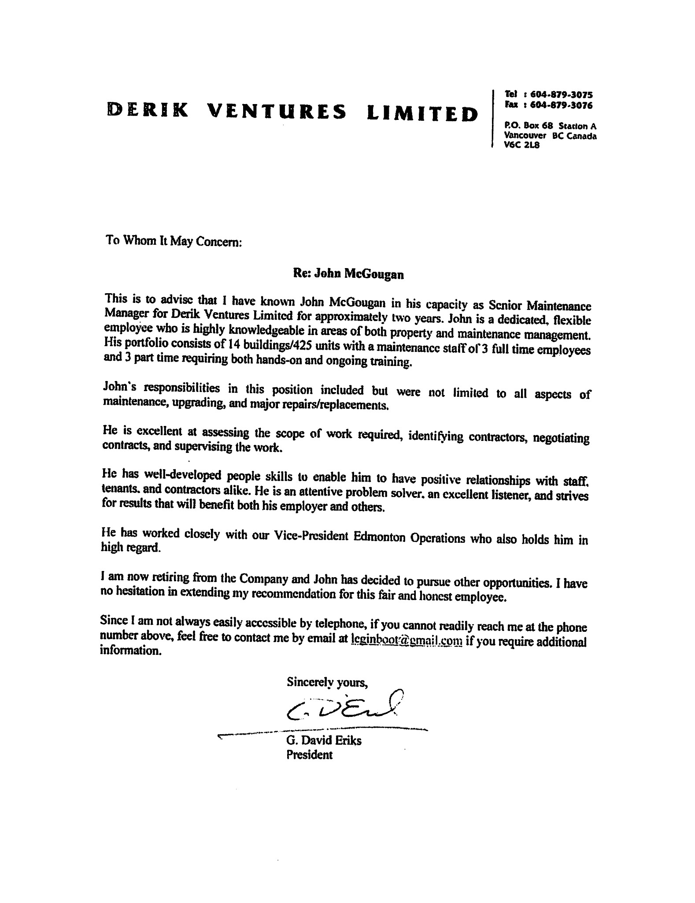
John McGougan
250-801-8207
johnmcgougan@yahoo.ca

OBJECTIVES
To obtain employment as Building Manager
SKILLS
- Experience in all areas of apartment hotel and condominium maintenance.
- Coordinating, organizing, and communicating.
- Troubleshooting and critical thinking skills.
- Committed, innovative, adaptable, motivated, and honest.
- Work well independently or in a team.
- An effective management style that includes leading by example.

EXPERIENCE
Private Contracts 2016 to present
Renovating homes and landscaping

Senior Maintenance Manager Jan. 2014 to 2016
Derik Ventures Limited
- Responsible for all aspects of maintenance, building upgrading and maintenance staff.
- Training Resident Managers and staff in proper procedures for, building cleaning proper building grounds maintenance,
- Budgeting annual expenditures for building upgrades, maintenance, and staffing.
- Major upgrades which include assessing the scope of work required, identifying contractors, negotiating contracts, and supervising the work.
- Tenant education and relations concerning maintenance issues.

Maintenance Technician 2012-2013
Larlyn Property Management and Tudor Manor
Residential Maintenance Services
- Drywall repair, painting, window and door repair, diagnosing problems and estimating cost of repairs.
- Electrical, plumbing and heating system repairs.
- General maintenance and contractor supervision.
- Monitoring all mechanical equipment.

John McGougan
250-801-8207
johnmcgougan@yahoo.ca

RESIDENT MANAGER (couple’s live-in position)
Gateway Property Management/Odyssey Towers (3) Calgary, AB 2009-2011
The Pavilions at Rocky Ridge Calgary AB (two condominium complexes 175 units)
- General repairs to plumbing fixture replacement and upgrading.
- Electrical repairs (switches, plugs, ballasts, breakers) and bulb replacement program.
- Gardening, flower planting, watering, feeding and general upkeep.
- Manage third party contractor/supplier repairs, maintenance, and other projects as required.
- Inspect, maintain, and clean common areas daily.
- Daily inspection of all HVAC systems and record data.
- Maintain all common areas, including drywall repairs, painting, moulding and trim replacement, carpet and tile replacement.
- Inspect, test and repair emergency lights, smoke detectors, CO detectors, and fire alarms.

LICENSED REALTOR 2002 - 2009
Coldwell Banker Panda Realty West Edmonton, AB 2002 - 2008
Re/Max Central Edmonton, AB
- Listed, leased and sold residential and commercial properties.

HOTEL MAINTENANCE
Coast Capri Hotel Kelowna, BC (185 Rooms) 1995 – 2000
Green Gables Inn Victoria BC (56 Rooms)
- General maintenance and room upgrading.
- Physical plant operation including swimming pool and hot tub maintenance.
- General painting and refinishing.

CONSTRUCTI0N, RENOVATIONS AND LANDSCAPING
Highlander Services Kelowna/Victoria BC 1994 - 2002
- Plumbing and Electrical maintenance, repairs, and fixture replacement.
- Painting and Drywall installation and repairs.
- Layout, planting, and maintenance of soil and water gardens, pruning, landscaping, and shrubbery restoration.
- Extensive landscaping including plantings, irrigation, retaining walls, water gardens and maintenance.

REFERENCES:

Derik Ventures Limited letter attached.

