Robert Wright
Heavy Duty Mechanic
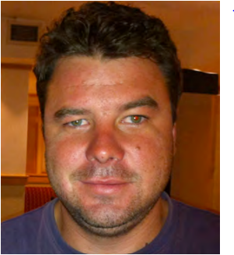

Contact details

20 Helderberg Unit 2
Elandsrand
Brits
South Africa
0250
Cell +27 279 888 7934
roblenwright@gmail.com

Profile
Heavy Duty Mechanic with 7 Years experience. With one year (Senior) Maintenance Planning and 4 Years Apprentice Experience at Liebherr Afrika. Have experience on various machines. Like new challenges and love to learn new machines and got knowledge in various departments.

Education and Qualifications

Sundra High School
Grade 12 (2006)

Merseta Training as Earthmoving equipment mechanic

Eartmoving equipment mechanic Certificate (Red Seal)

Machine Specific Experience

Mining Shovels | 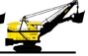
Overburden Drills  - Atlas Copco D65; T45 Smart Rock(Tier 3)  - Sandvik DK25S | 
Underground Mining Equipment: Drill Rigs, Roof bolters, Continues Miners | 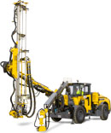
Excavators  - Liebherr R994; R9400: R9350: R9250; R9150; R984: R974; R964  - Kumatsu PC800; PC600; PC400 |   
Haul Trucks (off High Way)  Caterpillar 785; 777; 773  - Terex TR100  - Volvo A40 A45  - Bell 35 | 
Graders  - Caterpillar 140H; 160H; 24H | 
Loaders  - Caterpillar 950; 992 | 
TLB  - Case  - JCB | 
Tamping Roller | 
Dump Trucks and Articulated Dump Trucks  - Volvo  - Bell  - Terex | 
Bulldozer  - Caterpillar D9T; D10T;D11R | 
Various Trucks
- Toyota Dyna
- Western star
- Mercedes
LDV’s
- Toyota

Tractors
- Ford 4 cylinder & 6 cylinder, 2x4 & 4x4

Compressors  - Atlas copco | 
Cranes, Forklifts and telehandlers  - Caterpillar  - New Holland | 
Mobile cranes

- Liebherr 1060, 1130

Agriculture Equipment

- Ford
- Fiat

Experience

Work Experience

Tharisa Minerals (3420 HRS)
September 2017- Current
Marikana South Africa
Heavy Duty Mechanic and Maintenance Planner (Open Pit)

Name Jacques Julius
Cell phone +27 061 516 4307
E-mail address jjulius@tharisa.com
Title of reference Shift Foreman

Heavy Duty Mechanic Duties
- Maintain and repair
- Fault finding
- Mechanical and Electrical
- Daily service
- Service
- Preventative Maintenance
- PM scheduling
- Long and short term planning
- Maintain AMT(Asset Management System)
- Oil analysis
- Failure reports
- OEM upgrades planning
- Order spares and service kits
- Maintain OEM standards

Mcc Group (13680 HR)
January 2011-September 2017
Midrand South Africa
Heavy Duty Mechanic and Maintenance Planner (Open Pit)

Name Johan Louw
Cell phone +27 072 420 6426
E-mail address
Title of reference Maintenance Superintendent

Heavy Duty Mechanic Duties
- Maintain and repair
- Fault finding
- Mechanical and Electrical
- Daily service
- Service
- Preventative Maintenance
- PM scheduling
- Long and short term planning
- Maintain AMT(Asset Management System)
- Order spares and service kits
- Maintain OEM standards

Liebherr-Africa (9120 HRS)
January 2006- October 2010
Brakpan South Africa
Heavy Duty Mechanic Apprentice (Open Pit)

Name Jaco Myburgh
Cell phone +27 082 561 9596
E-mail address
Title of reference Maintenance Forman

Heavy Duty Mechanic Duties
- Maintain OEM Standards
- Fault finding
- Mechanical duties
- Mobile cranes
- Excavators
- Dozers
- Loaders
- Rebuilds on excavators
- Service

My family

Married


