
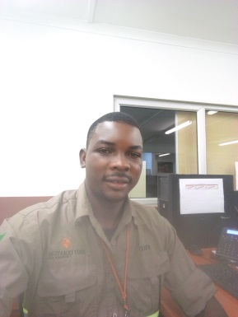 Fred lukwesa

House No. 204/4n kantanshi Mufulira

Mobile: +260964851241 E-mail: lukwesafred@gmail.com

Personal Profile

An experienced mining and engineering person in mobile machine maintenance, machine rebuilds, planning, administration, project management and acid plant maintenance.

Skills and Attributes

- A versatile, analytical and hardworking man with practical hands on approach who always preserves to achieve the best results.
- Ability to multi-task and work well under pressure.
- Good verbal and written communication skills.
- Able to read and understand maintenance manuals.
- Initiative and ability to take responsibility make decisions and achieve good results shown in current work.

Education and Qualifications

Heavy Equipment Repair Certificate 2009 to 2010, Mufulira Technical Treainning Institute under the Technical Education Vocation and Enterpreneurship Training Authority (TEVETA)
Bachelor of Arts in Project Management, Currently studying with Information Communication University.
Teaching Methodology Diploma, Currently studying with Unified Learn.
Member of the Engineering council of Zambia.
Work Experience

First Quantum Minerals 2017 to date.
Currently working as a Maintenance planner.
Key Responsibilities:
- To produce details and comprehensive plans /schedules of work orders for planned routine and follow maintenance strategy and plan in support of the goals and objectives.
- Ensure that all maintenance parts and materials meet required plan.
- Manage all aspects of operational rotable componets and associate documents.
- Obtain parts description, quotes and complete ANSI for all new spares.
- Arrange collection and delivery of service parts.
- Maintain close contact with procurement expediting in order to ensure earliest cost-effective delivery to site.
LIEBHERR ZAMBIA 2016 – 2016
Worked as a Heavy Equipment Repair Technician on assembling of T284 Dump trucks while providing a high level of customer support and after sale service and kept up to date with the latest technology in mobile equipment.
HITACHI CONSTRUCTION MACHINERY LUMWANA AND KANSANSHI MINE 2013 - 2015
Experience on Hitachi Excavator 5500-6, Hitachi Excavator 5500-5, Hitachi Euclid Dump Truck 4500, and Hitachi Euclid Dump Truck3500-2.Duties entailed of Rebuild of the trucks, maintenance, servicing, repairing and attending to breakdowns.
HYSPEC MINING SERVICES LUMWANA 2012 TO 2013
worked as a Hose Technician/ Auto-lube Technician. Duties entailed of servicing fuel pumps, water pumps, Hydraulic pumps at the Fuel bay. Installation of Auto-lube system on Earth moving machines. Making of hydraulic Hoses and identification of hydraulic fittings to satisfy customer’s needs.
RICKMAT UNDER MOPANI COPPER MINES MUFULIRA MINE SITE 2011-2012
Worked as a Maintenance Technician at the Acid Plant. Duties entailed of maintenance of the Acid plant, servicing of pumps, repairing of drive units, maintenance of mobile cranes, General plant maintenance.
Skills

Technical: Welding and Cutting, Splicing of steel wires, ability to interpret circuit diagrams be it hydraulic or electrical, advanced hydraulic system, Machine Operating

Interpersonal: Microsoft Office, pronto and Project Management.
Other: Driving
Hobbies and Interests

Learning new things, Reading and Travelling

Referees

Joe Mumbi Leonard Mulenga
Human Resources Officer, Hitachi Superintendent Training, Barrick Gold
Mobile: +260 966 735 840 Phone: +260 96615381
Email: joem@hcamf.com Email: mulengaleonard@gmail.com

