Dear Sir/Madam

Greetings!

I have the honor to apply as Marine Electrician in your company as published on your website. I am Christopher H Martinez, 42 years old of age, married from Mangaldan, Pangasinan, Philippines. I am Honorable Discharged Philippine Navy Personnel, position Electrician and presently working at Saudi Royal Naval Forces Ship Repair Facility (SRF) Drydock, as position Marine Electrician from October 2016 to 25 Sept 2018.
Furthermore, I am signifying my interest to join and serve your prestigious company and I hereby assure you of my noble intention and my commitment to work hard.
Listed below are my credentials for your ready reference.
Thanking you in anticipation for giving ample time to read my resume.

CHRISTOPHER H MARTINEZ 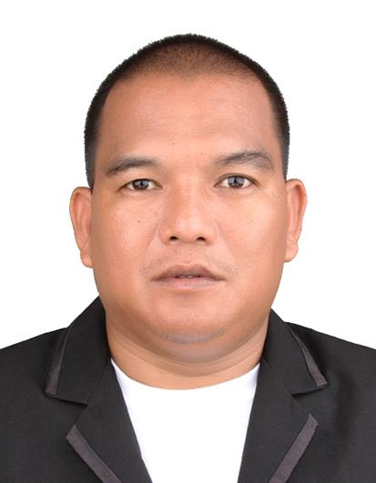 E-mail christhreekids@gmail.com
Mobile : +1 (599) 3214776

OBJECTIVE:
To obtain a job position relevant to my qualification and work experience.

PERSONAL PROFILE:

Home address : Philippines
Present Address : 4443 North Archie Ave.,Fresno, California, USA
Date of Birth : 11 December 1975
Place of Birth : San Fernando, La Union, Philippines
Age : 42 year old
Civil Status : Married
Nationality : Filipino
Language or dialects spoken : English, Tagalog
Religion : Roman Catholic
Certification / Licensed : Registered Master Electrician

EDUCATIONAL BACKGROUND:

Colleges Level : Pangasinan Merchant Marine Academy Address : Perez Blvd, Dagupan City, Philippines Year Graduated : Jun 1993 to Mar 1996
Courses : Associate in Marine Engineering

Secondary Education : Mangaldan National High School
Pangasinan, Philippines
Year Graduated : March 1993

ELEMENTARY : Talogtog Elementary School
Pangasinan, Philippines
Year Graduated : March 1989

PROFESSIONAL EXPERIENCES:
Employer: Saudi Royal Naval Forces
Position: Marine Electrician
Date: 15 October 2016 to 25 Sept 2018
Address: Ship Repair Facility Dry Dock, Saudi Royal Naval Force, Jeddah, KSA

Job Description:

  - To perform working with knowledge and experienced in operation, maintenance, repair and installation of fire alarm, safety sensor, generators, motor controllers, battery charger, gyro, synchro motors, switchboard and electronic module controller and others electrical equipment.
  - To perform working according to blueprints, technical manuals, job orders and makes condition report and keeps records of all service to be done.
  - To perform working electrical and electronics in difficult assignments such as emergency and rescue situation, additional working time and days.
  - To perform troubleshoot and testing of using special tools, multi-tester, clamp meter, megger test in continuity, Low-High voltages AC/DC, amperes, hertz, vibration and alignment of rotation in single / three phase motors.
  - “Safety First” in wearing the uniform, using power tools, working in the hazard area, Lock-out / Tag-out procedure.
  - To develop Risk Management and continuous improvement in decision making, accurate and complete proposal.
  - To participate and cooperate in shipbuilder support to resolve technical issues.

Military Career Experience

Unit: PS-22 Patrol Force Philippine Fleet Philippine Navy
Position: Chief Electrician / Petty Officer Third Class (shipboard)
Date: September 2000 up to 2011
Employer: Philippine Navy
Address: San Felipe, Cavite City, Philippines

Unit: United Nation Contingent
Position: Electrician / Security (Field Technician)
Date: 24 September 2011 up to 19 March 2012
Employer: United Nation
Address: 15 Otubre Blvd., Tabarre, Port-Au-Prince, Haiti

Unit: Public Engineering Unit
Position: Electrician, Lineman, Driver ( Water Plant, Power Plant)
Date: February 2013 to May 2015
Employer: Philippine Navy
Address: NETC, San Antonio, Zambales, Philippines

SPECIAL SKILLS:

- Electrician

- Computer Literate

SEMINARS/TRAINING

Registered Master Electrician - Licensed
Republic of the Philippines
Professional Regulation Commission
Manila, Philippines
16th September 2015

Basic Training/ Safety of Life At Sea - Certificate
Far East Maritime Foundation, San Fabian,
Pangasinan. Philippines
28th August 2014

Basic Training/ Watchkeeping - Certificate
Far East Maritime Foundation, San Fabian,
Pangasinan, Philippines
23rd December 2014

Electrician’ Mate Specialization Course - Certificate
Naval Education Training Command, San Antonio,
Zambales, Philippines
16th December 2005

Basic Leadership Course - Certificate
Naval Education Training Command, San Antonio,
Zambales, Philippines
Janaury 2013

References:

I hereby certify that the above information are true and correct to the best of my belief.

Christopher H Martinez
Applicant

