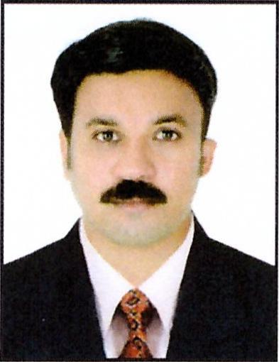
CURRICULUM VITAE

Name: Ratheesh Maliyakkalkattady George
Address: Dubai, United Arab Emirates
Email: ratheeshmaliyakkalkattady@jobsearchuae.com

Desired Position: Electrician

To manage, oversee and ensure the safety, efficiency and integrity of the electrical systems on all projects undertaken by the Company.

Career Objective

Willing to work in a dynamic, Challenging and growth — oriented company that allows me to utilize my knowledge and experience to contribute for the growth of the organization.

Personal Strength & Skills

- Ability to work under pressure while maintaining accuracy. Excellent verbal and written communications skills (English). Excellent customer handling and diplomacy skills.
- Personal accountability & commitment to achieve.

Work Experience
- Presently Working as an "IT TECHNICIAN/CUSTOMER SERVICE" in” ELINT INFOTECH-DMCC CO. L.L.C" Dubai (UAE) since 04-10-2018 to till now.
- 02 Years Working Experience as an "ELECTRICIAN" with "QUALITY INTERNATIONAL Co. Ltd.FZE." Sharjah, (UAE)
- 02 Years Working Experience as an "ELECTRICIAN" with "AL ANWAR ELECTRICAL CO.LTD." Sharjah, UA.E.
- 02 Years’ Experience as an "ELECTRICIAN" with "AL KHALEEJ MODERN LIGHTS" Doha, Qatar.
- 02 Years Working Experience as a "ELECTRICIAN" with "THREESOME PAPER CONVERSION INDUSTRIES CO" Kerala, India.

Academic Qualification
- S.S.L.C
- ITI (Electrician

TRAINING
- 0.K Institute of Engineering Technology (Electrician)
- IIB Technician (Digital Security Surveillance)
- IIB Optical Fiber Technician

PERSONAL PROFILE
Name : Ratheesh Maliyakkalkattady George
Name of Father : Maliyakkalkattady Ouseph George
Name of Mother : Omana George
Date of Birth : 24-02-1983
Nationality : Nepali
Place of Birth : Kerala
Gender : Male
Marital Status : Married
Religion : Christian
Languages Known : ENGLISH, HINDI, and MALAYALAM & TAMIL
Passport Details
Passport No : L8367870
Date of Issue : 31-03-2014
Date of Expiry : 30-03-2024
Place of Issue : Cochin, Kerala
Status of Visa : Employment Visa
Emirates ID No : 784-1983-4835329-7
Date of Expiry : 03-10-2021

I hereby certify that the above mentioned statement is correct and true to the best of my knowledge and belief.

Ratheesh Maliyakkalkattady George

