

PERSONAL INFORMATION MUHAMMAD FARHAAD

 7155 Abaas al maliki street al mirqab district city center, 35514 Al Jubail (Saudi Arabia)  +966581014852
 farhaad.fmechtech@gmail.com Skype farhadf11267
Sex Male | Date of birth 14/01/1995 | Nationality Pakistani

JOB APPLIED FOR Plant/Industrial Mechanic Millwright / Field Service Technician / Mechanical Maintenance Technician / Plant Technician

WORK EXPERIENCE

01/02/2015–01/02/2016 Industrial Mechanic Millwright

Infinity Engineering (Pvt) Ltd
13-KM Shekhupura Road, 54000 Lahore (Pakistan) www.infinityengg.com
- Assembling and installing new machinery.
- Being the first point of contact with management when equipment goes down.
- Follows all Safety protocol
- Ability to calculate lay-out and draw; balance and align equipment
- Perform Maintenance on: lubricating systems, agitators/mixers, blowers, compressors, fans, pumps, conveyors, feeders, elevators, bearings, seals, gearboxes, dissolves, filters, collectors, screens and other heavy equipment
- Perform rigging activities, safety-related functions and other miscellaneous maintenance functions
- Demonstrate safe and proficient use of shop tools (both hand and power)
- Ability to utilize or fabricate parts needed from cold rolled steel, stainless steel, steel plate, structural steel members, other metals, plastics, fittings, valves and all types of mechanical parts
- Ability to use of oxyacetylene torch work and welding
- Must demonstrate ability to safely utilize a forklift and high lift
- Laser alignment and vibration monitoring knowledge if required
- Physically capable of performing heavy mechanical work
- Knowledge of predictive/preventive maintenance and pipe fitting
- Perform installation and maintenance work as part of a team of skilled trades workers
- Self-starter, able to receive orders as directed
- Other duties as assigned
- Reading blueprints and schematic drawings to understand how machinery should be assembled.
- Attaching new parts to the basic unit of a piece of equipment.
- Makes accurate measurements to align and fit machine parts together; uses hand tools, squares, rules, and other equipment for several tasks.
- Operates equipment, such as grinders, to modify machine parts for use in equipment.
- Tests equipment to make sure it is working properly.
- Takes machinery apart for replacement or repair and then adjusts, oils, fixes, and replaces machinery parts.
- Troubleshoots problems with equipment and adjusts as necessary.
- Constructs parts or orders replacement parts and installs them.

Business or sector Automobile 20/04/2016–17/09/2017 Industrial Mechanic

Sadara Chemical Company (Contractor Corporation Nayef Mohammed Basheri Contracting)
Jubail 2, 35514 Jubail Industrial City 2 (Saudi Arabia) www.sadara.com
- Read blueprints and layouts.
- Level and align pump-motor.
- Level and align equipment such as compressors, turbines, and centrifuge, conduct pump repair and maintenance.
- Set impeller clearance on pumps.
- Set fan blades.
- Alignment of motor to gearbox.
- Measurement of precision fit.
- Monitoring the condition of rotating machinery utilizing parameters including vibration, temperature, pressures, flows, and currents.
- Taking field vibration readings, and understanding basic data.
- Understanding and assessing the daily operation of various types of equipment including centrifuges, reciprocating and centrifugal compressors, conveyors, screw feeders, mills, conveyors, crushers, blowers and pumps.
- Providing recommendations to improve reliability, based on assessment.
- Maintaining equipment to design specifications including, but not limited to, centrifugal pumps, reciprocating pumps & compressors, fans, gear reducers/increasers & other mechanical equipment (valves, operators, testing tools).
- Replacing pump seals, mechanical seals, pump packing.
- Providing proper alignment for all rotating equipment.
- Performing preventative/predictive maintenance and troubleshooting problems.
- Determining material needs, sequence of operations, and job methods including the use of a computer for storing and using information for preventive/predictive maintenance.
- Maintaining familiarity with warehouse parts management, design specifications, and applicable maintenance procedures.
- Keeping maintenance records.
- Instructing apprentices.
- Reading blueprints, sachems, and drawings.

Business or sector Petrochemical, Oil & Gas

25/09/2017–28/08/2018 Plant/Industrial Mechanic

Saudi Iron & Steel Company (Contractor Corporation Naeyf Mohammed Basheri Contracting)
Jubail 1, 35514 Jubail Industrial City (Saudi Arabia) www.sabic.com
- Repair, modify, and overhaul all mechanical equipment including: pneumatic, hydraulic machine tools, gear driven, and equipment.
- Correct malfunctions in hydraulic, vacuum and compressed air systems and adjust general controls and regulators.
- Installs and commissions of new equipment.
- Read and interpret diagrams and blue prints.
- Maintain plant PM procedures.
- Coordinate with other trades to minimize interruption and down time on equipment.

- Read blueprints, diagrams and schematic drawings to determine work procedures.
- Install, troubleshoot and maintain power transmission, vacuum, hydraulic and pneumatic systems.
- Inspect and examine machinery and equipment to detect and investigate irregularities and malfunctions
- Adjust machinery and repair or replace defective parts
- Operate machine tools such as lathes and mill machines to fabricate parts required during overhaul, maintenance or set-up of machinery
- Assemble machinery and equipment prior to installation using hand and power tools and welding equipment.
- Troubleshooting/repairs/installations of processing equipment with a working knowledge of electrical to allow efficient repair/replacement results.
- Extensive mechanical knowledge including power transmission, pneumatics and hydraulics.
- Optimize equipment safety, efficiency and reliability, participating in continuous improvement projects and completing work orders according to PM schedules.
- Comply with all applicable legislative and Bakery food safety, health and safety and environmental policies and procedures.
- Service, clean and perform preventative maintenance and overhaul on all production and bakery equipment.
- Continually improve equipment function via design improvements.
- Ensure that work area is clean of debris and hazards at all times and check work area for such hazards upon arrival and when departing each area of work.
- Work in a safe manner in accordance with legislated and company health and safety standards.
- Perform other related duties as assigned or required.

Business or sector Iron & Steel

07/08/2018–Present Plant/Industrial Mechanic

Saudi Aramco/Hyundai Arabia Llc (Contractor Corporation Naeyf Mohammed Basheri Corporation)
Jazan Refinery Terminal Al Baish, 84877 Jazan Ecnomic City (Saudi Arabia) www.saudiaramco.com
- Maintain cleanliness and general appearance of facilities and surrounding work area as needed.
- Perform routine checks and low complexity mechanical tasks.
- Perform basic maintenance such as inspect and replace belts, inspect and/or grease couplings, cleaning and preparing parts, oil changes, etc.
- Operate hoisting equipment. Check parts, special tooling and lifting equipment are available.
- Provide support and assistance to technicians as required. Perform routine maintenance on HVAC, air compressors, boilers, air dryers, dehydration systems.
- Perform routine maintenance on steam turbines, reciprocating engines, and associated auxiliary equipment (pumps and motors).
- Operate basic electronic test equipment.
- Perform low complexity PM and corrective tasks as assigned.
- Describe station philosophy and operational sequencing.
- Start, stop and operate drivers.
- Identify faulty mechanical equipment and bring to attention of senior personnel.
- Troubleshoot, test, & maintain auxiliary and HVAC systems.
- Monitor trend data, (vibration, pressure, temperature), and take appropriate action.
- Read and interpret drawings & schematics.
- Perform major maintenance on steam turbines, reciprocating engines, and associated auxiliary equipment.
- Respond to emergency situations.

- Perform medium complexity PM and corrective tasks.
- Repair and rebuild pumps, gear boxes and mixers. Laser alignment of pumps and motors.
- Perform readings with vibration monitoring equipment.
- Function as lead on local projects/outages.
- Perform installation, commissioning/decommissioning, testing, troubleshooting, repair, and mechanical maintenance on power plant equipment.
- Schedule, coordinate and inspect the work of third party contractors.
- Maintain records for required regulatory, and company procedures.
- Perform high complexity PM and corrective tasks (e.g. boroscope tests).
- Operate specialized mechanical equipment such as lathes, presses, etc. Commission and decommission large pumps and motors. Perform complex hoisting and rigging activities. Perform QA on manufactured components.
- Identify when modifications, upgrades and adjustments to maintenance cycles are required.
- Complete reports based on trend data analysis.

Business or sector Oil & Gas

EDUCATION AND TRAINING

02/08/2011–15/02/2015 Diploma of Associate Engineer (Mechanical Technology 3 Year) EQF level 4

Lahore Polytechnic Institute Ravi Road Lahore
Manzoor Trade Center 37-Main Ravi Road Lahore, 54000 Lahore (Pakistan) www.lgtc.edu.pk
- Mathematics ▪ Applied Physics and Mechanics ▪ Applied Chemistry ▪ Computer Application ▪ Engineering Drawing and CAD ▪ Industrial Safety and Procedure ▪ Workshop Practice (Metal and Fabrication, Wood Carpentry, Welding, Machining, Forging, Casting and Foundry ▪ Business Communication ▪ Metrology ▪ Applied Electricity and Electronics ▪ Metallurgy ▪ Business Management and Industrial Economics ▪ Applied Thermodynamics ▪ Machine Design and Analysic ▪ Tool and Mould Design ▪ Metrical Testing and Heattreatment ▪ Industrial Manegment and Human Realation ▪ Hydraulics and Flued Machine ▪ Industrial Planning and Production Method ▪ CAD/CAM ▪ CNC Machine

PERSONAL SKILLS

Mother tongue(s) Urdu

Foreign language(s)
UNDERSTANDING |  | SPEAKING |  | WRITING
Listening | Reading | Spoken interaction | Spoken production

English B1 B1 B1 B1 B1
International English Language Test System

Levels: A1 and A2: Basic user - B1 and B2: Independent user - C1 and C2: Proficient user Common European Framework of Reference for Languages

Organisational / managerial skills ▪ Team Leader / Shift Operator / Engineer Assistant / Vice Supervisor / Work Area Coordinator

Job-related skills ▪ Rotating equipment such as Pump, Compressor, Gear Box, Gas/Steam Turbine, Convyer, Centrifeuge, IC Engine, Motor, Agetator, Fin Fan and Blower Installing, Moving, Modification, Dismentelling, Replacing, Overhualing, Breakdown Maintenance, Preventive and Corrective Maintenane, Commisioning and De Commisiong, Maintain and Run.
- Shaft Alignment (Revers Dial, Cross Revers Dial, Laser Alignment) Horizontal and Vertical.
- Shaft Coupling.
- Bearing Maintenance, Installing and Removing.

- Mechanical Seal Maintenance, Installing and Removing.
- High Pressur Pipe fittings such as Flange, Spool, Elbow, Blind, Gaskets, Tee Joint, Y Joint, Reducer, Uniuon and other fittings Installing, Replacing, Removing, Modify.
- High Pressure Valve such as Gate, Globe, Ball, Butterfly, Needle, Diaphrame, Check, and Puppet Valve Installing, Repaire, Removing.
- Bolt Torcuqing, Tighting, Tenshioning.
- Isometric, Blue print, P&ID, Orthographics View, Assembly Drwaing, Schematice Drwaing Reading.
- Rigging & Lifting.
- Over Head Crane Operating.
- Welding & Fabrication.
- Grinding, Cutting, Polishing, Buffing.
- Drilling.
- Hydrolics & Pnumatics System Maintenance.
- Valve Operating.
- Equipment Box-Up.
- Equipment Lubrication & Greacing.
- Shrink Fitting.
- Matrice & Imperial System.
- Metirial Loading & Handling.
- Visual Inpection, Test, Check, Examine.
- Equipment Run Test.
- Piping Isolation, Lock out/Tag out.
- Belt/Chain/Pully Alignment.
- Convyer Alignment.
- Mechanical System Maintenance as per Manufacture Manual and Procedure.
- Heavy Assembly and Dis Assembly of Equipment.
- Understant working Situation and Solving Problem.
- Detect Machine Problem.

Digital skills SELF-ASSESSMENT

Information processing | Communication | Content creation | Safety | Problem solving
Proficient user | Proficient user | Basic user | Proficient user | Proficient user
Digital skills - Self-assessment grid

- Microsoft Office
- Microsoft Window
- Computer Network, Software, Hardware
- Gmail
- Autodesk Auto CAD

ADDITIONAL INFORMATION

Sponsorship Temporary Work Permit / Visa Request
I want Canadian Sponsorship Work Permit.



European skills passport
MUHAMMAD FARHAAD

Table of contents


Name of attachment Page

Mechanical Engineering Diploma.jpg 2 High School Certificate.jpg 3 College Certificate.jpg 4 IELTS test report.jpg 5 Sadara ID.jpg 6 SADARA CERTIFICATE.jpg 7
Saudi Aramco Id.jpg 8 SABIC HADEED ID.jpg 9
Profile 2-min.jpg 10 Profile pic 1-min.jpg 11


Mechanical Engineering Diploma.jpg
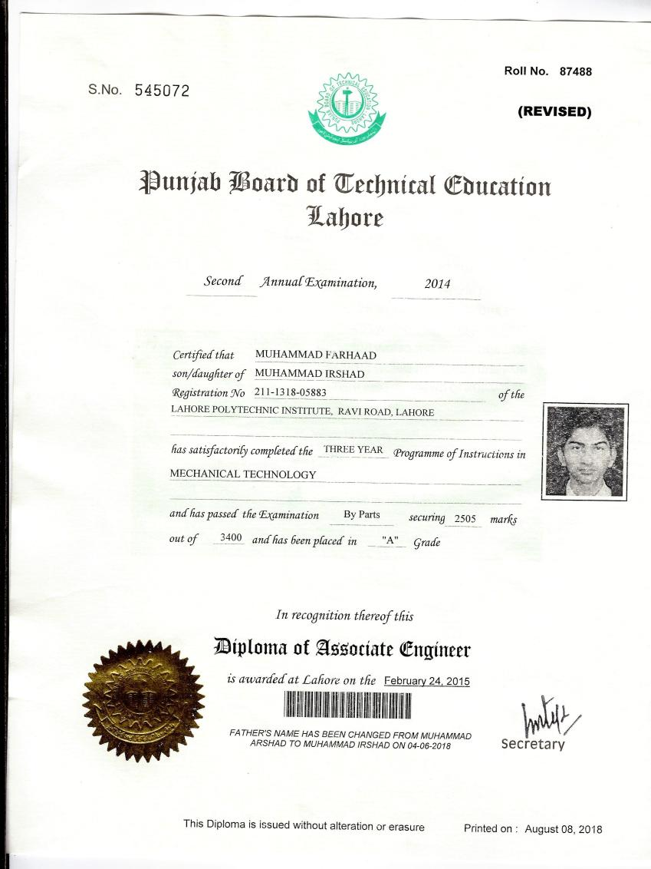


High School Certificate.jpg
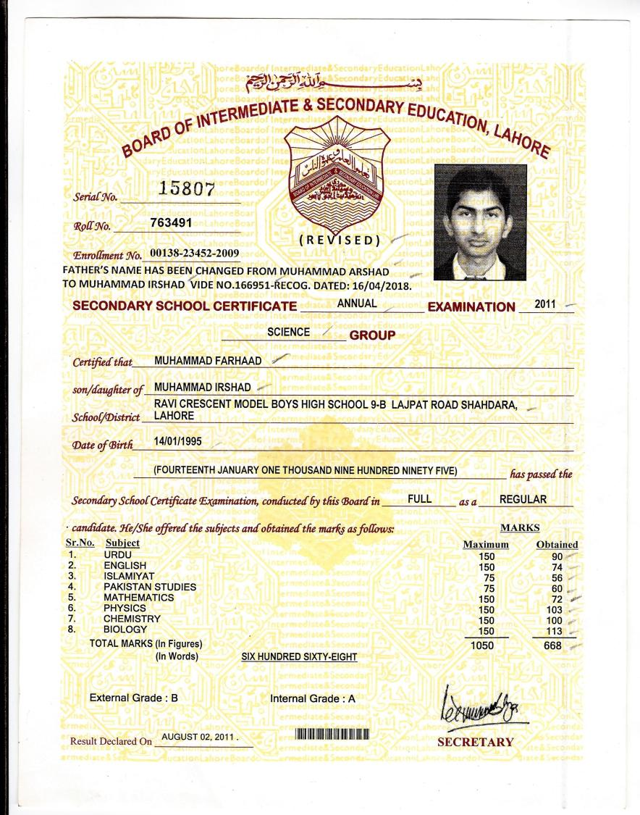


College Certificate.jpg
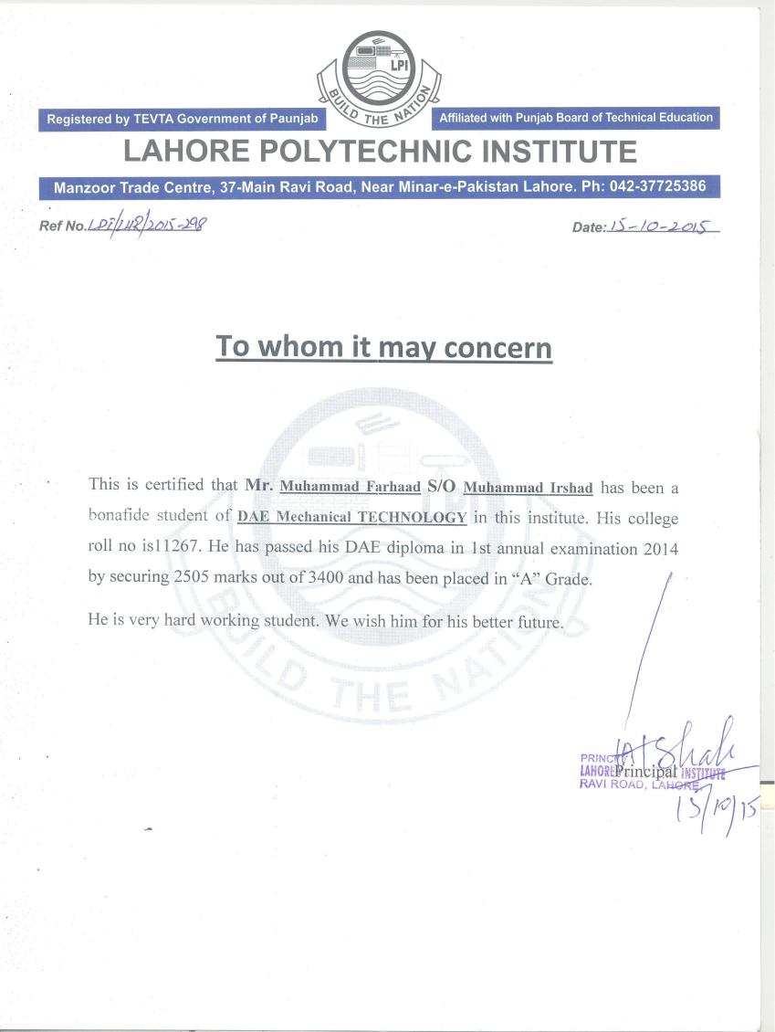

IELTS test report.jpg
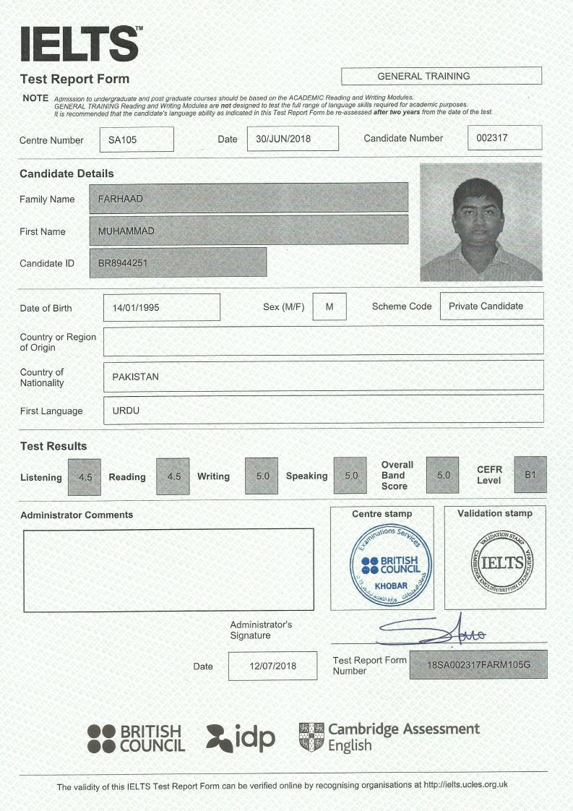

Sadara ID.jpg
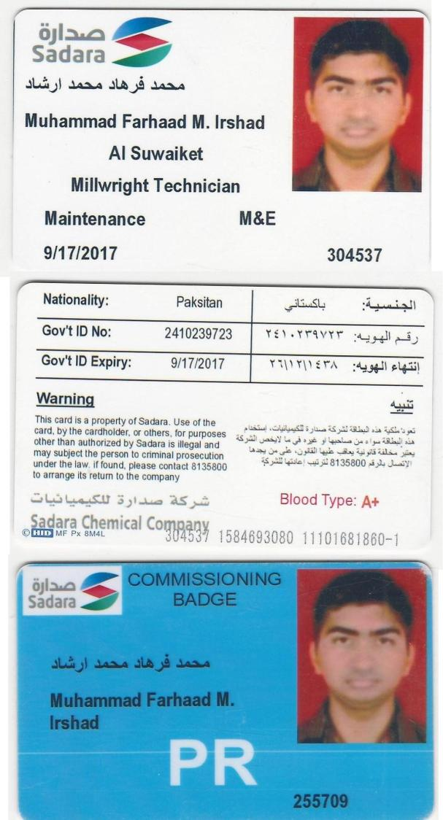

SADARA CERTIFICATE.jpg
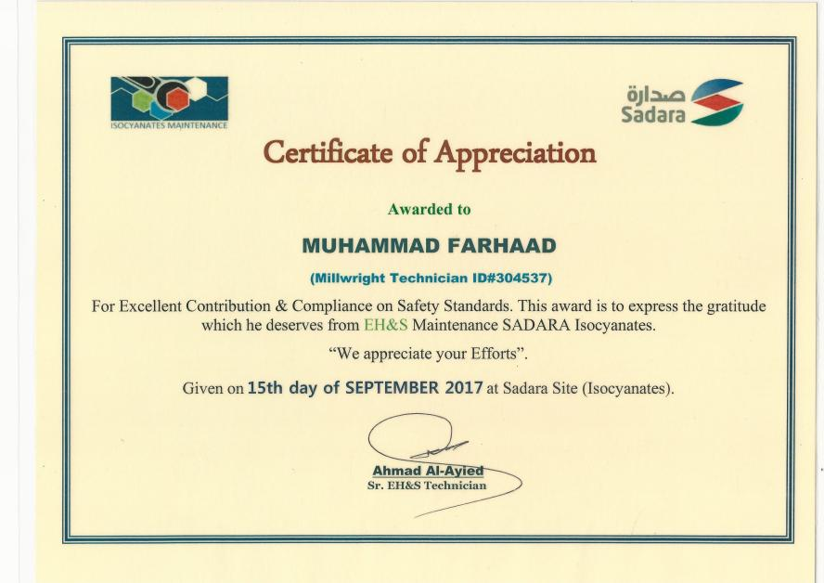

Saudi Aramco Id.jpg
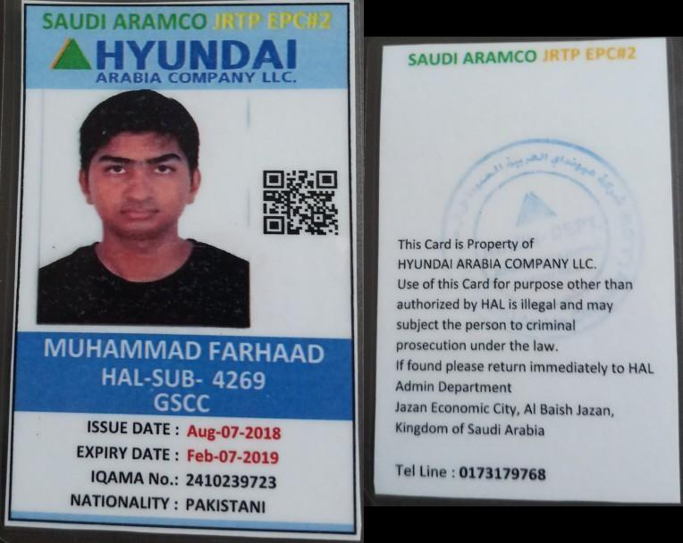

SABIC HADEED ID.jpg
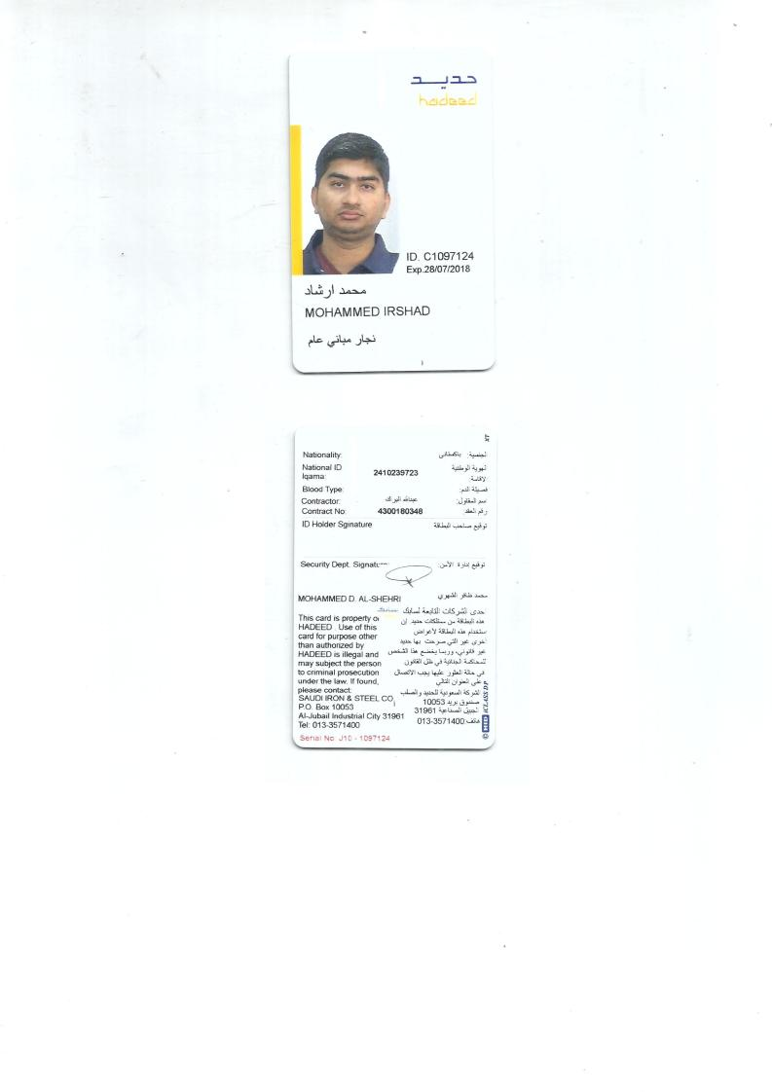

Profile 2-min.jpg
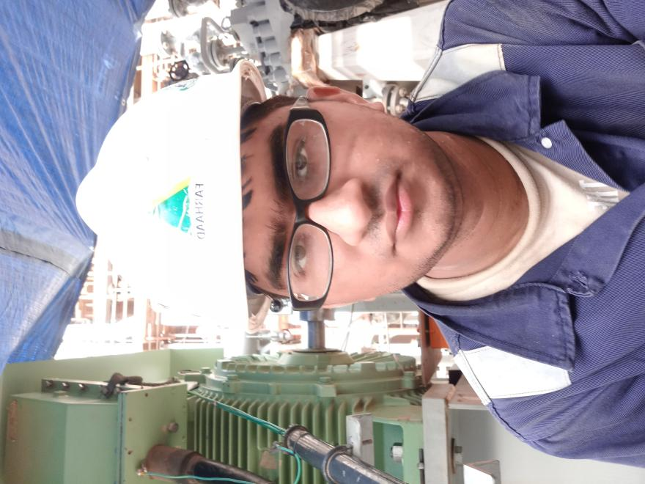

Profile pic 1-min.jpg
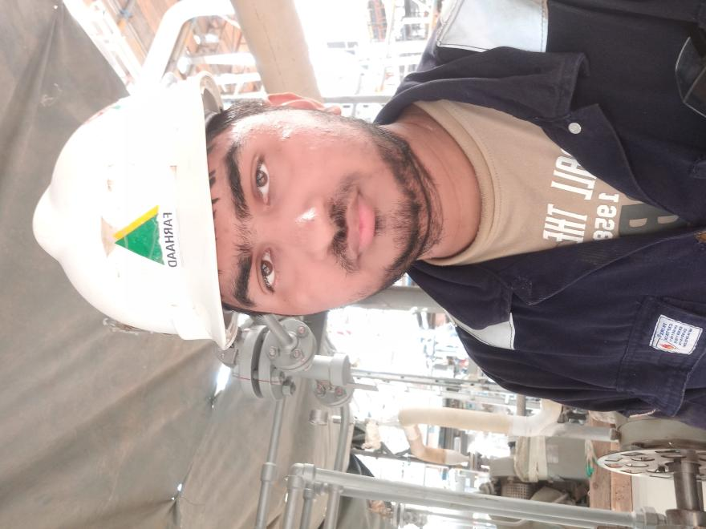

Language passport MUHAMMAD FARHAAD

Mother tongue(s) Foreign language(s)
Urdu English

English
Self-assessment of language skills
UNDERSTANDING |  |  | SPEAKING |  |  | WRITING
  Listening |   Reading |  |   Spoken interaction |   Spoken production |  |   Writing
B1  Independent user | B1  Independent user |  | B1  Independent user | B1  Independent user |  | B1  Independent user
Certificates and diplomas
Title |  | Awarding body |  |  | Date |  | Level*
International English Language Test System |  | British Council Saudi Arabia |  |  | 12/07/2016 |  | B1
Linguistic and intercultural experience
Description |  |  |  |  | Duration
Using languages at work:  - Saudi Aramco  - Sadara Chemical Company  - Saudi Iron & Steel Company |  |  |  |  | 01/04/2016–Present


The Europass Language Passport is part of the European Language Portfolio developed by the Council of Europe (www.coe.int/portfolio).

Common European Framework of Reference for Languages - Self-assessment grid

 |  | A1  Basic user | A2  Basic User | B1  Independent user | B2  Independent user | C1  Proficient user | C2  Proficient user
Understanding |   Listening | I can understand familiar words and very basic phrases concerning myself, my family and immediate concrete surroundings when people speak slowly and clearly. | I can understand phrases and the highest frequency vocabulary related to areas of most immediate personal relevance (e.g. very basic personal and family information, shopping, local area, employment). I can catch the main point in short, clear, simple messages and announcements. | I can understand the main points of clear standard speech on familiar matters regularly encountered in work, school, leisure, etc. I can understand the main point of many radio or TV programmes on current affairs or topics of personal or professional interest when the delivery is relatively slow and clear. | I can understand extended speech and lectures and follow even complex lines of argument provided the topic is reasonably familiar. I can understand most TV news and current affairs programmes. I can understand the majority of films in standard dialect. | I can understand extended speech even when it is not clearly structured and when relationships are only implied and not signalled explicitly. I can understand television programmes and films without too much effort. | I have no difficulty in understanding any kind of spoken language, whether live or broadcast, even when delivered at fast native speed, provided I have some time to get familiar with the accent.
Understanding | Reading | I can understand familiar names, words and very simple sentences, for example on notices and posters or in catalogues. | I can read very short, simple texts. I can find specific, predictable information in simple everyday material such as advertisements, prospectuses, menus and timetables and I can understand short simple personal letters. | I can understand texts that consist mainly of high frequency everyday or job- related language. I can understand the description of events, feelings and wishes in personal letters. | I can read articles and reports concerned with contemporary problems in which the writers adopt particular attitudes or viewpoints. I can understand contemporary literary prose. | I can understand long and complex factual and literary texts, appreciating distinctions of style. I can understand specialised articles and longer technical instructions, even when they do not relate to my field. | I can read with ease virtually all forms of the written language, including abstract, structurally or linguistically complex texts such as manuals, specialised articles and literary works.
Speaking | Spoken interaction] | I can interact in a simple way provided the other person is prepared to repeat or rephrase things at a slower rate of speech and help me formulate what I'm trying to say. I can ask and answer simple questions in areas of immediate need or on very familiar topics. | I can communicate in simple and routine tasks requiring a simple and direct exchange of information on familiar topics and activities. I can handle very short social exchanges, even though I can't usually understand enough to keep the conversation going myself. | I can deal with most situations likely to arise whilst travelling in an area where the language is spoken. I can enter unprepared into conversation on topics that are familiar, of personal interest or pertinent to everyday life (e.g. family, hobbies, work, travel and current events). | I can interact with a degree of fluency and spontaneity that makes regular interaction with native speakers quite possible. I can take an active part in discussion in familiar contexts, accounting for and sustaining my views. | I can express myself fluently and spontaneously without much obvious searching for expressions. I can use language flexibly and effectively for social and professional purposes. I can formulate ideas and opinions with precision and relate my contribution skilfully to those of other speakers. | I can take part effortlessly in any conversation or discussion and have a good familiarity with idiomatic expressions and colloquialisms. I can express myself fluently and convey finer shades of meaning precisely. If I do have a problem I can backtrack and restructure around the difficulty so smoothly that other people are hardly aware of it.
Speaking | Spoken production | I can use simple phrases and sentences to describe where I live and people I know. | I can use a series of phrases and sentences to describe in simple terms my family and other people, living conditions, my educational background and my present or most recent job. | I can connect phrases in a simple way in order to describe experiences and events, my dreams, hopes and ambitions. I can briefly give reasons and explanations for opinions and plans. I can narrate a story or relate the plot of a book or film and describe my reactions. | I can present clear, detailed descriptions on a wide range of subjects related to my field of interest. I can explain a viewpoint on a topical issue giving the advantages and disadvantages of various options. | I can present clear, detailed descriptions of complex subjects integrating sub-themes, developing particular points and rounding off with an appropriate conclusion. | I can present a clear, smoothly-flowing description or argument in a style appropriate to the context and with an effective logical structure which helps the recipient to notice and remember significant points.
Writing | Writing | I can write a short, simple postcard, for example sending holiday greetings. I can fill in forms with personal details, for example entering my name, nationality and address on a hotel registration form. | I can write short, simple notes and messages. I can write a very simple personal letter, for example thanking someone for something. | I can write simple connected text on topics which are familiar or of personal interest. I can write personal letters describing experiences and impressions. | I can write clear, detailed text on a wide range of subjects related to my interests. I can write an essay or report, passing on information or giving reasons in support of or against a particular point of view. I can write letters highlighting the personal significance of events and experiences. | I can express myself in clear, well- structured text, expressing points of view at some length. I can write about complex subjects in a letter, an essay or a report, underlining what I consider to be the salient issues. I can select a style appropriate to the reader in mind. | I can write clear, smoothly-flowing text in an appropriate style. I can write complex letters, reports or articles which present a case with an effective logical structure which helps the recipient to notice and remember significant points. I can write summaries and reviews of professional or literary works.
Common European Framework of Reference for Languages (CEF): © Council of Europe

