CURRICULUM VITAE
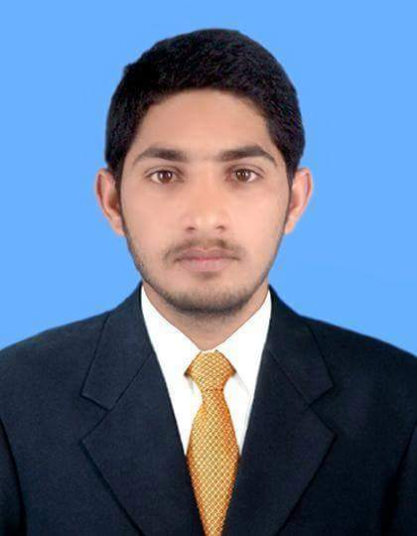

Name: Nasir Amanat
Son Of: Amanat Ali
Address:
Mohallah Nuqsh.e.Lasani Nagar
Tehsil Shakargarh District Narowal Pakistan.
Cell#0341-7880300
amanatnasir984@gmail.com
PERSONAL INFORMATION
Date Of Birth: 08-May-1995
C.N.I.C No : 34502-5872629-3
Religion : Islam
Nationality: Pakistani
Language Competency: Urdu,Punjabi,Arabice&English
Domicile/PRC: Punjab,District Narowal
OBJECTIVE:
To be a part of technical team of any organization and utilize my technical experiencel knowledge and professional skills in achieving all the assigned tasks.

ACADEMIC EDUCATION
Middle Pass(Hafiz.e.Quraan)
Technical experience
01)- 05 Years Experience in Air conditioner/Refrigerator in Islamabad.
A/C Installation & Heating & cooling Air conditioner Repairing & No frost & Direct cool refrigerator Repairing & Water cooler Repair & Water dispenser Repair,
02)- 03 Years Experience as electricion at ittifaq Steel industries, Lahore.
03)- 07 Years Experience in repairing & Maintenance of All electrical Appliances,
single phase & 3phase wiring Repair, Microwave Oven, electric heater, washing Machine, Celling fan, pedestal fan, Air cooler Repairing, And Motor winding single phase,
PROFESSIONAL SKILLS
Courses: Repair & Maintenance of electrical appliances,
Repair & Maintenance of Refrigeration & conditioning,
Institute: Vocational training institute Zafarwal Narowal,
Period: (14 Month)
Year Passing: (2009)
REFRENCE
Furnish upon Request

