CURRICULUM VITAE

Contact: 00966594268208 Email: rehman_lah@hotmail.com

Job Title: Fire Alarm and FM-200 System Supervisor
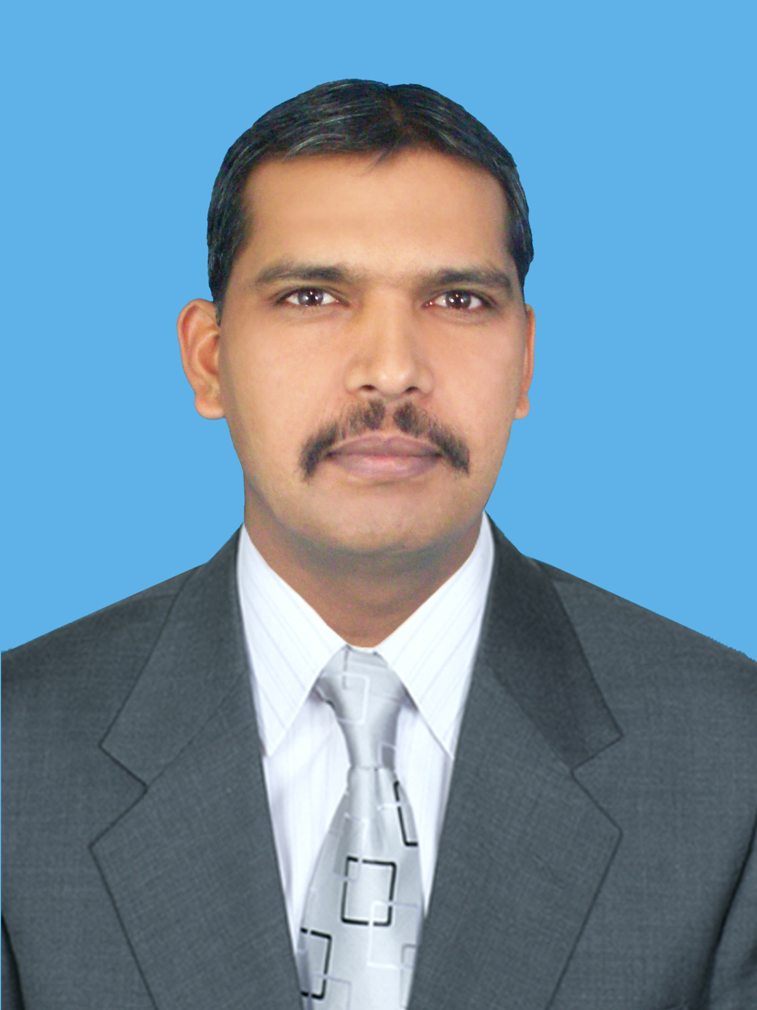

PERSONAL INFORMATION

Name: Abdul Rehman
Father Name: Abdul Ghafoor
Date Of Birth: 02-05-1979
NIC No: 374052-207858-1
Nationality PAKISTANI
Passport Number: EB9158582
Driving license: Expiry Date: 29-06-2016 / Pakistani
Driving license: Expiry Date: 23-03-2019 / SAUDI ARABA
Education: Matric in June 27 1996
Permanent Address: House #15 Street # 01 Block # 01 Bhalwal Distt. Sargodha
Permanent Address: Dar Al Arkan Al Qasar Community Swadi Riyadh Saudi Arabis

Course Fire Fighting

Certificate | Institute | Years
Basic Fire Fighting Course | FASTC (Fire And Safety Training Centre) Course # 104 in Lahore | August 28, 1998
Basic Fire Fighting Course | FASTC (Fire And Safety Training Centre) Course # 146 in Lahore | April 17, 2004

Course Fire Alarm System and Fire Fighting

Certificate | Institute | Years
Fire Alarm Technician | AGT Institute of Technical & Professional Education (Rawalpindi ) | Ending date 05 June 2008  Reg. N0. F-FTG. 3360
Fire Fighting Course | AGT Institute of Technical & Professional Education (Rawalpindi ) | Ending date 16 March 2009  Reg. N0. F-FTG. 4365

Computer courses

Certificate | Institute | Years
M.S OFFICE | FEDERAL College Of Computer & Sciences in Rawalpindi | 03 Months  Complete 22-january 2000
Advance Diploma in computer Sciences | Super Tech Institute Of Computer Sciences in Rawalpindi | 03 Months  Complete January 2001
Working Experience

- I am working in Haseen Habib Corporation (Pvt.) Ltd. In Rawalpindi Office as a Fire Alarm Technician and marketing Fire Alarm and Fire Extinguishers. I am also installer Fire Alarm system and FM-200 Systems.
I am work Haseen Habib Corporation (Pvt.) Ltd. March 1997 to 31 December 2009.

- I Am Working of Prince Sultan Air Base Al-kharj as a Fire Alarm System Technician.
01 January 2010 To 30 November 2013

- I am working in General Technology & Development Est. Kilo-3 Jeddah 01 January 2014 to 31 August 2015

- i am working in Mena Arabia Treading and Contracting Company in Riyadh August 2015 to 31 July 2016.

- Know I am working Dar Al Arkan Al-Qasar Community Swadi Riyadh Saudi Arabia.

PROJECTS

- Nargis 110KV/13.8KV Sub-Station in Riyadh.
- Kuzamma 110KV/13.8KV Sub-Station in Riyadh.
- NIC Nasrea 48 NOVEC1230 System in Riyadh.
- Turaif 132KV/33KV Sub Station in Turaif.

I am Fire Alarm, FM-200, Fire Suppression System Installation, Servicing, maintenance testing and commissioning these systems. I have some knowledge of Fire Fighting like that Fire hose Reel, Fire Hose Cabinet, Fire Sprinkler etc. I have knowledge of all type of Fire Extinguishers how to use and which fire use which Fire use which Fire Extinguisher.
Read the drawing. I have driving license Saudi Arabia.

ABDUL REHMAN
CELL # 00966594268208

