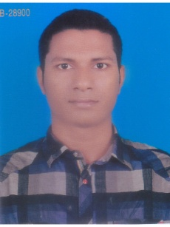
MD. TOFAZZAL HOSSAIN
Village: Chapulia, House No-124,
B.O.F., Joydebpur, Gazipur-1703.
Mobile No : +8801846758286
E-mail: htofazzal33@gmail.com

Career Objective

To obtain challenging and rewarding position where I utilize and grow my analytical and technical skills in a dynamic organization. I wish to refine my knowledge in the area of this highly competitive engineering sector with a blend of hardworking spirit and creative zeal.
Educational Qualification

- Diploma in Electrical Engineering
Model Institute of Science and Technology, Gazipur, Dhaka, Bangladesh
Year of passing: 2013
GPA: 3.12 (Out of 4.00)
-Secondary School Certificate (Science)
Bangladesh Machine Tools’ Factory High School, Gazipur, Dhaka, Bangladesh
Year of passing: 2009
GPA: 4.38 (Out of 5.00)
Language Proficiency

- Bengali : Native Language
- English : Good command in Speaking, reading and writing
Computer Skills

- Knowledge in Microsoft Word/Excel/PowerPoint.
- Knowledge in MATLAB, C, Java etc.
Additional Qualification

- Internship ( November 2012 to January 2013)
Department of Youth Development, Gazipur.
- Electrical Skill Pass from Singaporean BCA Academy ,
Trained in Weltech Test Centre, Ashulia, Savar.
Experiences

- 2017-Present
Serveyer
FOSTA PTE. LTD., Singapore
- General Worker
Rich-link Construction PTE. LTD., Singapore

Personal Information

Father’s Name : Md. Humayun Kabir
Mother’s Name : Khodeza Begum
Permanent Address : Village: Chapulia, House No: 124, Post Office: B.O.F.,
Police Station: Joydebpur, District: Gazipur- 1703.
Date of Birth : 10-08-1994
Marital Status : Unmarried
Religion : Islam
Nationality : Bangladeshi
Passport No : BT0565960
Blood Group : O+

I hereby declare that the above furnished information is authentic to the best of my knowledge and belief.

…………………………..
(MD. Tofazzal Hossain)

