PERSONAL DATA
NAME: WAQAS AHMED

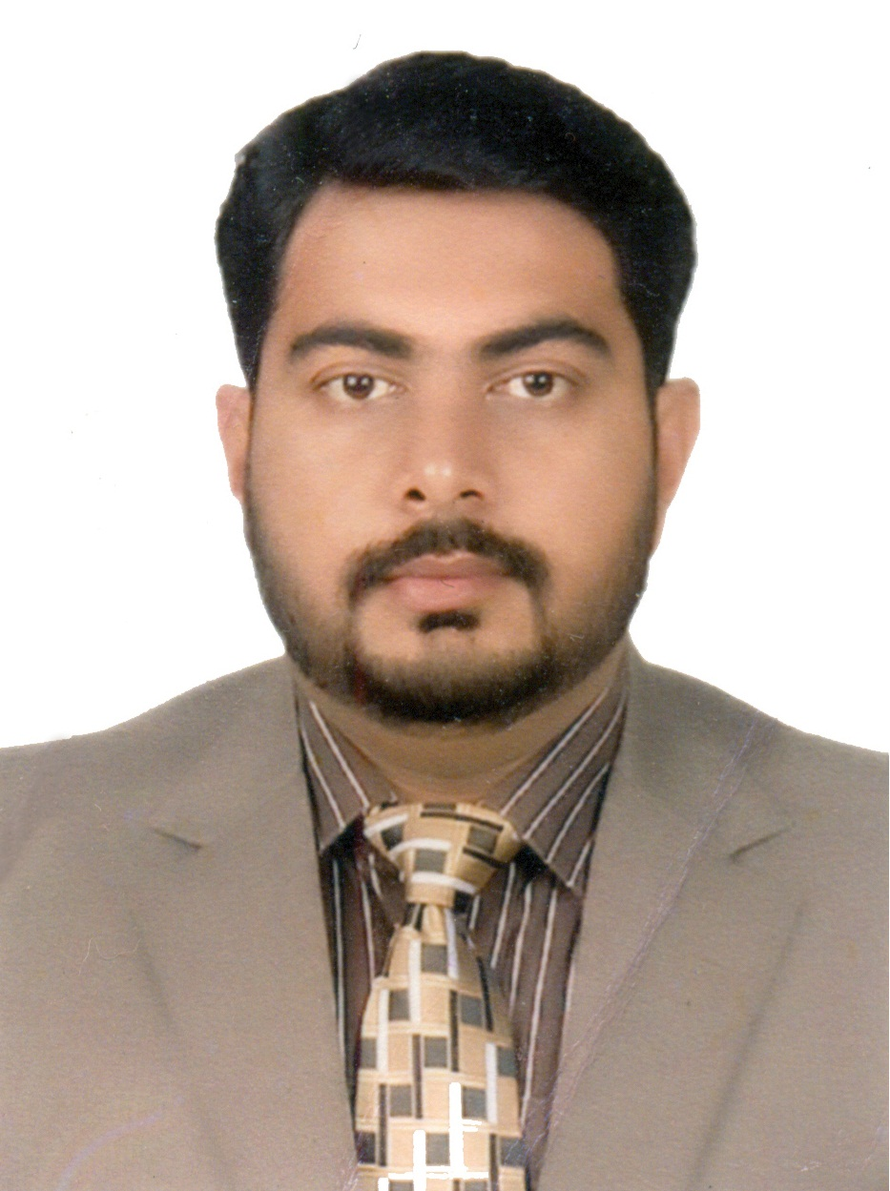

DATE OF BIRTH: OCTOBER 6TH 1985

CITIZENSHIP: PAKISTANI

NIC #: 42501-2078097-1

PASSPORT #: UG1150972

RESIDENTIAL ADDRESS: R-14 MARINA GARDENS, JAMIA MILLIA ROAD, MALIR CITY,
KARACHI-75050, PAKISTAN
Cell: (+92) 345-3033051
E-Mail: shkwaqasahmed@gmail.com

WORK EXPERIENCE

ARTOTEC Pvt. Ltd. June 2016 to date
Working as a, Electronic In-charge

- Installation, troubleshooting and work on offset printing machines of KBA
- RAPIDA 145-6+L
- RAPIDA 105-6+L
- Installation and maintenance of die-cutting, paper cutting & reel cutting machines
- NIKKO (YOCO JY-106E)
- BOBST NOVACUT-106
- SCHNEIDER SENATOR 115 MC
- SCHNEIDER SENATOR S-LINE 115H
- BOBST AMBITION
- HOSON ZH-88 Folding Gluing
- GAOKE Folding Gluing

Job Description
- To process and execute preventive maintenance task for printing machines as prescribed by manufacturer
- To process an execute preventive maintenance task for die-cutting as prescribed by manufacturer
- To process an execute preventive maintenance task for pasting machines as prescribed by manufacturer
- To process and execute preventive maintenance task periodically for chiller plant and generator and all additional utilities
- Handling and installation of other packaging machineries and equipment
- To provide training and guidance to machine operators for better handling
- To troubleshoot faults in machine and perform respective task for its remedy
- Identifying of worn out parts and order for replacement or repair accordingly
- To develop store for maintaining spare parts and proper placement of parts and equipment with identification
- Design new strategies to improve the process

INTERNATIONAL PRINTING AGENCIES March 2010 to June 2016
Worked as, Senior Electronic Engineer
- Installed, troubleshoot and work on offset printing machines of KBA
- RAPIDA 105-6+L
- RAPIDA 72-5+L
- RAPIDA 75-6+L
- RAPIDA 104-6+L
- RAPIDA 104-6+ALV
- Installed and maintain of die-cutting and paper cutting machines like BOBST, NIKKO & SCHNEIDER SENATOR also work experience on folder-gluers machines.
- BOBST SP-102 CER
- SCHNEIDER SENATOR S-LINE 115H
- SCHNEIDER SENATOR E-LINE 78

Job Description
- Operational worked on market dominant systems including COMPAX drives, BAUMULLER & INVT Drives, HMI, PLCs including B&R, ABB, OMRON & MITSUBISHI.
- Read and managed large & complex drawings and diagrams with the utilization of designing tools.
- Command & control all types of sensors, transducer, proximity sensors, ultrasonic and capacitive sensors and encoders.
- Repaired customize electronic cards & boards.
- Correspondence to supplier and vendor for some critical situation and guidance regarding any serious fault and any trouble.
- Managed desktop remote maintenance through modem and M-guard connection.
- Excellent command on communication control techniques like ARCNET,CS31, serial communication and Ethernet
- Excellent command on managing computer networks (switching & routing), hardware and software tools and its trouble-shooting.
- Check and maintain atmospheric temperature and humidity according to machine requirement.
- To provide training and briefly explain to customers and machine operators regarding operation of machine and handling.

SOME IPA CLIENTS AND AFTER SALE SERVICES INDUSTRIES:

- Pakistan Security Printing Corporation (Pvt.) Ltd. Karachi.
- Artotec (Pvt.) Ltd. Karachi.
- Century Packages. (Pvt.) Ltd. Karachi.
- Printsol (Pvt.) Ltd. Lahore.
- Paradise Printers (Pvt.) Ltd. Karachi.
- Grey Printers (Pvt.) Ltd. Karachi.

TRAINING
- Electrical, Mechanical and Operational training on KBA Rapida-145 6+ALV
from KBA Radebeul, Germany 2016 (3 Weeks)

- Training from Shanghai YOKO industrial corporation ltd. China 2015 (2 Weeks)

- CCNA Training at Etronic Solution Provider 2011 (3 Months)

EDUCATIONAL BACKGROUND

QUALIFICATIONS:

2005-2009 B.E (ELECTRONICS)
USMAN INSTITUTE OF TECHNOLOGY
(HAMDARD UNIVERSITY) (1st Division)
Karachi

2003-2004 HIGHER SECONDARY CERTIFICATE
Board of Intermediate Education
Govt. Degree College Stadium Road
Major: Pre-Engineering (2nd Division)
Karachi

2001-2002 SECONDARY SCHOOL CERTIFICATE
Board of Secondary Education
Prince Aly Boys School
Major: Computer Science (1st Division)
Karachi

REFERENCES
will be provided on request.

