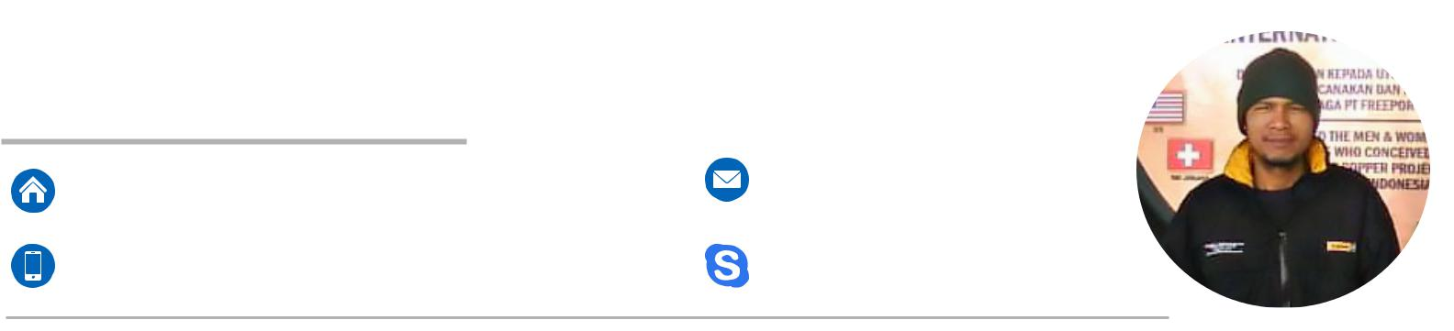
Z U N A I D Y. Z
Senior Mechanical Technician

Dawar blandong, mojokerto, Surabaya | joened_z@yahoo.com
East Java-Indonesia, 61354 | joened.joe
+6281354071670 | joened.joe

SUMMARY

More than 15 years of experience as a Mechanical Technician, working with high spirit, unyielding in resolving a problem and provide the best results for the company in the work

EXPERIENCE

Soroako, Indonesia

May 2017 - Present

Kumtor, Kyrgyzstan

Sept. 2015 - Feb. 2016

Lafarge Cement,

Karbala, Iraq
Feb. 2015 - July 2015

Grassberg Mine, Papua,
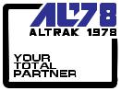
Indonesia
Nov 2013 - July 2014

Grassberg Mine, Papua,

Indonesia
Oct. 2008 - Nov. 2013

Grassberg Mine, Papua,

Indonesia

Jan. 2007 - Aug. 2008

Surabaya, East Java,
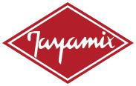
Indonesia
April 2005 - Jan. 2007

Kuala Kencana,Timika
Papua, Indonesia
Sept. 2003 - March. 2004

Leader ( Senior Mechanical Technician under PT.JIM )

Troubleshoot, repair and maintain Equipment D6M.D8R.D10NRT. Cat320 Exca.Truck Cat 777C.Cat loader 966H.988F.992. Grader 14M.16H.16M.24H.Komatsu WA800-C

Senior Mechanical Technician ( HPRS Recruitment )

Remove And Install Small & Big Component Truck CAT 785,789 D10R,D10T Over Houl Component., Repair & Troubleshoot Equipment .Performance Test Equipment & Adjusting

Senior Mechanical Technician
Repair & Maintenance Engine Hyundai Himsen H 21 HFO,18 MW

Senior Mechanical Technician

Troubleshoot, repair and maintain Komatsu 930E uses Cummins Engines: QSK 60, Shovel Terex RH 200 uses Cummins KTTA38, Shovel O&K 120 uses Engine Cummins KTTA19 and small Cummins Engine series

Acting Foreman ( Senior Mechanical Technician JDA Recruitment )

Troubleshoot, repair and maintain Truck Komatsu 930E

uses Cummins Engines QSK 60,Shovel Terex RH 200 uses Cummins KTTA38,Shovel O&K120 uses Cummins Engine KTTA19 small Engine series on underground bigosan freepot mine as equipment Tamrock loader EJC ,Maxijet,Mixer Truck,loader Cat Elphinstone

R 1600 Engine cummins QSB 6.7,Sisorlift,Boom Truck,lube Truck, Water Truck,Anfo Trcuk,Schwing Pump Engine Cummins Series QSB 4,5 & 6.7

Mechanical Technician Assembler ( Buma Recruitment )

Troubleshoot.Repair,Heavy Equipment Maintenance Haul Truck CAT 793B,793C. Remove and install small and big component on Truck for Pcr

Mechanical Technician

Troubleshoot,Repair & Maintenance Heavy Equipment: Nissan, Hino, Isuzu Truck, Loader CAT 926E, 966F, Komatsu Loader WA180, Furukawa Loader 200Pc, Concrete Pump Isuzu, CAT Gen-Set 3512 , Genset Engine Cummins

Mechanical Technician Assembler ( Buma Recruitment )
Troubleshoot,Repair ,Maintenance Equipment.Remove& Assembling

793B Upgrade 793C OHT.CAT Loader Elphinstone R1600, R1700 CAT

Pekanbaru, Riau

Indonesia
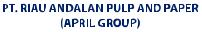
March 1998 – Des 2001

Mechanical Technician
Troubleshoot,Repair ,Maintenance Heavy Equipment Truck Volvo, Scania Nissan for logging, Excavator Komatsu PC 200, CAT Skyder, Cummins Gen-Set, Forklift 20t & 40,Engine Perkins Maintenance

SKILLS

- Mechanical Troubleshoot - Electronic Technician

- Electrical Troubleshoot - Equipment Operate

- Testing & adjusting - Remove install Component

- Maintainance & Service - Product Improvement

- Failure Analysis & Technical report - Work with many heavy Equipment models type and brand

SPECIAL ACHIEVMENT

working with pre-determined target and minimize down equipment at field & Zero time incident

EDUCATION & COURSE

1993 - 1996

2007 - 2014

Technical Senior High School
Aceh Utara, Lhoksuemawe - Indonesia

Training Maintenance Cummins Engine

Training Engine Rebuild & Repair

Training Fundamental Engine

Training Fundamental Power train

Training Fundamental Hydraulic

Training Fundamental Electric

Training Basic Mechanic

Training Center Freeport - Grassberg mine, Papua Indonesia

ADDITIONAL INFORMATION

Passport Republic of Indonesia | A 8916982
21 Aug 2014 until 21 Aug 2019

Reference | Muhammad Sudirman
Muhammad_sudirman@fmi.com

+628124074848

Wani Najoan ( As Superintendet )

Wani_najoan@fmi.com

+6281240019949

