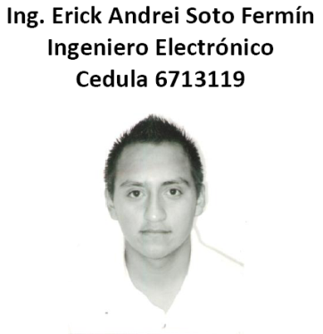
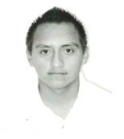

ING.ERICK ANDREI SOTO FERMIN
Ing. Electrónica Especiality (Instrumentación & Control)
36 años, México, Married. R.F.C. SOFE8207024L3
https://www.linkedin.com/in/erick-andrei-soto-fermin-22065959?lipi=urn%3Ali%3Apage%3Ad_flagship3_profile_view_base_contact_details%3BvkuiTSgURluqcb3TrVYfKQ%3D%3D
Street: 2583 RENFREW ST
City: Vancouver
British Columbia
Tel. (044) 2281239922 (044) 2281885790
erickandretty@hotmail.com
eransofe@gmail.com
Tipo de sangre 0-

Labor goal
Develop my skills and learning acquired by studies and jobs that have given the experience to solve situations or concerns within the company.

Experiencia laboral
09-2017-08-2018 CFE
Supervise the construction of Lines in Medium Tension as well as preparation of domestic services in low tension; works in office as elaboration of works Bitacoras, as well as physical progress of the supervised work for signature of the respective progress of construction by contractor.
Develop and document progress and present profitability of the Investment Project Financing

2016-12 / 2017-07 TROY
Working on project Pidiregas phase 7 contractor company as supervisor in medium voltage (force cycles) and low voltage

07-2013 / 10-2016 CFE
The detection and recovery of Energy in CFE is carried out as well as the construction of Murals and Preparations in Low and Medium Tension,

09-2012 | 06-2013 FIDE, Trust for the Electric Energy Saving (CFE)
Visit to several companies in Zone, Xalapa, and Poza Rica Ver. To implement energy diagnostics in the public and private sector, applying financing to large clients in OM and HM rates starting with Habit Changes based on the Business Effectiveness tool and factor correction. power based on analysis of inductive or harmonic loads correcting with capacitor banks or filters respectively to obtain considerable savings in their monthly invoicing, sometimes only the transformers that FP is passing are oversized this is well below 90%.

05-2012 | 08-2012 SUCAT, Supervision and Technical Advisory S.A. of C.V.
PROSSAPYS-CONAGUA Project, Social assistance activities in rural communities with agreements for the implementation of potable water and drainage systems.
Developing field operation activities with agreements with the Municipality, Municipal Agents and Committees for the benefit of the localities.

06-2011 | 12-2011 SUCAT, Supervision and Technical Advisory S.A. of C.V.
PROSSAPYS-CONAGUA Project, Social assistance activities in rural communities with agreements for the implementation of potable water and drainage systems.
Developing field operation activities with agreements with the Municipality, Municipal Agents and Committees for the benefit of the localities.

10-2010 | 11-2010 CFE, Mexico. Energy
Instrumentist Montador, Develop,implement and improve solutions for the increase of power in the construction area as well as calibration and adjustment of Fieldbus equipment in the area of ​​instrumentation and control, installation of tube trac and As Built, Pneumatic and Hydrostatic tests to pipeline Stainless steel, Field Bus equipment and fastening bolts respectively.

03-2006 | 02.2007 Hotel, Fiesta Inn Xalapa
Operator of clothes washing equipment and customer service developing supervisory activities in the department of housekeeping laundry area.
Public Areas developing cleaning activities and supervision of the rooms and halls of the Hotel itself.

COURSES OBTAINED
• COURSE BENEFITS TO CORRECT THE LOW POWER FACTOR
• MAOH COURSE BUSINESS COURSE
• REMOTE TERMINAL UNIT COURSE (UTR) FOR SUBSTATIONS
• COURSE DISTRIBUTION AND SUBSTATIONS WITH SF6
• MEASUREMENT COURSE (CALIBRATION OF MULTIMETERS FLUKE, RM-10, RM-17, MANTTO, ARTIFICIAL LOAD)
• POE COURSE (GREEN LAGOON).
ENGLISH COURSE HARMON HALL
ENGLISH COURSE CANADIAN COLLEGE VANCOUVER
ING. ERICK ANDREI SOTO FERMIN

